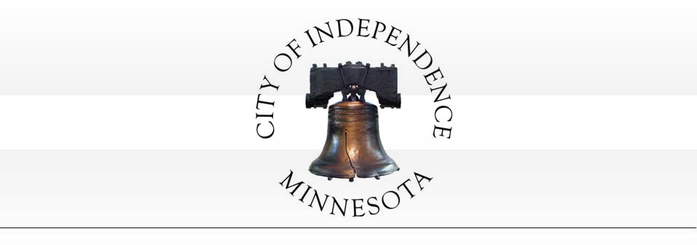

CITY COUNCIL MEETING AGENDA REGULAR MEETING
TUESDAY, MAY 9, 2017

CITY COUNCIL MEETING TIME: 7:30 PM

- Call to Order

- Pledge of Allegiance

- Roll Call

- ****Consent Agenda****

All items listed under Consent Agenda are considered to be routine by Council and will be acted on by one motion. There will be no separate discussion of these items. If discussion is desired, that item will be removed from the Consent Agenda and will be considered separately.

  - Approval of City Council minutes from the April 25, 2017 Regular City Council Meeting.
  - Approval of minutes from the April 25, 2017 Board of Appeal and Equalization Meeting.
  - Approval of Accounts Payable; Checks Numbered 17103-17139.
  - Approval of MnDOT Master Partnership Contract for the Highway 12 Light Maintenance.
    - RESOLUTION NO. 17-0509-01.

- Set Agenda – Anyone Not on the Agenda can be Placed Under Open/Misc.

- Reports of Boards and Committees by Council and Staff.

- Director Gary Kroells, West Hennepin Public Safety - Activity Report for the Month of March, 2017.

- PUBLIC HEARING: Jason Sievers (Applicant/Owner) requests that the City consider the following actions for the property located at 1180 County Road 83 (PID No. 25-118-24-32- 0001) in Independence, MN:

763-479-0527 (Phone) 1920 County Road 90 763-479-0528 (Fax)
Independence, MN 55359 http://independence.govoffice.com

  - RESOLUTION NO. 17-0509-02 - recommending denial of a variance to allow a reduced side yard setback for the subject property.

Consideration of Adopting an Ordinance Amendment Pertaining to Public Safety:

  - ORDINANCE NO. 2017-01 – Adoption of a predatory offender dwelling location restriction ordinance.

Discussion of City Council Meeting Dates/Times.

- Open/Misc.

- Adjourn.

MINUTES OF A REGULAR MEETING OF THE INDEPENDENCE CITY COUNCIL
TUESDAY, APRIL 25, 2017 –7:30 P.M.

- CALL TO ORDER.

Pursuant to due call and notice thereof, a regular meeting of the Independence City Council was called to order by Mayor Johnson at 7:30 p.m.

- PLEDGE OF ALLEGIANCE.

Mayor Johnson led the group in the Pledge of Allegiance.

- ROLL CALL

PRESENT: Mayor Johnson, Councilors Betts, Grotting, Spencer and McCoy ABSENT: None
STAFF: City Administrative Assistant Horner, City Administrator Kaltsas, City Attorney Vose VISITORS: Lynda Franklin

- ****Consent Agenda****

All items listed under Consent Agenda are considered to be routine by Council and will be acted on by one motion. There will be no separate discussion of these items. If discussion is desired, that item will be removed from the Consent Agenda and will be considered separately.

  - Approval of minutes from the April 11, 2017 Joint City Council Meeting.
  - Approval of minutes from the April 11, 2017 Board of Appeal and Equalization Meeting.
  - Approval of minutes from the April 11, 2017 Regular City Council Meeting.
  - Approval of Accounts Payable; Checks Numbered 17073-17102.

Motion by Betts, second by McCoy to approve the Consent Agenda. Ayes: Johnson, Grotting, McCoy, Spencer and Betts. Nays: None. Absent: None. MOTION DECLARED CARRIED.

- SET AGENDA – ANYONE NOT ON THE AGENDA CAN BE PLACED UNDER OPEN/MISC.

- REPORTS OF BOARDS AND COMMITTEES BY COUNCIL AND STAFF

Spencer attended the following meetings:
- Planning Commission Meeting
- Board of Review and Appeal Meeting

Grotting attended the following meetings:
- Planning Commission Meeting
- Board of Review and Appeal Meeting

McCoy attended the following meetings:
- Board of Review and Appeal Meeting

- Retired Police Chiefs Event in St. Cloud
- Wright/ Hennepin Pork Chop Dinner in Rockford
- Community Easter Egg Hunt in Maple Plain

Betts attended the following meetings:
- Board of Review and Appeal Meeting

Johnson attended the following meetings:
- Northwest League of Municipalities Meeting
- Community Action Partnership Meeting
- Wright/ Hennepin Pork Chop Dinner Event in Rockford
- Highway 55 Corridor Meeting
- Alumni Association Meeting at U of M
- Judge at State FFA Convention
- Senior Community Services Finance Committee Meeting
- Orono School Board Meeting
- Board of Review and Appeal Meeting

Horner attended the following meetings:
- Board of Review and Appeal Meeting
- Planning Commission Meeting

Kaltsas attended the following meetings:

- PRELIMINARY ORDINANCE DISCUSSION:

  - Massage Parlor Ordinance – Discussion relating to possible update to the City’s massage parlor ordinance based on recommendation of West Hennepin Public Safety.

Kaltsas said West Hennepin Public Safety has worked with the City of Maple Plain to adopt an ordinance regulating the licensing of massage services parlors. The ordinance was developed following difficulties the City and West Hennepin had with non-legitimate massage parlors. West Hennepin would like the City to consider adopting a similar ordinance for the purpose of regulating the licensing of massage services parlors in Independence.

He said the basis of the ordinance is to regulate the licensing of individuals and business providing massage services in the City. The City has reviewed the ordinance adopted by the City of Maple Plain and believes that it could adopt similar language in order to regulate licensing of legitimate businesses and individuals. WHPS has reviewed the ordinance and believes that adoption of the ordinance would better protect the City and its residents. Staff is seeking discussion and direction from the City Council relating to the possibility of adopting an ordinance similar to that adopted in Maple Plain. Based on the discussion and direction provided by the City Council, staff would bring back an official ordinance for consideration and adoption.

Grotting asked what the issue was with the massage parlor that was operating in Maple Plain and if it was a prostitution issue. Kaltsas said alledgedly they were providing more than massages. Grotting asked if there was a law in place against prostitution already. Kaltsas said the issue is enforcement. He said an ordinance would ensure that these types of businesses would not be able to operate within the City of Independence.

Vose said it would be efficient for WHPS to have like ordinances on the books between Maple Plain and Independence. He stated that massage therapists are currently not licensed through the state.

  - Predatory Offender Ordinance – Discussion relating to possible adoption of a predatory offender dwelling location restriction ordinance.

Kaltsas said many metropolitan area cities have recently contemplated adopting certain residency location restrictions for predatory offenders. Cities that have adopted local legislation have typically found that such residency location restrictions would be prudent to protect the local health, safety and welfare of their residents. Cities have adopted a relatively standard and consistent model ordinance language as an amendment to local zoning codes.

Most ordinances restrict Level II and III offenders.

- The model ordinance defines “protected areas” such as schools, playgrounds, parks, and other
places children are known to regularly congregate Level II and III predatory offenders would be prohibited from living a certain distance from those protected areas (e.g. 750 feet measured lot line to lot line).

- Ordinances exempt residences which were established by Level II and III offenders prior to adoption of the ordinance.

- Typically, an offender is also allowed to move into a residence with certain relatives (e.g. parents,
siblings, spouses, children etc.) regardless of the proximity to a protected location. The City of Independence Attorney has prepared a draft ordinance based on the model language used by other similar communities.
While these residency restriction ordinances can be further customized by cities, there are two factors that are typically needing to pertain to the specific city. Independence will need to consider the type of protected area (i.e. parks, daycare facilities, schools, etc.) and the restricted distance that offenders will be prohibited from living from protected areas.

Types of Protected Areas:

The types of protected areas are typically those areas where children commonly congregate. Most cities identify schools, public parks and licensed daycare facilities. Some cities have found other similarly used areas as needing to be defined in the ordinance. Staff did not identify any similar use areas that appear to need further definition in the ordinance.

Restricted Distance:

The City can determine the distance from restricted areas that residency of predatory offenders would be restricted. The distances established by the City cannot purposefully restrict the entire City. The general standard adopted by most Cities is 2,000. The 2,000 feet is measured from the outer edge of the restricted properties to the property line of the residential properties. If any portion of a residential property falls
within the distance, the entire property becomes prohibited. Based on the discussion and direction provided by the City Council, staff would bring back an official ordinance for consideration and adoption.

**to view the draft copy see the city council packet**

Johnson asked if they were bound by state law on where they could live. Vose said no, that once they are out they are not supposed to be told where not to live. Predators are the highest rate of repeat offenders.

Motion by Betts, second by McCoy to direct staff to work on crafting the Massage Parlor Ordinance and the Predatory Offender Ordinance for further review. Ayes: Johnson, Grotting, McCoy, Spencer and Betts. Nays: None. Absent: None. MOTION DECLARED CARRIED.

- COMMUNITY SURVEY – DISCUSS DRAFT SURVEY.

Kaltsas said based on the information developed and provided during the initial kick-off meeting for the 2040 Comprehensive Plan, staff has prepared a draft community survey. The community survey was developed
in an effort to solicit feedback and comments from constituents relating to land use, planning, parks, economic development and transportation. Questions were formulated to seek feedback that will be used to help direct the development of the 2040 comprehensive plan.

The survey incorporates a variety of question formats as discussed during the joint meeting. The number of questions was strategically limited to a reasonable number. It was intended that this survey would have limited redundancy and/or open ended questions. The questions seek to provide the City with tangible feedback relating to key planning and growth issues. Several topics are presented in multiple-questions,
but with different context (i.e. do you think the City should pursue a type of development; and then, do you think the City should utilize public funding to support the development).

The draft survey was prepared in a single-page mail-able format but is also anticipated to be available on the City’s website as an online survey. Staff would anticipate that the City will mail a copy of the survey to every resident and have a pre-paid return reply. In addition, the City will have the survey available on the website.

Kaltsas noted residents would be able to respond via mail or electronically through the website. One survey would be sent to each household but residents would also be able to go online if more than one person in the household wanted to fill out their own survey. Johnson said he was concerned people would fill out more than one and skew the results.

Spencer thought there should be a question regarding affordable housing and water quality.

McCoy said the question about commuting to work should also have a N/A answer or retired option.

Kaltsas said content can be difficult as tainting the questions should be avoided. He noted the questions can be tweaked and a final draft can be approved. He said residents would have 3-4 weeks to respond.

- ADJOURN.

Motion by McCoy, second by Grotting to adjourn at 8:30 p.m. Ayes: Johnson, Grotting, McCoy, Spencer and Betts. Nays: None. Absent: None. MOTION DECLARED CARRIED.

Respectfully Submitted,

Trish Bemmels/ Recording Secretary

Continuation -BOARD OF REVIEW AND APPEAL- MINUTES TUESDAY, APRIL 25, 2017
6:45 P.M.

- RECONVENE

Pursuant to due call and notice thereof, an appeal meeting of the Independence City Council/ Board of Review was recovened by Mayor Johnson at 7:00 p.m.

- ROLL CALL

PRESENT: Mayor Johnson, and Councilors Betts, Grotting, McCoy and Spencer ABSENT: None
STAFF: City Administrative Assistant Horner VISITORS: Melissa Potter, Dave Thomsen, Lynda Franklin

- Board of Appeal –

Johnson stated that the Council needed to decide if they wanted to re-open the hearing. He noted there were five people that contacted Hennepin County since the last hearing and they may want to be on the agenda. Spencer stated it would not be an issue to open and consider the five new requests and any others that may be present.

Motion by Spencer, second by Betts to reconsider the motion to close the appeal process to new reviews from April 11, 2017. Ayes: Johnson, Betts, Grotting, McCoy and Spencer. Nays: None. Absent: None. MOTION DECLARED CARRIED.

Motion by Betts, second by Spencer to hear the five inquiries should they present themselves at the hearing tonight. Ayes: Johnson, Betts, Grotting, McCoy and Spencer. Nays: None. Absent: None. MOTION DECLARED CARRIED.

Thomsen stated recommendations on parcels presented noting valuation changes or no changes.

1030 Co. Rd. 83
1015 Drake Court
“vacant” 01-118-24-21-0005
“vacant” 01-118-24-21-0001
4672 Lake Sarah Dr. S

6390 Co. Rd. 11
6775 Fogelman Rd. 5112 S. Lakeshore Dr. 3175 Co. Rd. 90
2825 Co. Rd. 90
3145 Co. Rd. 92
2585 Valley Rd.
1985 Copeland Rd. 1030 Marsh Ridge Circle
“vacant” -01-118-26-32-0004
872 Co. Rd. 92
4825 Co. Rd. 6

Motion by Spencer, second by Betts to accept the assessor’s recommendation for valuations. Ayes: Johnson, Betts, Grotting, McCoy and Spencer. Nays: None. Absent: None. MOTION DECLARED CARRIED.

Thomsen addressed the properties that came in for review after the initial Board of Review meeting.

Motion by Spencer, second by Grotting to accept the assessor’s recommendation for valuations. Ayes: Johnson, Betts, Grotting, McCoy and Spencer. Nays: None. Absent: None. MOTION DECLARED CARRIED.

- Open/Misc.

- Adjourn

Motion by McCoy, second by Grotting to adjourn at 7:15 p.m. Ayes: Johnson, Betts, Grotting, McCoy and Spencer. Nays: None. Absent: None. MOTION DECLARED CARRIED.

__________________________________________
Trish Bemmels Recording Secretary

City of Independence
Consider Approval of Master Partnership Contract with MnDOT for the Highway 12 Lights

To: City Council

From: Mark Kaltsas, City Administrator
Meeting Date: May 9, 2017

Discussion:

The City of Independence and MnDOT entered into an agreement last fall relating to the maintenance of the new lighting installed along the Highway 12 corridor in 2015. The City determined that contracting maintenance and location services with MnDOT for the Highway 12 lighting was the best solution. Since the City entered into the agreement last fall, no maintenance, replacement or location services have been required. MnDOT has presented the City with a renewal for the Master Partnership Agreement. The contract would run through 2022. The City can opt out of the agreement with 30 days written notice. In the future, the City can reevaluate the agreement to determine the service and value provided by MnDOT.

Summary:
The Council is asked to consider entering into a master services agreement with MnDOT and allowing for the Public Works Director to authorize work orders in accordance with the provisions stipulated in the contract. In order to proceed with the maintenance contract, the Council will need to adopt Resolution 17-0509-01.

ATTACHMENTS: Master Partnership Agreement

Resolution 17-0509-01

Page 1

D E PA R T M E NT O F
r-nI .
T R A N S P O R T A T IO N

Metro State Aid
1500 County Road B2, Roseville, MN 55113
651-234-7773
sharon.lemay@state .mn.us

To: Local Agency Date:April 24,2017
R E: Proposed Master Partnership Contract

Attached is a copy of a proposed master partnership contract between the Minnesota Department of Transportation (Mn/DOT) and your Local Agency.

The Master Partnership Contract provides a framework for Mn/DOT and Local Agencies to provide services and payment to each other . A few MnDOT provided routine services are included in the contract-see Exhibit A-- but all other services require work orders describing costs and scope.

Kindly review the enclosed document and if acceptable,arrange to have it presented to your Council/Board for their approval and execution. Please provide signatures only under the Local Government heading.

Also required is a new resolution passed by the Council/Board authorizing its officials to sign and execute the agreement on its behalf. (Only the named officials may sign the agreement: if anyone else signs in the named official's place, the agreement will not be executed.)

Please return to me at the address listed above or as a pdfto sharon.lemay@ state .mn.us. Please note that no work shall be performed by Mn/DOT personnel until the full execution of the agreement . After execution by Mn/DOT and other State officials,a copy of the agreement will be returned to you.

If you have any questions or require additional information,please feel free to contact me at 651-234- 7773 . If your local agency will not be executing this contract, please send me an email informing me of this so Ican remove you from our list.

Thank You

Sharon LeMay, Metro State Aid

An Equal Opportunity Employer
•
0 0 0 0

D E PA R T M E N T OF
T R A N S PO R TAT I O N MnDOT Contract Number: 1028142

STATE OF MINNESOTA
AND
CITY OF INDEPENDENCE MASTER PARTNERSHIP CONTRACT

This master contract is between the State of Minnesota , acting through its Commissioner of Transportation in this contract referred to as the "State" and the City of Independence, acting through its City Council in this contract referred to as the "Local Government."
Recitals
I . The parties are authorized to enter into this contract pursuant to Minnesota Statutes, §§15.061, 471.59 and 174.02.
  - Minn . Stat. § 161.20, subd. 2, authorizes the Commissioner of Transportation to make arrangements with and cooperate with any governmental authority for the purposes of constructing, maintaining and improving the trunk highway system.
  - Each party to this contract is a "road authority" as defined by Minn. Stat. §160.02, subd. 25.
  - Minn. Stat. § 161.39, subd. 1, authorizes a road authority to perform work for another road authority. Such work may include providing technical and engineering advice, assistance and supervision , surveying, preparing plans for the construction or reconstruction of roadways , and performing roadway maintenance.
  - Minn . Stat. §174.02, subd. 6, authorizes the Commissioner of Transportation to enter into contracts with other governmental entities for research and experimentation ; for sharing facilities, equipment, staff, data, or other means of providing transportation-related services; or for other cooperative programs that promote efficiencies in providing governmental services, or that further development of innovation in transportation for the benefit of the citizens of Minnesota.
  - Each party wishes to occasionally purchase services from the other party, which the parties agree will enhance the efficiency of delivering governmental services at all levels. This Master Partnership Contract (MPC) provides a framework for the efficient handling of such requests. This MPC contains terms generally governing the relationship between the parties. When specific services are requested, the parties will (unless otherwise specified) enter into a "Work Order" contracts.
  - After the execution of this MPC, the parties may (but are not required to) enter into "Work Order" contracts. These Work Orders will specify the work to be done, timelines for completion , and compensation to be paid for the specific work.
  - The parties are entering into this MPC to establish terms that will govern all of the Work Orders subsequently issued under the authority of this Contract.

Master Partnership Contract
- Term of Master Partnership Contract; Use of Work Order Contracts; Survival of Terms
  - Effective Date: This contract will be effective on the date last signed by the Local Government, and all State officials as required under Minn. Stat. § l 6C.05, subd. 2.
  - A party must not accept work under this Contract until it is fully executed.
  - Expiration Date. This Contract will expire on June 30, 2022.

Page I of 13
CM Master Pannership Contract (CM Rev. 04/ 10/2017)

MnDOT Contract Number:
--1-0'-28.1;:4_2

  - Work Order Contracts. A work order contract must be negotiated and executed (by both the State and the Local Government) for each particul ar engagement, except for Technical Services provided by the State to the Local Government as specified in Article 2. The work order contract must specify the detailed scope of work and deliverables for that project. A party must not begin work under a work order until the work order is fully executed. The terms of this MPC will apply to all work orders contracts issued, unless
specifically varied in the work order. The Local Government understands that this MPC is not a guarantee of any payments or work order assignments, and that payments will only be issued for work actually performed under fully-executed work orders.
  - Survival of Terms. The following clauses survive the expiration or cancellation of this master contract and all work order contracts: 12. Liability ; 13. State Audits; 14. Government Data Practices and
Intellectual Property; 17. Publicity; 18. Governing Law, Jurisdiction, and Venue; and 22. Data Disclosure. All terms of this MPC will survive with respect to any work order contract issued prior to the expiration date of the MPC.
  - Sample Work Order. A sample work order contract is available upon request from the State.
  - Definition of "Providing Party "and "Requesting Party". For the purpose of assigning certain duties and obligations in the MPC to work order contracts, the following definitions will apply throughout the MPC. "Requesting Party"is defined as the party requesting the other party to perform work under a work order contract. "Providing Party" is defined as the party performing the scope of work under a work order contract.
- Technical Services
  - Technical Services include repetitive low-cost services routinely performed by the State for the Local Government. These services may be performed by the State for the Local Government without the execution of a work order, as these services are provided in accordance with standardized practices and processes and do not require a detailed scope of work. Exhibit A -Table of Technical Services is attached.
    - Every other service not falling under the services listed in Exhibit A will require a work order contract.
  - The Local Government may request the State to perform Technical Services in an informal manner, such as by the use of email, a purcha se order, or by delivering materials to a State lab and requesting testing. A request may be made via telephone, but will not be considered accepted unless acknowledged in writing by the State.
  - The State will promptly inform the Local Government if the State will be unable to perform the requested Technical Services. Otherwise, the State will perform the Technical Services in accordance with the State's normal processes and practices, including scheduling practices taking into account the availability of State staff and equipment.
  - Payment Basis. Unless otherwise agreed to by the parties prior to performance of the services, the State will charge the Local Government the State's then-current rate for performing the Technical Services. The then-current rate may include the State's normal and customary additives. The State will invoice the Local Government upon completion of the services, or at regular intervals not more than once monthly as
agreed upon by the parties. The invoice will provide a summary of the Technical Services provided by the State during the invoice period.
- Services Requiring A Work Order Contract
  - . Work Order Contracts: A party may request the other party to perform any of the following services under individual work order contracts.

Page 2 of 13

CM Master Partnership Contract (CM Rev. 04/101201 7)

MnDOT Contract Number: 1028142

  - Professional and Technical Services. A party may provide professional and technical services upon the request of the other party. As defined by Minn . Stat. §16C.08, subd. 1, professional/technical services "mean s services that are intellectual in character, including consultation , analysis, evaluation, prediction , planning, programming, or recommendation; and result in the production of a report or completion of a task." Professional and technical services do not include providing supplies or materials except as incidental to performing such services. Professional and technical services include (by way of example and without limitation) engineering services, surveying, foundation recommendations and reports, environmental documentation, right-of-way assistance (such as performing appraisals or providing relocation assistance, but excluding the exercise of the power of eminent domain), geometric layouts, final construction plans, graphic presentations, public relations, and facilitating open houses. A party will normal ly provide such services with its own personnel; however, a party's professional/technical services may also include hiring and managing outside consultants to perform work provided that a party itself provides active project management for the use of such outside consultants.
  - Roadway Maintenance. A party may provide roadway maintenance upon the request of the other party.
Roadway maintenance does not include roadway reconstruction. This work may include but is not limited to snow removal, ditch spraying, roadside mowing, bituminous mill and overlay (only small projects), seal coat, bridge hits, major retaining wall failures, major drainage failures, and message painting. All services must be performed by an employee with sufficient skills, training, expertise or certification to perform such work, and work must be supervised by a qualified employee of the party performing the work.
  - Construction Administration. A party may administer roadway construction projects upon the request of the other party. Roadway construction includes (by way of example and without limitation) the construction, reconstruction , or rehabilitation of mainline, shoulder, median, pedestrian or bicycle pathway, lighting and signal systems, pavement mill and overlays, seal coating, guardrail installation, and channelization. These services may be performed by the Providing Party's own forces, or the Providing Party may administer outside contracts for such work. Construction administration may include letting and awarding construction contracts for such work (including state projects to be completed in conjunction with local projects). All contract administration services must be performed by an employee with sufficient skills, training, expertise or certification to perform such work.
  - Emergency Services.A party may provide aid upon request of the other party in the event of a man-made disaster, natural disaster or other act of God. Emergency services includes all those services as the parties mutually agree are necessary to plan for, prepare for, deal with, and recover from emergency situations. These services include, without limitation, planning, engineering, construction, maintenance, and removal and disposal services related to things such as road closures, traffic control, debris removal, flood protection and mitigation , sign repair, sandbag activities and general cleanup. Work will be performed by an employee with sufficient skills, training, expertise or certification to perform such work, and work must be supervised by a qualified employee of the party performing the work. Ifit is not feasible to have an executed work order prior to performance of the work, the parties will promptly confer to determine whether work may be commenced without a fully-executed work order in place. If work commences without a fully-executed work order, the parties will follow up with execution of a work order as soon as feasible.
  - When a need is identified, the State and the Local Government will discuss the proposed work and the resources needed to perform the work. If a party desires to perform such work, the parties will negotiate the specific and detailed work tasks and cost. The State will then prepare a work order contract. Generally, a work order contract will be limited to one specific project/engagement , although "on call" work orders may be prepared for certain types of services, especially for "Technical Services" items as
identified section 2.1.. The work order will also identify specific deliverables required, and timeframes for completing work. A work order must be fully executed by the parties prior to work being commenced.

Page 3 of 13

CM Master Partnership Contract (CM Rev. 04/ l 012017)

The Local Government will not be paid for work performed prior to execution of a work order contract and authorization by the State.
- Responsibilities of the Providing Party

  - Terms Applicable to ALL Work Order Contracts. The terms in this section 4.1 will apply to ALL work order contracts.
4.1.l. Each work order will identify an Authorized Representative for each party. Each party's authorized representative is responsible for administering the work order, and has the authority to make any decisions regarding the work, and to give and receive any notices required or permitted under this MPC or the work order.
    - The Providing Party will furnish and assign a publicly employed licensed engineer (Project Engineer), to be in responsible charge of the project(s) and to supervise and direct the work to be performed under each work order contract. For services not requiring an engineer, the Providing Party will furnish and assign another responsible employee to be in charge of the project. The services of the Providing Party under a work order contract may not be otherwise assigned,
sublet, or transferred unless approved in writing by the Requesting Party' s authorized representative. This written consent will in no way relieve the Providing Party from its primary responsibility for the work.
    - Ifthe Local Government is the Providing Party, the Project Engineer may request in writing specific engineering and/or technical services from the State, pursuant to Minn. Stat. Section
161.39. The work order Contract will require the Local Government to deposit payment in advance. The costs and expenses will include the current State additives and overhead rates, subject to adjustment based on actual direct costs that have been verified by audit.
    - Only the receipt of a fully executed work order contract authorizes the Providing Party to begin work on a project. Any and all effort, expenses, or actions taken by the Providing Party before the work order contract is fully executed are considered unauthorized and undertaken at the risk of non-payment.
    - In connection with the performance of this contract and any work orders issued, the Providing Agency will comply with all applicable Federal and State laws and regulations. When the Providing Party is authorized or permitted to award contracts in connection with any work order, the Providing Party will require and cause its contractors and subcontractors to comply with all Federal and State laws and regulations.
  - Additional Termsfor Roadway Maintenance. The terms of section 4.1 and this section 4.2 will apply to all work orders for Roadway Maintenance.
    - Unless otherwise provided for by contract or work order, the Providing Party must obtain all permit s and sanctions that may be required for the proper and lawful performance of the work.
    - The Providing Party must perform maintenance in accordance with MnDOT maintenance manuals, policies and operations.
    - The Providing Party must use State-approved materials, including (by way of example and without limitation), sign posts, sign sheeting, and de-icing and anti-icing chemicals.
  - Additional Termsfor Construction Administration. The terms of section 4.1 and this section 4.3 will apply to all work order contracts for construction administration.
4.3.l . Contract(s) must be awarded to the lowest responsible bidder or best value proposer in accordance with state law.
Page 4 of 13

CM Master Paru1ership Contract (CM Rev. 04/ I 0/2017)

MnDOT Contract Number: 1028 142

    - Contractor(s) must be required to post payment and performance bonds in an amount equal to the contract amount. The Providing Party will take all necessary action to make claims against such bonds in the event of any default by the contractor.
    - Contractor(s) must be required to perform work in accordance with the latest edition of the Minnesota Department of Transportation Standard Specifications for Construction.
    - For work performed on State right-of-way , contractor(s) must be required to indemnify and hold the State harmless against any loss incurred with respect to the performance of the contracted work, and must be required to provide evidence of insurance coverage commensurate with project risk.
    - . Contractor(s) must pay prevailing wages pursuant to applicable state and federal Jaw.
    - Contractor(s) must comply with all applicable Federal, and State laws, ordinances and regulations, including but not limited to applicable human rights/anti-discrimination laws and laws concerning the participation of Disadvantaged Business Enterprises in federally-assisted contracts.
    - Unless otherwise agreed in a work order contract, each party will be responsible for providing rights of way, easement, and construction permits for its portion of the improvements . Each party will, upon the other's request, furnish copies of right of way certificates, easements, and construction permits.
    - The Providing Party may approve minor changes to the Requesting Party's portion of the project work if such changes do not increase the Requesting Party's cost obligation under the applicable work order contract.
    - The Providing Party will not approve any contractor claims for additional compensation without the Requesting Party's written approval , and the execution of a proper amendment to the applicable work order contract when necessary. The Local Government will tender the processing and defense of any such claims to the State upon the State's request.
    - The Local Government must coordinate all trunk highway work affecting any utilities with the State's Utilities Office.
    - The Providing Party must coordinate all necessary detours with the Requesting Party.
    - Ifthe Local Government is the Providing Party, and there is work performed on the trunk highway right-of-way, the following will apply:
      - The Local Government will have a permit to perform the work on the trunk highway . The State may revoke this permit if the work is not being performed in a safe, proper and skillful manner, or if the contractor is violating the terms of any law, regulation , or permit applicable to the work. The State will have no liability to the Local Government , or its contractor, if work is suspended or stopped due to any such condition or concern.
      - The Local Government will require its contractor to conduct all traffic control in accordance with the Minnesota Manual on Uniform Traffic Control Devices.
      - The Local Government will require its contractor to comply with the tenns of all permits issued for the project including, but not limited to, National Pollutant Discharge Elimination System (NPDES) and other environmental permits.
      - All improvements constructed on the State's right-of-way will become the property of the State.
- Responsibilities of the Requesting Party

  - After authorizing the Providing Party to begin work, the Requesting Party will furnish any data or material in its possession relating to the project that may be of use to the Providing Party in performing the work.
  - All such data furnished to the Providing Party will remain the property of the Requesting Party and will be promptly returned upon the Requesting Party 's req uest or upon the expiration or termination of this contract (subject to data retention requirement s of the Minnesota Government Data Practices Act and other applicable law).
  - The Providing Party will analyze all such data furnished by the Requesting Party. Ifthe Providing Party finds any such data to be incorrect or incomplete, the Providing Party will bring the facts to the attention of the Requesting Party before proceeding with the part of the project affected. The Providing Party will investigate the matter, and if it finds that such data is incorrect or incomplete, it will promptly determine a method for furnishing corrected data. Delay in furnishing data will not be considered ju stification for an adjustment in compensation .
  - The State will provide to the Local Government copies of any Trunk Highway fund clauses to be included in the bid solicitation and will provide any required Trunk Highway fund provisions to be included in the Proposal for Highway Construction , that are different from those required for State Aid construction.
  - The Requesting Party will perform final reviews and inspections of its portion of the project work. Ifthe work is found to have been completed in accordance with the work order contract, the Requesting Party will promptly release any remaining funds due the Providing Party for the Project(s).
  - The work order contracts may include additional responsibilities to be completed by the Requesting Party.
6. Time
Inthe performance of project work under a work order contract, time is of the essence.
- Consideration and Payment
  - Consideration. The Requesting Party will pay the Providing Party as specified in the work order. The State's normal and customary additives will apply to work performed by the State, unless otherwise specified in the work order. The State's normal and customary additives will not apply if the parties agree to a "l ump sum" or "unit rate"payment.
  - State's Maximum Obligation. The total compensation to be paid by the State to the Local Government under all work order contracts issued pursuant to this MPC will not exceed $500,000.00.
  - Travel Expenses. It is anticipated that all travel expenses will be included in the base cost of the Providing Party's services, and unless otherwise specifically set forth in an applicable work order contract, the Providing Party will not be separately reimbursed for travel and subsistence expenses incurred by the Providing Party in performing any work order contract. In those cases where the State agrees to reimburse travel expenses, such expenses will be reimbursed in the same manner and in no
greater amount than provided in the current "MnDOT Travel Regulations"a copy of which is on file with and available from the MnDOT District Office. The Local Government will not be reimbursed for travel and subsistence expenses incurred outside of Minnesota unless it has received the State's prior written approval for such travel.
  - Payment.
7.4.l. Generally. The Requesting Party will pay the Providing Party as specified in the applicable work order, and will make prompt payment in accordance with Minnesota law.
    - Payment by the Local Government.

Page 6 of 13
CM Master Pannership Contract (CM Rev. 04110/2017)

MnDOT Contract Number: 1028142

      - The Local Government will make payment to the order of the Commissioner of Transportation.
      - IMPORTANT NOTE: PAYMENT MUST REFERENCE THE "MNDOT CONTRACT N UMBER" SHOWN ON THE FACE PAGE OF THIS CONTRACT AND THE "INVOICE NUMBER" ON THE INVOICE RECEIVED FROM MNDOT.
      - Remit payment to the address below: MnDOT
Attn: Cash Accounting
RE: MnDOT Contract Number I 028142 and Invoice Number tl##tl##
Mail Stop 215
395 John Ireland Blvd St. Paul, MN 55155

    - Payment by the State.
      - Generally. The State will promptly pay the Local Government after the Local Government presents an itemized invoice for the services actually performed and the State's Authorized Representative accepts the invoiced services. Invoices must be
submitted as specified in the applicable work order, but no more frequently than monthly.
      - Retainagefor Professional and Technical Services. For work orders for professional and technical services, as required by Minn. Stat. § 16C.08, subd. 2(10), no more than 90 percent of the amount due under any work order contract may be paid until the final product of the work order contract has been reviewed by the State's authorized representat ive. The balance due will be paid when the State's authorized representative
determines that the Local Government has satisfactorily fulfilled all the terms of the work order contract.
- Conditions of Payment
All work performed by the Providing Party under a work order contract must be performed to the Requesting Party's satisfaction, as determined at the sole and reasonable discretion of the Requesting Party 's Authorized Representative and in accordance with all applicable federal and state laws, rules, and regulation s. The Providing Party will not receive payment for work found by the State to be unsatisfactory or performed in violation of federal or state law.
- Local Government's Authorized Representative and Project Manager; Authority to Execute Work Order Contracts
  - The Local Government's Authorized Representative for administeri ng this master contract is the Local Government's Engineer, and the Engineer has the responsibility to monitor the Local Government 's performance. The Local Government's A uthorized Representative is also authorized to execute work order contracts on behalf of the Local Government without approval of each proposed work order contract by its governing body.
  - The Local Government 's Project Manager will be identified in each work order contract.
- State's Authorized Representative and Project Manager
I 0.1. The State's Authorized Representative for this master contract is the District State Aid Engineer, who has the responsibility to monitor the State's performance.
I 0.2. The State's Project Manager will be identified in each work order contract.

- Assignment, Amendments, Waiver, and Contract Complete
1J .1. Assignment Neither party may assign or transfer any rights or obligations under this MPC or any work order contract without the prior consent of the other and a fully executed Assignment Contract, executed and approved by the same parties who executed and approved this MPC, or their successors in office.
1 1.2. Amendments.Any amendment to this master contract or any work order contract must be in writing and will not be effective until it has been executed and approved by the same parties who executed and approved the original contract, or their successors in office.
  - Waiver. If a party fails to enforce any provision of this master contract or any work order contract, that failure does not waive the provision or the party' s right to subsequently enforce it.
  - Contract Complete. This master contract and any work order contract contain all negotiation s and contracts between the State and the Local Government. No other understanding regarding this master contract or any work order contract issued hereunder, whether written or oral may be used to bind either party.
- Liability.
Each party will be responsible for its own acts and omissions to the extent provided by law. The Local Government 's liability is governed by Minn. Stat. chapter 466 and other applicable law. The State's liability is governed by Minn. Stat. section 3.736 and other applicable law. This clause will not be construed to bar any legal remedies a party may have for the other party 's failure to fulfill its obligations under this master contract or any work order contract. Neither party agrees to assume any environmental liability on behalf of the other party. A Providing Party under any work order is acting only as a "Contractor" to the Requesting Party, as the term "Contractor" is defined in Minn. Stat. §1158.03 (subd. 10), and is entitled to the protections afforded to a "Contractor" by the Minnesota Environmental Response and Liability Act. The parties specifically intend that Minn. Stat. §471.59 subd. la will apply to any work undertaken under this MPC and any work order issued hereunder.
- State Audits
Under Minn. Stat. § 16C.05, subd. 5, the party's books, records, documents, and accounting procedure s and practices relevant to any work order contract are subject to examination by the parties and by the State Auditor or Legislative Auditor, as appropriate, for a minimum of six years from the end of this MPC.
- Government Data Practices and Intellectual Property
  - Government Data Practices. The Local Government and State must comply with the Minnesota Government Data Practices Act, Minn. Stat. Ch. 13, as it applies to all data provided by the State under this MPC and any work order contract, and as it applies to all data created, collected, received , stored, used, maintained, or disseminated by the Local GovemtJlent under this MPC and any work order contract.
The civil remedies of Minn. Stat. § 13.08 apply to the release of the data referred to in this clause by either the Local Government or the State.
  - Intellectual Property Rights
    - Intellectual Property Rights. The Requesting Party will own all rights, title, and interest in all of the intellectual property rights, including copyrights, patents, trade secrets, trademarks, and service marks in the Works and Documents created and paid for under work order contracts. Works means all inventions, improvements, discoveries (whether or not patentable), databases, computer program s, reports, notes, studies, photographs, negatives, designs, drawings, specifications, materials, tapes, and disks conceived, reduced to practice, created or originated by the Providing Party, its employees, agents, and subcontractors, either individually or jointly with others in the performance of this master contract or any work order contract. Works includes "Documents." Documents are the originals of any databases, computer programs, reports, notes,
Page 8 of 13
CM Master Partnership Contract (CM Rev. 04/ 10/20 17)

MnDOT Contract Number: 10=2-=8-=1-4--2=---
studies, photographs, negatives, designs, drawings, specifications, materials, tapes, disks, or other materials, whether in tangible or electronic fonns, prepared by the Providing Party, its employees, agents, or contractors, in the perfonnance of a work order contract. The Documents will be the exclusive property of the Requesting Party and all such Documents must be immediately returned to the Requesting Party by the Providing Party upon completion or cancellation of the work order contract. To the extent possible, those Works eligible for copyright protection under the United States Copyright Act will be deemed to be "works made for hire." The Providing Party Government assigns all right, title, and interest it may have in the Works and the Documents to
the Requesting Party. The Providing Party must, at the request of the Requesting Party, execute all papers and perfonn all other acts necessary to transfer or record the Requesting Party's ownership interest in the Works and Documents . Notwithstanding the foregoing, the Requesting Party grants the Providing Party an irrevocable and royalty-free license to use such intellectual property for its own non-commercial purposes, including dissemination to political subdivisions of the state of Minnesota and to transportation-related agencies such as the American Association of State Highway and Transportation Officials.
    - Obligations with Respect to Intellectual Property.
      - Notification. Whenever any invention, improvement, or discovery (whether or not patentable) is made or conceived for the first time or actually or constructively reduced to practice by the Providing Party, including its employees and subcontractors, in the performance of the work order contract, the Providing Party will immediately give the Requesting Party's Authorized Representative written notice thereof, and must promptly furnish the Authorized Representative with complete infonnation and/or disclosure thereon.
      - Representation. The Providing Party must perfonn all acts, and take all steps necessary to ensure that all intellectual property rights in the Works and Documents are the sole property of the Requesting Party, and that neither Providing Party nor its employees, agents or contractors retain any interest in and to the Works and Documents.
- Affirmative Action
The State intends to carry out its responsibility for requiring affirmative action by its Contractors, pursuant to Minn. Stat. §363A.36. Pursuant to that Statute, the Local Government is encouraged to prepare and implement an affinnative action plan for the employment of minority persons, women, and the qualified disabled, and submit such plan to the Commissioner of the Minnesota Department of Human Rights. In addition, when the Local Government lets a contract for the performance of work under a work order issued pursuant to this MPC, it must include the following in the bid or proposal solicitation and any contracts awarded as a result thereof:
  - Covered Contracts and Contractors. If the Contract exceeds $100,000 and the Contractor employed more than 40 full-time employees on a single working day during the previous 12 months in Minnesota or in
the state where it has its principle place of business, then the Contractor must comply with the requirements of Minn. Stat. § 363A.36 and Minn. R. Parts 5000.3400-5000 .3600. A Contractor covered by Minn. Stat. § 363A.36 because it employed more than 40 full-time employees in another state and does not have a certificate of compliance, must certify that it is in compliance with federal affinnative action requirements.
  - Minn. Stat. § 363A.36. Minn. Stat. § 363A.36 requires the Contractor to have an affinnative action plan for the employment of minority persons, women, and qualified disabled individuals approved by the Minnesota Commissioner of Human Rights ("Commissioner") as indicated by a certificate of compliance. The law addresses suspension or revocation of a certificate of compliance and contract consequences in that event. A contract awarded without a certificate of compliance may be voided.
15.3. Minn. R. Parts 5000.3400-5000.3600.
Page 9 of 13
CM Master Partnership Contract (CM Rev. 04/ 10/2017)

MnDOT Contract Number: 1028142

    - General. Minn. R. Parts 5000.3400-5000.3600 implement Minn. Stat. § 363A.36. These rules include, but are not limited to, criteria for contents, approval, and implementation of affirmative action plans; procedures for issuing certificates of compliance and criteria for determining a contractor's compliance status; procedures for addressing deficiencies, sanctions, and notice and hearing; annual compliance reports; procedures for compliance review; and contract consequences for non-compliance. The specific criteria for approval or rejection of an affirmative
action plan are contained in various provisions of Minn. R. Parts 5000.3400-5000 .3600 including, but not limited to, parts 5000.3420-5000 .3500 and 5000.3552-5000.3559.
    - Disabled Workers. The Contractor must comply with the following affinnative action requirements for disabled workers :
      - The Contractor must not discriminate against any employee or applicant for employment because of physical or mental disability in regard to any position for which the employee or applicant for employment is qualified. The Contractor agrees to take affirmative action to employ, advance in employment, and otherwise treat qualified disabled persons without discrimination based upon their physical or mental disability in all employment practices such as the following: employment, upgrading, demotion or transfer, recruitment, advertising, layoff or termination, rates of pay or other forms of compensation, and selection for training, including apprenticeship.
      - The Contractor agrees to comply with the rules and relevant orders of the Minnesota Department of Human Rights issued pursuant to the Minnesota Human Rights Act.
      - In the event of the Contractor's noncompliance with the requirements of this clause, actions for noncompliance may be taken in accordance with Minn. Stat. Section 363A.36, and the rules and relevant orders of the Minnesota Department of Human Rights issued pursuant to the Minnesota Human Rights Act.
      - The Contractor agrees to post in conspicuous places, available to employees and applicants for employment, notices in a form to be prescribed by the commissioner of the Minnesota Department of Human Rights. Such notices must state the Contractor's obligation under the law to take affirmative action to employ and advance in employment qualified disabled employees and applicants for employment, and the rights of applicants and employees.
      - The Contractor must notify each labor union or representative of workers with which it has a collective bargaining agreement or other contract understanding, that the Contractor is bound by the terms of Minn. Stat. Section 363A.36, of the Minnesota Human Rights Act and is committed to take affirmative action to employ and advance in employment physically and mentally disabled persons.
    - Consequences. The consequences for the Contractor's failure to implement its affirmative action plan or make a good faith effort to do so include, but are not limited to, suspension or revocation of a certificate of compliance by the Commissioner, refusal by the Commissioner to approve subsequent plans, and termination of all or part of this contract by the Commissioner or the State.
    - Certification. The Contractor hereby certifies that it is in compliance with the requirements of Minn. Stat. § 363A.36 and Minn. R. Parts 5000.3400-5000.3600 and is aware of the consequences for noncompliance .

16. Workers' Compensation
Each party will be responsible for its own employees for any workers compensation claims. This MPC, and any work order contracts issued hereunder, are not intended to constitute an interchange of government employees under Minn. Stat. §15.53. To the extent that this MPC, or any work order issued hereunder, is determined to be
Page 10 of 13

CM Master Partnership Contract (CM Rev.04/1012017)

subject to Minn. Stat. §15.53, such statute wiJI control to the extent of any conflict between the contract and the statute.
- Publicity
17.I . Publicity. Any publicity regarding the subject matter of a work order contract where the State is the Requesting Party must identify the State as the sponsoring agency and must not be released without prior written approval from the State's A uthorized Representative. For purposes of this provision, publ icity includes notices, informational pamphlets, press releases, research, reports, signs, and similar public notices prepared by or for the Local Government individually or jointly with others, or any subcontractors, with respect to the program , publications, or services provided resulting from a work order contract.
17.2. Data Practices Act. Section 17.1 is not intended to override the Local Government's responsibilities under the Minnesota Government Data Practices Act.
- Governing Law, Jurisdiction, and Venue
Minnesota law, without regard to its choice-of-law provisions, governs this master contract and aJI work order contracts. Venue for all legal proceedings out of this master contract or any work order contracts, or the breach of any such contracts, must be in the appropriate state or federal court with competent jurisdiction in Ramsey County, Minnesota.
- Prompt Payment; Payment to Subcontractors
The parties must make prompt payment of their obligations in accordance with applicable law. As required by Minn. Stat. § l6A.1245, when the Local Government lets a contract for work pursuant to any work order, the Local Government must require its contractor to pay all subcontractors, less any retainage, within 10 calendar days of the prime contractor's receipt of payment from the Local Government for undisputed services provided by the subcontractor(s) and must pay interest at the rate of one and one-half percent per month or any part of a month to the subcontractor(s) on any undisputed amount not paid on time to the subcontractor(s).
- Minn. Stat. § 181.59. The Local Government will comply with the provisions of Minn. Stat. § 181.59 which requires: Every contract for or on behalf of the state of Minnesota, or any county, city, town, township, school, school district, or any other district in the state, for materials, supplies, or construction shaJI contain provisions by which the Contractor agrees: (I) That, in the hiring of common or skiJled labor for the performance of any work under any contract, or any subcontract, no contractor, material supplier, or vendor, shall, by reason of race, creed, or color, discriminate against the person or persons who are citizens of the United States or resident aliens who are qualified and available to perform the work to which the employment relates; (2) That no contractor, material supplier, or vendor, shall, in any manner, discriminate against, or intimidate, or prevent the employment of any person or persons identified in clause (I ) of this section, or on being hired, prevent, or conspire to prevent, the person or persons from the performance of work under any contract on account of race, creed, or color; (3) That a violation of this section is a misdemeanor; and (4) That this contract may be canceled or tenninated by the state, county, city, town, school board, or any other person authorized to grant the contracts for employment, and all money due, or to become due under the contract, may be forfeited for a second or any subsequent violation of the terms or conditions of this contract.
- Termination; Suspension
  - I . Termination by the Statefor Convenience. The State or commissioner of Administration may cancel this MPC and any work order contracts at any time, with or without cause, upon 30 days written notice to the Local Government. Upon termination , the Local Government and the State will be entitled to payment , determined on a pro rata basis, for services satisfactorily performed.
  - Termination by the Local Govemmentfor Convenience. The Local Government may cancel this MPC and any work order contracts at any time, with or without cause, upon 30 days written notice to the State.

Page 11 of 13

CM Master Paru1ership Contract (CM Rev. 04/ 10/20 17)

MnDOT Contract Number : 1028142

Upon termination , the Local Government and the State will be entitled to payment, detennined on a pro rata basis, for services satisfactorily performed.
  - Terminationfor Insufficient Funding. The State may immediately terminate or suspend this MPC and any work order contract if it does not obtain funding from the Minnesota legislature or other funding source; or if funding cannot be continued at a level sufficient to allow for the payment of the services covered here.Termination or suspension must be by written or fax notice to the Local Government. The State is not obligated to pay for any services that are provided after notice and effective date of termination or suspension. However, the Local Government will be entitled to payment, detennined on a pro rata basis, for services satisfactorily performed to the extent that funds are available. The State will not be assessed any penalty if the master contract or work order is terminated because of the decision of the Minnesota legislature or other funding source, not to appropriate funds. The State must provide the Local Government notice of the lack of funding within a reasonable time of the State's receiving that notice.
  - Data Disclosure
Under Minn. Stat. §270C.65, subd. 3, and other applicable law, the Local Government consents to disclosure of its federal employer tax identification number, and/or Minnesota tax identification number, already provided to the State, to federal and state tax agencies and state personnel involved in the payment of state obligations. These identification numbers may be used in the enforcement of federal and state tax laws which could result in action requiring the Local Government to file state tax returns and pay delinquent state tax liabilities, if any.
- Defense of Claims and Lawsuits
If any lawsuit or claim is filed by a third party (including but not limited to the Local Government's contractors and subcontractors), arising out of trunk highway work performed pursuant to a valid work order issued under this MPC, the Local Government will, at the discretion of and upon the request of the State, tender the defense of such claims to the State or allow the State to participate in the defense of such claims. The Local Government will, however, be solely responsible for defending any lawsuit or claim, or any portion thereof, when the claim or cause of action asserted is based on its own acts or omissions in performing or supervising the work. The Local Government will not purport to represent the State in any litigation, settlement, or alternative dispute resolution process. The State will not be responsible for any judgment entered against the Local Government, and will not be bound by the terms of any settlement entered into by the Local Government except with the written approval of the Attorney General and the Commissioner of Transportation and pursuant to applicable law.
- Additional Provisions

[The balance of this page has intentionally been left blank -signature page follows]

Page 12 of 13
CM Master Partnership Contrnct (CM Rev. 041I0/2017)

LOCAL GOVERNMENT
The Local Government certifies that the
appropriate person(s) have executed the contract on behalf of the Local Government as required by applicable ordinance, resolution, or charter provision.
COMMISSIONER OF TRANSPORTATION

By:

Title: Date:

By: Title Date:

CM Master Partnership Contract (CM Rev. 04/ 10/20 I 7)
By:

Title Date:

By: Date:

Page 13 of 13

(with delegated authority) Assistant Commissioner or
Assistant Division Director

COMMISSIONER OF ADMINISTRATION
As delegated to Materials Management Division

Page l of 4 MPC Program FY 2017-2022
Exhibit A - Table of Tech Serv Used with TA98 Project IDs
If a source code is not on this list, a work order is needed.
Date: 04/20/20 17

0032

0152

0400

0600

1182

1312
1421

1434

1501

j t513
Business Unit Management Support Services
Equipment Calibration-Mat Insp General Training Attended
----
Soils/Foundation Field/Laboratory Tests

Tech Assist-Outside MnDOT Bridge Management System Operation/Administration/Data
Structural Metals Inspection-Non DOT

Traffic Management System (TMS)

Traffic Management System (TMS) Integration
All expenses of business/office managers for general management and administration of support functions. includes administering central facilities maintenance and facilities capital budgets.
Work that supports general office management, system management such as entering data into SWIFT, PPMS, PUMA and other MnDOT systems, attending staff meetings and other indirect support activities.
-
Use when performing periodic equipment calibration for equipment used in the materials lab or on construction projects .

All costs (time, registration, materials, travel expenses, etc.) for attending or participating informal or informal training, including conferences that primarily provide training.
All laboratory testing necessary to provide geotechnical information to complete roadway soils recommendati ons and approvals for use in the development of Final Design Plans and Special Provisions. Lab work includes R-value, resilient modulus, soil classification, gradation, proctor testing, unconfined compression, consolidation, direct simple shear, direct sheer, permeability and triaxial tests.
Use when providing technical assistance to an organization external to MnDOT.
Use for tasks related to the Bridge Management System, including operations, administration , or data entry.

Reviewing shop drawings furnished by suppliers, fabricators, and contractors (working drawing or calculations), and for tasks related to structural metals inspection (materials surveys, physical and chemical laboratory testing, material inspection and engineering, and technical services in the field and offices) for local agency proiects.
Used by traffic operations staff for all tasks that support the RTMC's operations center (or TOCC) providing traveler information, managing incidents and monitoring the FMS. Includes dynamic message sign maintenance, ramp meter maintenance, camera maintenance, and loop detection activities. Includes maintenance activities related to any ITS or TMS device such as RTMC cables, monitor wall, switchers, routers, or modems. Use to record all costs for maintenance activities related to traffic management fiber optics.Use for tasks related to maintaining traffic operations software including minor software enhancements and fixes. Use when providing traffic operations technical assistance external to MnDOT.
i

,rporation ofnew and existing TMS devices (cameras, loops, DMS, and other ITS devices) into existing infrastructure to ensure proper operation. Use with the Construction/Program Delivery Appropriation .

1520
Pavement Management System For tasks related to the operation of the pavement management system, including development and maintenance/technical support.
Includes tasks to meet needs external to MnDOT.

1716
Record Sampling
Used by Materials and Research Section and district materials staff to verify inspector" sampling and testing procedures and checking inspectors' equipment during project construction as required by FHWA. Use when performing field tests on split sample.

1721 Traffic Sign Work Orders
Use for work involved in preparing work orders for traffic signs.Use only with Maintenance Operations appropriation (T79008 l).

Page 2 of 4 MPC Program FY 2017-2022
Exhibit A - Table of Tech Serv Used with TA98 Project IDs
If a source code is not on this list, a work order is needed .
Date: 04/20/2017

1732 Material Testing & Inspection
Perfonning construction phase and research physical and chemical laboratory testing, and related technical services in the districts
and central labs, and for perfonning research and construction phase non-destructive testing materials surveys, and related technical services in the field and offices. Includes detour surveys.Non-destructive tests include, skid resistance and falling weight

I deflectometer (FWD) testing,_. ---------------------------
1733 Concrete Plant Inspections Perfonning QA/QC physical testing at the plant; sampling and transporting of materials from the plant to the lab for lab testing, plant
reviews, and operations; investigating plant discrepancies ; and other technical services in the plant or office associated with

1734 Construction Materials Inspection s
s_ta_tionary concrete plants or mobile concrete aving plant inseection . _J
Performing construction pJ'lase material inspection and engineering, for structural steel, precast and pre-stressed concrete,

reinforcement steel, and electrical products and related technical services in the field and office for materials to be used in multiple projects. Includes travel time, sampling, and sample delivery. Includes tasks related to reviewing shop drawings furnished by suppliers or fabricators and contractor working drawings or calculations, and for tasks related to structural metals inspection (material s surveys, physical and chemical laboratory testing, material inspection and engineering, and technical services in the field and offices).
1735 Bituminous Plant Inspection Perfonning QA/QC physical testing at the plant; sampling and transporting of materials from the plant to the lab for lab testing, plant reviews, and operations; investigating plant discrepancies; and other technical services in the plant or office associated with bituminous Iant inspection.

1738
State Project - Specific Materials Perfonning material inspection for materials designated for a specific construction project (SP). Generally applies to inspection of
Inspection such things as structural steel , prestressed concrete items, and most precast concrete items and for SP specific tasks related to
I .... . ..

str.uctural metals inspection (materials surveys, physical and chemical laboratory testing, material inspection and engineering and
- - - n - chnical services in the field and offices).

I1800
Field Inspection Occasional construction project field inspection (not cyclical inspection of assets); Includes field inspection of materials such as gradations, densities/DCP, proctors, compaction, slump tests, and field air testsand collecting and transporting samples for lab tests,

but not the actual laboratory verifications_. _

1870 Traffic Signal Maintenance

1871 Lighting Maintenance & Utilities

1875 Locate One Call

This work will not substitute for or alter existing cooperative construction agreements or traffic signal maintenance agreements. Work related to the occasional repair and replacement of traffic signal system structures and all electrical maintenance for traffic signal systems including electrical power, labor, equipment materials, GSOC locates, traffic control and responses to public inquiries.
All work related to installing, maintaining , restoring, or removing highway lighting systems and fixtures. Includes repairing, maintaining, or replacing supports necessary for roadway lighting luminaries. Includes patrol highway lighting, inspect lighting structures, electrical service for highway lighting, re-lamping, pump stations, anti-icing systems, truck roll-over warning systems and electrical repairs. Includes traffic control in support of roadway lighting activities. Use for tasks related to public inquiries/complaints, review utility billings, provide data, and conduct field reviews.

Finding and markin g locations of buried conduit, cables, hand holes, loops, etc. in order to maintain or repair the traffic management system, signal S>.'._Stems, or roadway lighting systems.

If a source code is not on this list, a work order is needed.

Page 3 of 4 MPC Program FY 2017-2022
Exhibit A - Table of Tech Serv
Used with TA98 Project IDs
Ifa source code is not on this list, a work order is needed.
Date: 04/20/2017

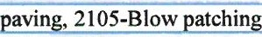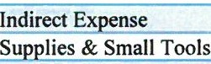1876 Traffic Counting Use to record labor, equipment usage, and material costs for activities related to traffic counts made for statewide traffic monitoring or traffic operations. Includes all activities related to traffic counting, such as talcing requests, assigning priorities, collecting field data, processing data, and developing_ new technioues for collection.

2102
Patchin
Related source tvoe codes: 2103-Heavy patching, 2104-Bituminous paving, 2105-Blow oatchin

2142 Overhead Sign Panel Maintenance Work related to the repair and replacement of overhead sign panels, extruded sign panels mounted on I-beams, and overhead sign
structures. Includes related cable locates and traffic control. Does not include structural work.
2210 Guardrail-Install/Repair/Maintenance Install, repair, or maintain low tension cable, plate beams, and end treatments; cable tension adjustments; and reflector replacement. includes related traffic control.
2222 Sign/Delineation/Marker Repair Replacing, repairing, and washing signs (including temporary stop signs).Includes re-sequencing intersection signing and
repair/replace overhead and extrude signs mounted on I-beams. Includes related cable locates and traffic control.

2316

2624
2629
2819
Brush & Tree Removal

Bridge Curb, Walk And Railing
Maintaining, watering, trimming, and removing highway right of way tree and brush. Includes chipping of tree limbs and stump removal/grinding . Includes related traffic control.

uioment, and suoolies that cannot be directly charged to a mobile eouioment unit.
Repairing and maintaining bridge curb, walk, rail, coping, and fencing connected to the rail. Includes glare screen and median barriers on bridees. Includes related traffic control.

2820 Bridge Deck Work associated with bridge deck and slab repair regardless of removal depth or type of material used for patching. Includes deck or slab overlays and replacements and underside deck delamination.Includes related traffic control.

2822 Miscellaneous Bridge Maintenance This source code does not include replacement or major repair.Miscellaneous maintenance tasks performed on a specific bridge or structure not covered by other source codes. Includes minor repairs and simple fixes on items such as stairways, drains, fencing, light bases, transient guards, and access doors. Includes transient removal, ordering materials, and picking up equipment. Includes related traffic control.
2824 Bridge Inspection-Non-Federal All tasks related to inventory, inspection, and load capacity rating work done on trunk highway bridges to meet the requirements of the National Bridge Inspection System and/or Minnesota Bridge Safety Inspection Program or for billing to local governments.
Includes related insoection reoorts and deck condition survevs.
2827 Bridge Expansion, Relief Joints All maintenance tasks associated with bridge expansion joints, except joint reestablishment. Includes tightening expansion device
bolts and reolacing eat glands. Includes related traffic control.
2828 Bridge Inspection-Federal Fund All bridge inspection tasks for non-MnDOT bridges funded by the federal Fracture-Critical Bridge Program (Project Code will begin with TSL and with the local bridge number). Includes related inspection reports. For MnDOT Trunk Highway bridges (Project Code begins with TSO followed by the bridge number) and local and Department of Natural Resources (DNR) (bridge number begins with 9A follow by bridge number) bridge inspections to be billed to the local government or Department of Natural Resources (DNR) use Source Code 2824.

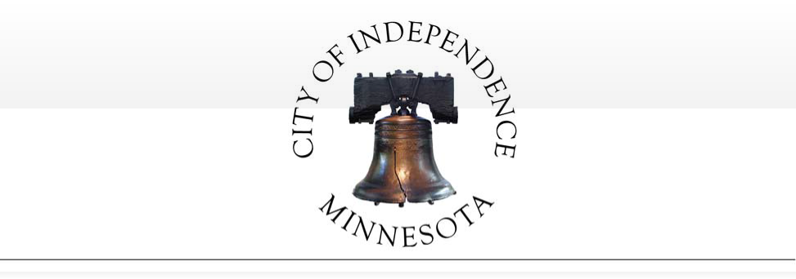

RESOLUTION NO. 17-0509-01

A RESOLUTION APPROVING A MASTER PARTNERSHIP AGREEMENT BETWEEN MNDOT AND THE CITY OF INDEPENDENCE

WHEREAS, the Minnesota Department of Transportation wishes to cooperate closely with local units of government to coordinate the delivery of transportation services and maximize the efficient delivery of such services at all levels of government; and

WHEREAS, MnDOT and local governments are authorized by Minnesota Statutes sections 471.59, 174.02, and 161.20, to undertake collaborative efforts for the design, construction, maintenance and operation of state and local roads; and

WHEREAS: the parties wish to able to respond quickly and efficiently to such opportunities for collaboration, and have determined that having the ability to write “work orders” against a master contract would provide the greatest speed and flexibility in responding to identified needs.

NOW, THEREFORE BE IT RESOLVED BY THE CITY COUNCIL OF THE CITY OF
INDEPENDENCE, MINNESOTA, that it should and hereby does approve the following:

  - That the City of Independence enter into a Master Partnership Contract with the Minnesota Department of Transportation, a copy of which was reviewed before the Council.

  - That the proper City officers are authorized to execute such contract and any amendments thereto.

  - That the City’s Public Works Director and Administrator is authorized to negotiate work order contracts pursuant to the Master Contract, which work order contracts may provide
for payment to or from MnDOT, and that the Public Works Director and Administrator may execute such work order contracts on behalf of the City of Independence without further approval by this Council.

This resolution was adopted by the city council of the City of Independence on this 9th

day of May, 2017, by a vote of
ayes and
nays.

ATTEST:
Marvin Johnson, Mayor

Mark Kaltsas, City Administrator

(SEAL)

Date: April 3, 2017

To:

From: SUBJECT:
Public Safety Commissioners
City of Independence Council Members City of Maple Plain Council Members

Director Gary Kroellsl / ­

MARCH 2017 ACTIVITY REPORT

The purpose of this report is to give the reader a quick overview of the activities of the Public Safety Department each month. It also compares monthly and year-to-date information to the reader.

The report is broken down into five categories, as defined by the Criminal Justice Reporting System.

CRIMINAL-- Criminal is broken down into Part I and Part II crimes .

Part I includes crimes against persons versus crimes against property; criminal homicide, forcible rape, robbery assault, aggravated assault, burglary -breaking or entering, larceny-theft, larceny analysis, motor vehicle theft and arson.

Part II includes other assaults , forgery and counterfeiting , fraud, embezzlement, stolen property, buying, receiving, possession; vandalism, weapons, carrying, possessing , etc.; prostitution and commercialized vice, sex offenses ; drug abuse violations, gambling, offenses against the family and children, driving under the influence, liquor laws, drunkenness , disorderly conduct , vagrancy , all other offenses, suspicion, curfew and loitering laws - persons under 18; and runaways - persons under 18.

TRAFFIC-- Includes violations of the road and driving laws.

PART Ill-- Lost and Found: Includes lost and found persons, animals, and property, and stalled and abandoned vehicles.

PART IV-- Casualties: Includes all motor vehicle accidents, boating, and snowmobile ; public home occupational accidents, fires, suicides, sudden deaths, burning permits, and burning violations.

PART V-- Miscellaneous Public: Includes open doors, gun permit applications, susp1c 1ous activities, animal complaints, motorist assists, alarm calls, parking complaints, house checks, driving complaints, civil matters, family disputes , department assists.

The balance of the report shows the total number of incidents handled, miles driven and how the Public Safety Department received calls. If anyone should desire more detailed statistical data, please contact my office.

\\WHPS#O\share\monthlyactivityreport\2017/lettertocouncilmonthlyreport.docx

West Hennepin Public Safety Department
1918 County Road 90 I Maple Plain, Minnesota 55359
Phone: (763) 479-0500 I Fax: (763) 479-0504
Web Address: http:/ / www.westhennepin.com E-mail: westhennepin@westhennepin.com

- - - - Monthly Activity Report - -
March 2017
This Same Month This Year Last Year
Offense Month Last Year To Date To Date
I - -- --- ·--
ity Of lndependence
- ->-- - - -
-

Criminal Traffic
- - - - -
- -
9 10 21
172 205 542

-
- -- -
21
543

Part Ill - -
6 - 13 19 38

Part IV
- 31
- 28 101
-,_ - 98

Part V
--- - ->-----
165
141
- -
---
407 ,

I
404
-

Total City of Independence 383 397 1,090 1,104

City Of Maple Plain
,_ I- - -- -
- - - - - -

--

Criminal 1 6 6 14
- -
Traffic 71 78 281 178
Part Ill 4 5 10 11
--- -
Part IV 16 24 38 76

Part V
- - -
125 128
377 348
--
-
-

TZD 19
Total City Of Maple Plain | 217 | 241 | 712 |  | 627
Grand Total Both Cities | 600 | 638 | 1,802 | I | 1,731

Agency Assists 56

11 I

20 0
141

ITotal ICR Reports 656 648 1,943 1,774
- -

Mileage 12,858
- 12,784 36,152 35,027

How Received -
Fax 19 11 40 40
-
>----- -

In Person --
Mail
43 47 80 138
-
- 2 2 6 5

Other -- 5 3
8 - 21

Phone
Radio
-- -
29
182
---
-
31 71 94
187 491 546

Visual 314 312 1,114 800

Email
Lobby Walk In
- 2 6 9 -
60 49 124
--
-
- -
12
118

Total 656 648 1,943 1,774

MonthlyActivityReport2017.xlsx

March 2017 Criminal Part I& II
City of Independence Grid #'s 3-5
AGN | ICR | Title | Create Date | Grid # | Reported  Date | MOC  range
WHPS | 17001322 | Drugs - Small Amount of Marijuana in  Motor Vehicle | 3/2/2017 | 3 | 3/2/2017 | DAS40
WHPS | 17001410 | csc | 3/6/2017 | 4 | 3/6/2017 | L7008
WHPS | 17001452 | Criminal Damage to Property - Mailbox | 3/9/2017 | 4 | 3/8/2017 | P3120
WHPS | 17001518 | 3rd Degree DWI | 3/10/2017 | 3 | 3/10/2017 | JFSOl
WHPS | 17001705 | Felony Stalking I Violation of  Harassment Order of Protection | 3/20/2017 | 3 | 3/20/2017 | N138B
WHPS | 17001758 | 3rd Degree DWI | 3/23/2017 | 5 | 3/23/2017 | JFSOl
WHPS | 17001828 | Criminal Damage to Property - Mailboxes | 3/27/2017 | 3 | 3/27/2017 | P3119
WHPS | 17001843 | Identity theft | 3/28/2017 | 3 | 3/28/2017 | U2733
WHPS | 17001894 | Drugs - Small Amount of Marijuana in Motor Vehicle I Drugs-Paraphernalia Possession | 3/30/2017 | 5 | 3/30/2017 | DAS40

City of Maple Plain Grid # 1-2
AGN
ICR
Title
Reported
Create Date Grid #
Date
MOC
range
WHPS 17001430 Domestic Assault - Felony 3/7/2017 1 3/7/2017 AD401
WHPS 17001502 Theft by Swindle 3/10/2017 1 3/10/2017 U0063
WHPS 17001663 4th Degree DWI 3/19/2017 1 3/19/2017 JGWOl
WHPS 17001736 Criminal Property Damage to City Park 3/22/2017 1 3/22/2017 P3129

March 2017 Criminal Part I& II
Towards Zero Death Grant Shift

AGN | ICR | Title | Create Date | Grid # | Reported  Date | MOC  range
WHPS | 17001801 | 5th Degree Possession of Marijuana | 42804 | 3 | 42804 | JFSOl

1000
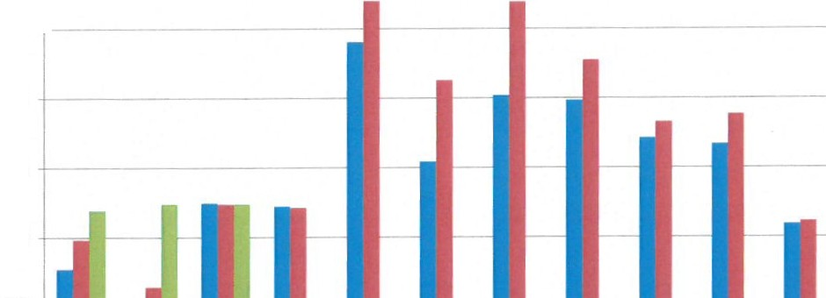900 l
800

700

600

THREE YEAR COMPARISON OF POLICE CALLS FOR SERVICE & ACTIVITY

• 15 Total

500 •16 Total
•17 Total

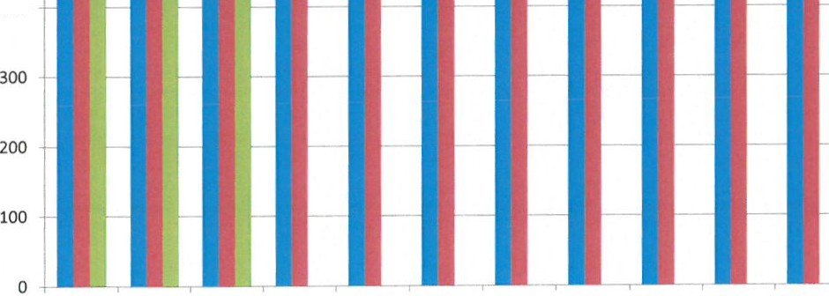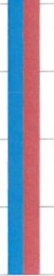
400
Jan Feb Mar Apr May June July Aug Sept Oct Nov
Dec

DIRECTOR'S NEWS & NOTES
WEST HENNEPIN PUBLIC SAFETY
March 2017 Activity Report

Year to Date Activity Report
At the end of March 31, 2017 West Hennepin Public Safety (WHPS) handled a total of 1,943 incident complaints, 712 incidents in Maple Plain and 1,090 in Independence. For the month of March 2017,
WHPS handled 217 incidents in Maple Plain and 383 in Independence. This is an increase of 169
incidents compared to the same time frame last year.
The Criminal Part I and Part II cases for both cities have been highlighted for your review on the attached documents.
Recent Highlighted Cases: Abandoned Vehicle
March 2 5200 Main Street, Maple Plain. Business owner reported a vehicle that's been parked in
their business parking lot for at least a week and he did not know whose it is. Police found the owner's name; advised the business owner and it was a customer who did not tell the business owner about the car.

Property Damage
Mar 3 Motorist called reporting he struck a sign at Oak St and Hwy 12, Maple Plain. He was westbound on Highway 12 to turn left onto Oak Street, was looking at the eastbound Hwy 12 traffic when he struck the sign in the median. MN DOT was notified of the damaged sign.

Suspicious Act
Mar 4 5:08 p.m. Police was dispatched to the water tower in Maple Plain for suspicious activity consisting of two females that climbed up on the water tower awning and tried to get into it. The females were driving a black pickup truck and were leaving the area. The water tower and the surrounding areas were searched and the truck was not located.
Police did not see any vandalism or damage done to the water tower or other buildings.

Damage to Property
Mar 6 The street sign at Budd and Perkinsville Streets, Independence was severely damaged, pushed over and bent in multiple places. It appeared to have been hit by a motor vehicle. Independence Public Works was notified of the damage.

Misc. Assist
Mar 6 Maple Plain caller requested information on guidelines for her 12 year old son to babysit his younger 7 year old sibling. She was provided with the Hennepin County Child Protection guidelines on babysitting.

Welfare Check
Mar 6 Vinland Center, 3675 lhduhapi Trail, Independence. A male reported he was assaulted.
The case is under investigation.

Road Debris
Mar 7 1700 Howard Ave., Maple Plain. Caller reported the high winds blew the neighbors trampoline unto the road. She would retrieve it but she had the flu. Police removed the trampoline into a yard it appeared to have blown out of.

Felony Domestic Assault
Mar 7 5000 Highway 12, Maple Plain. Police responded to a physical domestic, the victim was physically assaulted. 26 year old male from Maple Plain was arrested, transported to Hennepin County Jail charged with Felony Domestic Assault and Domestic Abuse - Violate Order of Protection.

Road Debris
Mar 8 3400 Co Rd 92N, Independence. High winds blew down a tree; the top of the tree was on the roadway. Hennepin County DOT responded to remove.

Sign Down
Mar 8 Co Rd 11 I Town Line Rd, Independence. Due to heavy winds the stop sign and street sign were down. Independence Public Works were notified for repairs.

Damaged Property
Mar 8 4600 Lake Sarah Drive S, Independence. Resident reported his mailbox was damaged, possibly by the snowplow. Police found the mailbox appeared to be damaged by a striking object other than a plow truck.

Traffic Complaint
Mar 9 Highway 12/ County Line Rd, Independence. Reported a semi-truck being driven 10 mph under the posted limit and crossing the center and fog lines. Police observed the semi cross the center and fog line, jerk left and swing wide to the left side of the curve into the turn lane. The driver said he had been distracted by talking on his phone and he had been up for a very long time. He was issued a citation for Failure to Exercise Due Care and Attention.

Shooting Complaint
Mar 10 900 Co Rd 19, Independence. Received a shooting complaint. Police found the property owner was shooting into a large berm on his property, was not within 500 feet of livestock or an occupied building and there is not a city ordinance preventing shooting within the city. The caller was advised of the findings.

Property Damage Crash/ DWI
Mar 10 Police dispatched for a crash at Co Rd 19 I Perkinsville Rd, Independence . Police found the driver Theo Onsando Mochama, 25 from Shoreview walking on the roadside near the intersection. Mochama was found under the influence of alcohol and gave a breath test resulting in a .16% Breath Alcohol Concentration. He was fingerprinted , photographed and booked into Hennepin Jailfor 3rd degree DWI.

Livestock Kill
Mar 11 5900 Fieldstone Place, Independence. Owner reported two neighbor dogs attacked her chickens. Four were killed, one is missing and one survived. The animal owner of both dogs was issued a citation for 'Dog Kills/Pursues Domestic Livestock.'
owner's liability (MSS 347.01 sub (B) ) and to reimburse the owner for the chickens.

Train Traffic Complaint
Mar 12 Police dispatched to a blocked railroad crossing complaint at Co Rd 92 N in the city of Independence. The train had been blocking the crossing for 1 1/2 hrs. Burlington Northern Sante Fe railway was contacted and they were unaware of the issue. A short time later the complainant called back and reported the train was moved.

Three Vehicle Property Damage Crash
Mar 12 4:44 p.m. Police dispatched to a three vehicle property damage crash. Police arrival found a vehicle in the ditch on its side and two vehicles were stopped eastbound on Highway 12 I Baker Park Rd, Maple Plain. 42 year old female from Delano stated she was WB on Hwy 12 when she lost control, slid across the roadway and into the ditch.A 61 year old male driver from Woodbury slid into the rear of a stopped vehicle driven by 41 year male from Dassel. No injuries reported. The road conditions were poor at the time due to falling snow.

Car Stall
Mar 12 10:11 p.m. MNDOT plow driver reported a darked out stall on Hwy 12/Co 29, Independence . Police found two citizens had been helping an elderly male jump start his car. It was very cold, the male was not dressed appropriately, wearing sandals without socks and did not speak any English. The Police language line was used and could not find out what language he spoke. The Male called his family and it was determined they were on the way. His family arrived and his daughter had a blanket wrapped around her, was wearing only pants and a shirt, no jacket. They were lectured for not being dressed appropriately for MN winter weather. Eventually they
were able to communicate enough that they wanted a tow truck. The vehicle was towed.

Personal Injury Crash
Mar 14 Co Rd 90 I Highway 12 Independence. Driver attempted to cross Highway 12 from Northbound Co Rd 90, pulled out into the lane of traffic and crashed into a westbound vehicle. Both drivers were wearing their seatbelts and both vehicle airbags were deployed. One was transported by ambulance to the hospital and the other driver refused transportation. Citation was issued for Failure to Drive with Due Care.

Traffic Complaint
Mar 14 6300 Co Rd 11, Independence . Residents on Co Rd 11 are concerned with the increase in traffic since the Highway 12 issues. Extra patrol to be given to the area.

Suspicious Act
Mar 16 2900 Lindgren Lane, Independence. Reported unknown person entered their house and left. Area was checked and did not locate anyone. Later reported it was their son who came home and then left. All ok.

Credit Card Fraud
Mar 16 500 Co Rd 11ON, Independence. A business reported their company had a security breach that the church uses for their cc orders. An attempt was made at a Walmart for purchases with the cc. The purchases were denied and the cc was canceled.

Traffic Complaint
Mar 17 7:46 p.m. Police dispatched by radio to a traffic complaint and possible road rage incident heading westbound HWY 12 I Co Rd 6 I Baker Park Rd, Maple Plain. Police contact with the driver, 76 year old male from Delano who stated the person in front of him was driving real slow and he tailgated the vehicle for a short period to try and get them to go faster. The driver he was following, 63 year old male from Maple Plain then hit his brakes hard and "brake checked" him. Police confirmed both drivers' stories.
Police explained to the 76 year old driver proper driving etiquette and that if he sees driving that is a concern he needs to call 911. Neither drivers were issued citation; both were at fault and had negative driving conduct.

Welfare Check
Mar 18 2:55 p.m. 3100 Nelson Rd, Independence. Resident reported she found a female in a black jacket , with Capri pants, lying down in the ditch at the end of her driveway looking at the sky. The resident made contact with the unknown female who was visually upset, who stated she was coming from Buffalo and just wanted to get to MPLS to see her
kids. The female asked if she could get a ride. The resident said no but she would call the police and they could help. The female said she did not want the police called and left walking eastbound on Highway 12. Police checked the area and no one was found.

4th Degree DWI
Mar 19 12:41 a.m. Driving complaint of a vehicle swerving between lanes, traveling towards Maple Plain. Police located the vehicle, observed it cross into a turn lane, then swerved back, and move into a turn lane before stopping at Budd Ave and Highway 12, Maple Plain. The driver was identified as Kenneth Wayne Carlson 52 from Savage. Carlson provided a breath sample that resulted in .14% breath alcohol concentration. Carlson was arrested for 4th Degree DWI.

Noise Complaint/ Civil Matter
Mar 19 1800 Newport Street, Maple Plain. Complainant stated he and his wife were doing jumping jacks work out and his downstairs neighbor came to their apartment and complained about the noise. Complainant and neighbor were advised nothing criminal is happening. Both were advised to bring the noise complaint to management.

Property Damage
Mar 19 6:08 p.m. Resident reported in Budd Ave, I Oak Street, Maple Plain two males, one was wearing a black and red jacket , threw a rock at a glass table that was on Oak Street
with a Free sign posted by it. Police were delayed in responding, later checked the area and did not find the males. Police did find the glass table which was shattered.

Head Injury
Mar 19 800 Copeland Rd, Independence. Reported a person had fallen off a horse and was in and out of consciousness. Police arrival found the female on the ground and conscious. She complained of no other injuries besides minor head pain. She was transported to the hospital by ambulance.

Welfare Check
Mar 20 1500 Howard Ave., Maple Plain. Parents unable to reach their son for several days requested a welfare check on him. Police checked the apartment, he was gone and Police left their business card for him to call. Few hours later the son called stating he was at Ridgedale Library looking for a job and he would call his parents. All was ok.

Grass Fire
Mar 20 3800 Lake Haughey Rd, Independence . Police were dispatched to a grass fire. Police found the homeowner had been burning sticks in less than a 3' X 3' burn size which does not need a burn permit. The fire had gotten out of control and was spreading to the swamp. Delano Fire Dept. responded and extinguished the fire which burned approx. acre of swamp that the homeowner owned.

Felony Stalking and Harassment Order Violation
Mar 20 10:10 p.m. 5600 Co Rd 6, Independence . Resident had reported on March 19 at 4:56
a.m. there was an unknown male at her door. She found out who he was and she had a Harassment Restraining Order against him. While Police and Resident were speaking a vehicle pulled into the driveway behind the squad car and a male approached the door asking to speak with the resident. The male was identified who had the HRO against him. Police placed him under arrest for violating an Order for Protection, Harassment Restraining Order. The male was transported to Hennepin County Jail.

Northside Park Vandalism
Mar 22 Someone broke into the storage area under the announcer's booth at Northside Park, Maple Plain. Also attempted to break into the concession stand but did not get in.

DWI
Mar 23

Garage Fire Mar 23

1:18 a.m. County Line Rd I Highway 12, Independence . Police observed vehicle swing wide into oncoming turn lane, than back into the lane of travel. Driver, Linda Lee Carpenter, 59 from New Hope was arrested for Driving under the Influence of Alcohol and was transported to Hennepin County Jail.

2300 Nelson Rd, Independence. Police responded to a garage fire and found a detached pole barn engulfed in flames. Delano Fire Dept. was assisted by Maple Plain and Watertown Fire Departments. The fire was extinguished.The pole barn was demolished and the animals inside perished.

Agency Assist Fatality
Mar 24 County Line Rd I Co Rd 17, Franklin Township. WHPS Officer assisted Wright County Sheriff's Office with a serious crash. A vehicle had left the roadway and struck a tree. WHPS assisted with traffic control.

Mail Theft
Mar 24 Reported in the 5700 Providence Curve, Independence. A resident observed a vehicle pull up to his mailbox and an occupant removed unknown amount of mailfrom his mailbox. The case is under investigation.

Medical I Fall
Mar 25 7500 Turner Road, Independence . Police dispatched for a female riding her horse, was thrown off when it was spooked by some loud noise.The female possibly had a broken arm and transported by North Ambulance to Abbott/Northwestern Hospital.

Suspicious Act
Mar 25 11:38 p.m. Reported juveni les on the roof of the Maple Plain Community Church, Maple Plain. No one was found on the roof. The Discovery Center was checked and a vehicle without a front license plate was stopped leaving the Christ Lutheran Church.The vehicle ignition had been tampered with, wires were hanging from it, and the driver did not have a valid DL; he was Driving after Revocation and had a Carver County Felony warrant. He was taken into custody and transported to jail. The vehicle had stolen license plates from the city of Richfield on it. The vehicle contained burglary tools and was loaded with tools and other equipment. The case is under investigation

Criminal Damage to Property
Mar 27 5000 Perkinsville Road, Independence. Resident reported two mailboxes were damaged. It appeared that the mailboxes were struck with a baseball bat or something similar due to the type of damage located on them. The plastic newspaper boxes were also knocked off. The estimated replacement cost for each mailbox with materials/labor is $75 each.

Traffic Complaint
Mar 31 Reported a white jeep was doing donuts in the parking lot again of the Park & Ride in Maple Plain. Police arrival the vehicle was gone. Police found registered owner information and contact with the owner is being attempted.

Game Fish I Over the Limit
Mar 31 2900 Lindgren Lane, Independence. Complainant had been watching a boat in the channel for the last hour and the fishermen were taking fish over the allowed limit. Water Patrol and DNR assisted Police with fisherman contact.

Medical
Mar 31 6400 Genaker Way, Independence . Male was walking around his house, got out of breath and got scared he was going to die.The male submitted a Preliminary Breath Test which resulted in .40% Breath Alcohol Concentration. He was transported to the ha.spital by ambulance.

City of Independence
Request for a Variance from the Side Yard Setback for the Property Located at 1180 County Road 83

To: City Council

From: Mark Kaltsas, City Planner
Meeting Date: May 9, 2017
Applicant: Jason Sievers
Owner: Jason Sievers
Location: 1180 County Road 83

Request:

Jason Sievers (Applicant/Owner) requests that the City consider the following actions for the property located at 1180 County Road 83 (PID No. 25-118-24-32-0001) in Independence, MN:

- A variance to allow a reduced side yard setback. The setback reductions would permit the construction of a home and garage addition attached to the existing house.

Property/Site Information:
The subject property is located at 1180 County Road 83. The property is on the east side of County Road 83 and south of the intersection of Timber Trail and County Road 83. There is an existing home and one small detached accessory structure on the subject property.

Property Information: 1180 County Road 83 Zoning: Rural Residential
Comprehensive Plan: Rural Residential
Acreage: 2.37 acres (103,237 square feet)

1180 County Road 83 (blue line)
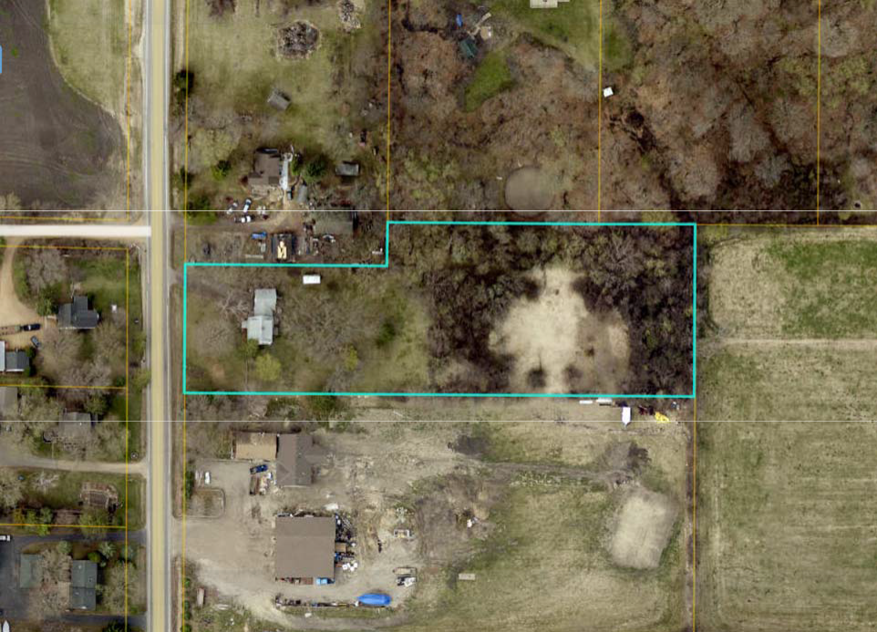

Discussion:

The applicant is seeking approval to construct an addition onto the existing home. The addition includes living space as well as a larger garage. The applicant is proposing to remove a portion of the existing house which includes the existing garage. It was noted by the applicant that the existing garage was connected to the home via an enclosed space at some point and used to be a detached garage. The applicant would like to construct an addition (new garage and living space) onto the portion of the existing home to remain. The existing home is currently in compliance with all applicable setbacks for this property (the existing home is setback 30 feet from the north property line).

The applicant is asking the City to consider granting a variance from the side yard setback (north property line) to allow expansion of the existing home. The City requires a side yard setback of 30 feet for properties zoned RR-Rural Residential. The applicant is proposing to construct the home addition so that it is setback 17.6 feet from the side property line rather than 30 feet as required. The resulting variance to the side yard setback would be 12.4 feet. The required setbacks for properties zoned RR-Rural Residential are as follows:

Front Yard Setback:
Required: 85 feet from centerline or 51 feet from the ROW Existing: 64 feet from ROW

Rear Yard Setback:
Required: 40 feet
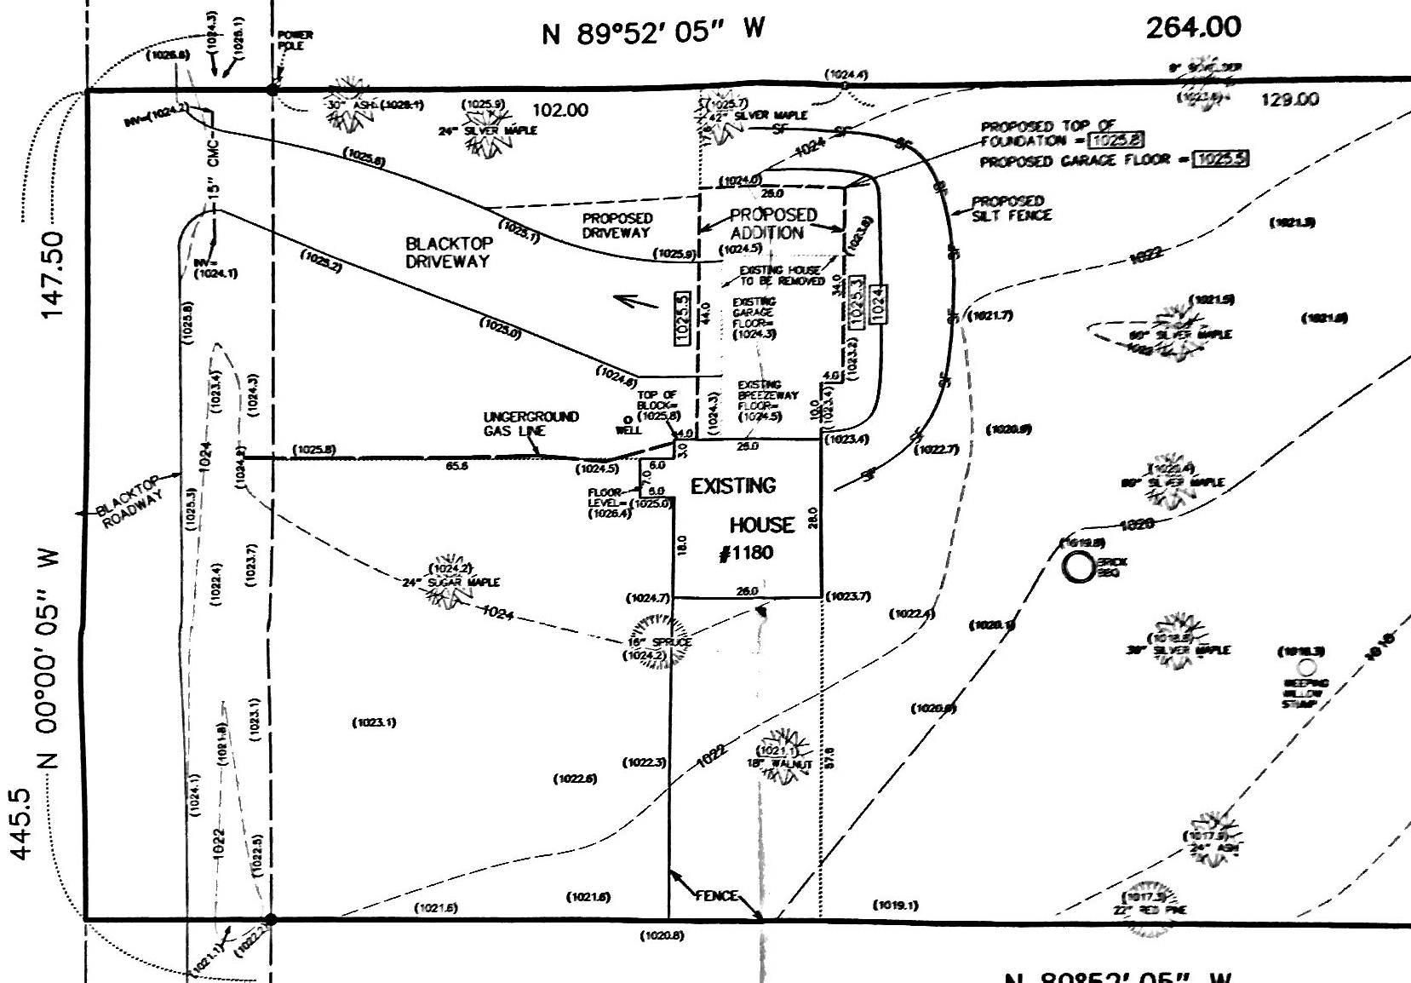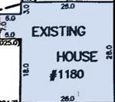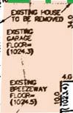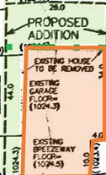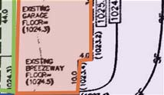Existing: 475 feet Side Yard Setback:
Required: 30 feet
Existing: 30 feet
Proposed: 17.6 feet (variance of 12.4 feet)
AREA OF HOME ADDITION
PORTION OF EXISTING HOUSE TO BE REMOVED AND REPLACED WITH NEW ADDITION
REQUIRED SETBACK
EXISTING PORTION
OF HOME TO REMAIN
GARAGE ADDITION IF
ROTATED 90 DEGREES

There are several factors to consider relating to granting a variance. The City’s ordinance has established criteria for consideration in granting a variance.

  - Standards for granting variances. Subdivision1. The City Council may grant a variance from the terms of this zoning code, including restrictions placed on nonconformities, in cases where: 1) the variance is in harmony with the general purposes and intent of this zoning code; 2) the variance is consistent with the comprehensive plan; and 3) the applicant establishes that there are practical difficulties in complying with the zoning code (Amended, Ord. 2011-08)

Subd. 2. An applicant for a variance must demonstrate that there are practical difficulties in complying with the zoning code. For such purposes, “practical difficulties” means:

    - The property owner proposes to use the property in a reasonable manner not permitted by the zoning code;

    - the plight of the property owner is due to circumstances unique to the property not created by the landowner;

    - the variance, if granted, will not alter the essential character of the locality.

Economic considerations alone do not constitute practical difficulties. Practical difficulties include, but are not limited to, inadequate access to direct sunlight for solar energy systems. (Amended, Ord. 2011-08)

Subd. 3. The City Council shall not grant a variance to permit a use that is not allowed under the zoning code based on the zoning classification of the affected property. (Amended, Ord. 2011-08)

  - Conditions and restrictions. The board of adjustments may recommend and the City Council may impose conditions on a variance. Conditions must be directly related to and must bear a rough proportionality to the impact created by the variance. (Amended, Ord. 2011-08)

Consideration of the criteria for granting a variance:
    - Residential use of the property is consistent with the Rural Residential District.

    - The City would need to find that the plight of the property owner is due to circumstances unique to the property that are not created by the landowner.

    - The character of the surrounding area is residential. There are several properties in the vicinity that do not meet all applicable building setbacks. The proposed expansion for a single-family home is in keeping with the City’s comprehensive plan.

There are several additional items that could be considered by the City:

      - The required detached accessory structure setback from the side yard is 15 feet. The applicant could locate a detached accessory structure on this property and meet applicable setbacks.

The property directly north of this property has several detached accessory buildings which do not meet applicable setbacks. The owner of the property directly north did provide a note to the City stating that they found the requested variance to be acceptable.
      - The applicant could rotate the proposed addition 90 degrees and meet all applicable setbacks.

      - There are many properties in the City of Independence that have similar conditions to that of the subject property. The City would need to find that the property has unique conditions that can be noted as the basis for granting the variance.
      - Several properties directly west of the subject property appear to have reduced front yard setbacks.
      - The proposed home/garage addition is a two-story addition which will be taller than the portion of the existing structure that is being removed.
Ultimately the City will need to find that the criteria for granting a variance have been met by the applicant.

Planning Commission Discussion:
Commissioners reviewed the requested variance and asked questions of staff and the applicant. Commissioners reviewed the proposed setback and asked for clarification relating to the portion of the home that was going to remain versus the portion of the home that was going to be removed.
Commissioners confirmed that the existing home meets applicable setbacks. Commissioners reviewed the criteria for granting a variance. Planning Commissioners asked for clarification relating to the criteria for granting a variance and whether or not all criteria needed to be considered. Commissioners discussed that the City has many similarly sized parcels with existing homes. Commissioners discussed the characteristics of the subject parcel and noted that there was a substantial amount of area that could accommodate a home/garage expansion. There was an initial motion to approve the variance request as presented. That motion did not receive a second and did not proceed. There was then a motion to deny the variance as requested. That motion did not initially receive a second until there was additional discussion. Commissioners ultimately recommended denial of the variance to the City Council with the following findings:

- Commissioners could not make the finding that the plight of the property owner is due to circumstances unique to the property not created by the landowner. Commissioners did not find unique circumstances or characteristics of the property that warranted a variance. Commissioners noted that this property is similar to many others in the City and that granting a variance without unique characteristics would establish a precedent for allowing reduced setbacks.

Public Comments:
The City received a letter from the neighboring property owner located at 1212 County Road 83 supporting the requested variance.

Recommendation:
The Planning Commission recommended denial of the requested variance with the following findings and conditions:

  - The proposed Variance request does not meet all applicable conditions and restrictions stated in Chapter V, Section 520.19, Procedures on variances, in the City of Independence Zoning Ordinance.

  - The Applicant’s variance request is denied because it does not meet the criteria established for granting a variance due to the lack of unique conditions or characteristics of the subject property.

  - The Applicant shall pay for all costs associated with the City’s review of the requested variance.

Attachments:
- Application
- Site Plan/Survey
- House Elevations
- Letter from Adjacent Property Owner
- Pictures

1180 County Road 83 (Looking East)
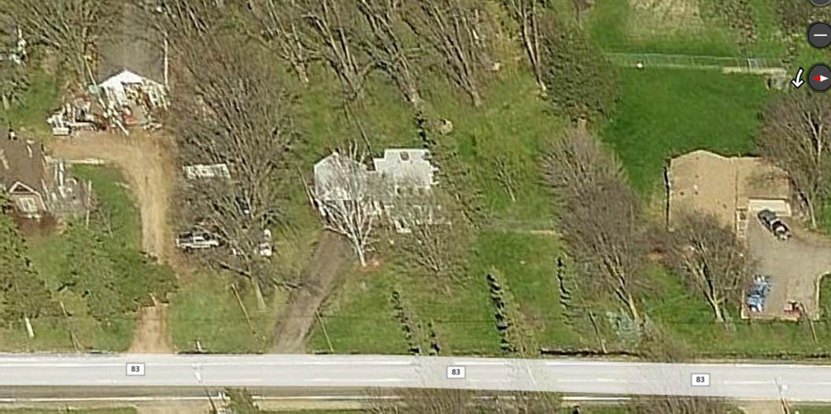

1180 County Road 83 (Looking North)
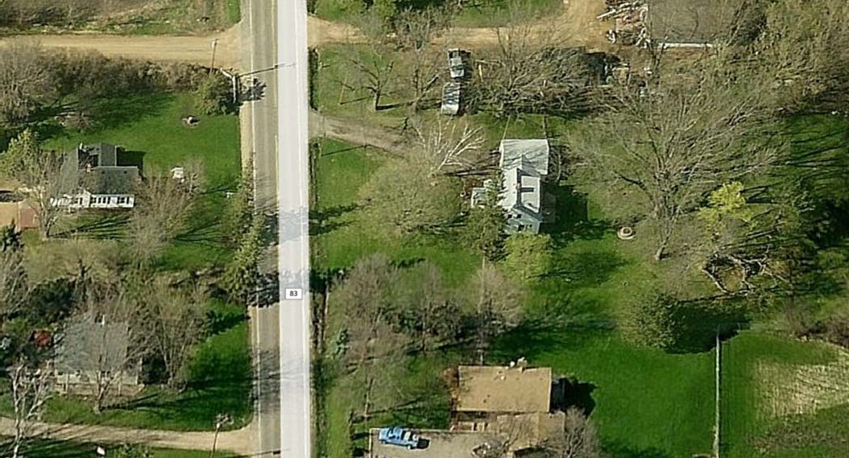

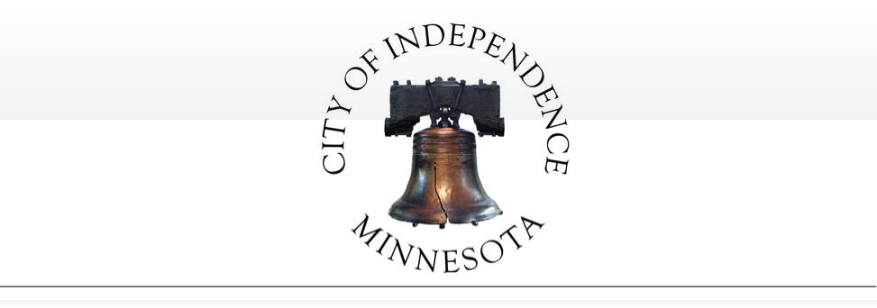

RESOLUTION NO. 17-0509-02

RESOLUTION DENYING APPLICATION FOR A VARIANCE TO ALLOW A REDUCED SIDE YARD SETBACK
FOR THE PROPERTY LOCATED AT 1180 COUNTY ROAD 83

WHEREAS, Jason Sievers, (the “Applicant”) submitted an application for a variance to allow a reduced side yard setback on the property located at 1180 County Road 83 (PID No. 25- 118-24-32-0001) (the “Property”); and

WHEREAS, the City’s planning commission held a public hearing on the application on April 18, 2017 and received testimony, written comment, and other information regarding the application; and

WHEREAS, based on all input received, the planning commission concluded that the variance does not meet the criteria established for granting a variance due to the lack of unique conditions or characteristics of the subject property; and

WHEREAS, on May 9, 2017, the city council accepted the planning commission’s recommendations, adopted the recommended zoning code amendment, and passed a motion denying the Applicant’s request; and

NOW, THEREFORE, BE IT RESOLVED, by the city council of the City of Independence, that the Applicant’s variance request is denied because it does not meet the criteria established for granting a variance due to the lack of unique conditions or characteristics of the subject property, in accordance with the planning commission’s recommendations.

BE IT RESOLVED FURTHER THAT the city council hereby reduces its denial to writing in accordance with Minn. Stat. § 15.99, and directs the city administrator to provide this resolution to the Applicant.

This resolution was adopted by the City Council of the City of Independence on this 9th

day of May, 2017, by a vote of
ayes and
nays.

ATTEST:
Marvin Johnson, Mayor

Mark Kaltsas, City Administrator

(SEAL)

Planning & Zoning Departm ent: Appli cationf or Planning Consideration (2016)

City of Independence

The Independence City Code was established to protect both current and future residents from the negative impacts of improper development and to ensure a positive future for the city. The land use application review is t11e mechanism that allows the city to examine proposed uses to ensure compatibility with the surrounding environment, natural or otherwise. It is important to understand that a proposed use may be acceptable in some circumstances, but unacceptable in others-all applications are viewed on a case-by-case basis.
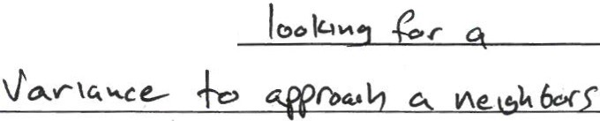•• • • • • • • • • • • • • •• • • • • • ••• • • • • • • • • ••• • • • ••
: D Request: Lu t>..,.t.
Appeal
••

D Comprehensive Plan Amendment
D Concept Plan
D Conditional Use Permit
Residential
_ Commercial/Light Industrial Telecommunications
_ Agriculture
_ Home Occupation
_ Non-Conforming Use Guest/Bunk House Institutional
-CUP Amendment
0 Extension Request
0 Final Plat
0 Interim Use Permit
- D Lot Consolidation
D Minor Subdivision (Survey)
Lot Subdivision Lot Combination
_ Lot Line Rearrangement

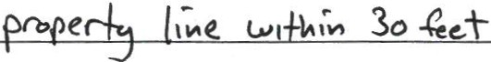

•

Site Address or Property Identification Number(s):

••
•• NOTE: Minnesota State Statute 15.99 requires local
•• governments to review an application within 15 days of its
•
- submission to detennine if an application is complete and/or
- if additional information is needed to adequately review the
: subject request. To ensure an expedited review, applicants
•• shall schedule apre-application meeting with the City

•• D Moving Buildings
•
D Preliminary Plat
0 Rezoning
D Site Plan Review (Commercial)
•• Planner/Administrator at least one week prior to submittal.
•• Most applications have a review period of 60 days; with the
City's ability to extend an additional 60 days if necessary due to insufficient information or schedule.
...................................................... ....................... ................. ·······················-·························· ·········-:
i
Office Use Only

·o Vacation
J(' Variance
_ Subdivision Regulations
_ Zoning
_ Road Frontage

0 Zoning Text Amendment

*Please check all that apply
: 1<//£CtrJ - !1 .isa
- 1 Application Amount
i ,.,
: i 7 50 .
•• l Escrow Paid

I
- ! Date Accepted by Planner
••
•
Date

Q
A l i
Application heck #

2 ) /
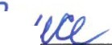Escrow Check

Accepted By

......................................: ; . City Planner ..................................................................................................................
:.............................. :

... ' -

***Note: All parties with af ee interest ill the real estate must sign this appl ication befo re the City will reviewfo r considerationI

Applicant Information:
Name: ScM S1.eve..r-f
Address: l lg>C) C ··dt &;_3
City, State, Zip: q0-fc>.b\oc.. , ,,M », S5 3S\
Phone: al7--7o 2- -6 't.o)
Email : ,," j e.St e.ve.r.s@2 ()1M.a., l·c o V\..
Signature:
Owner Information (if different than applicant)

City, State, Zip: _ Phone:----------------
Email: ---------------
Signature: _

Checklist: Please review the checklist that goes with the request(s) as all materials in the checklist unless waived by the City.

Review Deadline and Timeline: All applications must be received by the deadline according to the schedule attached hereto. Failure to submit by the date shown wi11 result in a delay in the scheduling of the application review by Planning Commission and City Council.

Applicationfor Planning Consideration Fee Statement

The City of Indeperidence has set forth a fee schedule for the year 2014 by City Ordinance. However, projects of large scope that include two or more requests will be required to provide a larger deposit than the resolution sets forth as set by the City Administrator. The fees collected for land use projects are collected as deposits.
All invoices associated with each land employ application will be billed to the applicant within 30 days upon receipt by the City for each project. The City of Independence often utilizes consulting firms to assist in the review of projects . The consultant and City rates are shown at the bottom of this form. By signing this form, the applicant recognizes that he/she is solely responsible for any and all fees associated with the land use application from the plan review stage to the construction monitoring stage through to the release of any financial guarantee for an approved project. Ifa project is denied by the City Council or withdrawn by the applicant, the fees associated for the project until such denial or withdrawal , remain the applicant's responsibility.

I UNDERSTAND THE FEE STATEMENT AND RESPONSIBILITIES ASSOCIATED WITH THIS LAND USE APPLICATION :

Applicant Signature: Date: 3( ?.CJ f 'lPt 7
Owner Signature (if different): _ Date: ------- -

CERTIFICATE OF SURVEY FOR
ROB SIEVERS
IN THE NW 1/4 OF THE SW 1/4 OF SEC. 25-118-24 HENNEPIN COUNTY, MINNESOTA

S 89°52' 05" E J52.00
-ri.-;...•--r----- --o--------------- ..r....... --.-- -----------------------,
¥ -.:r....'".:.. f bo a
I o
: ....<--i i L N 89"52' 05" w 264.00 --.:..1
r ..
t f.1;1 .,.. ,.,
, TL N1 l'Ollltt r.:..i.s !.N'.lOI UlllX C.
,
I ,
/ "°'.... '""'°
,
--
'
/
/ /

I
•.,. -.. //.....
, I
/
I·I
----- / /
.-
I ..........:.liJ,........... /
I / ,/ /
I
/ ,

l ,t I
I / ,/
q
··.......y /

f hi=L--
- r// ,, ,
"...'

. 1
,, -.!"'" ,,/
,
r7f ·-/I ()r:I>
/
/ "'
....

.,,
0
I·II
/
/
-·fJJ.... ··
,/
,/ a

,-' I
/' // 8

,,,-:... / //
/ ,_,/ /
z I
/
/ / /
_J / /,.., / /
·tt
/ /
/ /
/
/
,..,_ 8
"'

,-',1.
.•/

l - - 1
N 89'52' 05" W 616.00 l

I c:i M I
, o:: co I
j ·o I
0 ;-
LtGAL ocsciw 110N or PAP••stS. ·
c ii:'sf::1,f:!o1 ';J::'1; . ;t:'a1b o2:l a;: '°Olll \.':!'n a1' 0:ut ol
1

T 8z I
Southw•1t O\><w t•r dla\Qrll 264 IHI LOil ot tht Ntll' lft<rHI tOf Mt Of aold SOulfWl .t tff, thtrw:• COit on IOtG Nor th lo4w Jt):;iIHI, 11\tnce Soulri p(llMM •1tn 11... W••l ..... 01 •Ord

oi =: :oa.·,·.o,!041 :> 01 110
':. :,:i'.1)•'•f,in! a. :;u!16

t . - ...------·....-..·--·-·---J
1111 ..
wi\'1 1olll NorU1 lin1 :zft4 lul, \ha11u

oi lh HI lfet to

IN llO.fll OI beQ•""'•l1Q.

lXCLPT

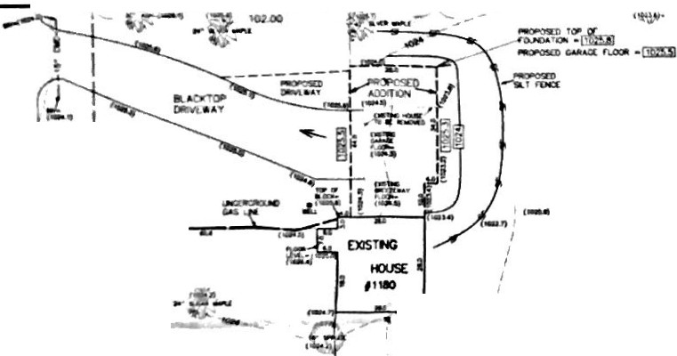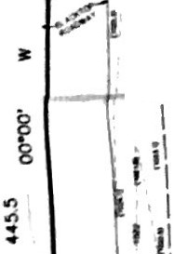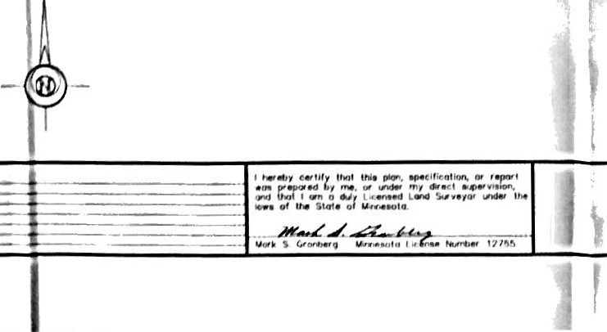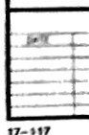the South 2118 IHI lhe1eol, OCCUHllng to th1 V.S. COldtfm11tn\ S...vey \h.,-,.01
I d9no\H lfon rnotk1t lounc:I
' (IK>l.l) ; dlOOIH ..1i111n9 •P-OI 1i.ot!ON, nieon ..o l w.i oolurft
([mjJ : d1nOIH j)l'O!"IOHd IPO\ •tovotlot1, lfllllft 110 l1v1I OOIVl'I"
911 d900l11 ••1111o0 cont our llrw. "'90n aeo i.vlM oot\11'1
-mm--< dlH\OIH P'OOOlld COll\OUt hne, rf\e()n ..lev.t doh.m
!J111w lnQ1 ahowo 011 bo..o 1o11>on °"' OHu out"""
lhl1 YI)' Int t o.rwi,. th• bOUl'\<k1!1M ol the above d•SC• P'GP"' IY. ,... 10cot11)C'I
ol oo 11•11\INJ hoVa•, dt•Y•,.or <M 1oot ehtvolooro1, on.I th• Pf OJM>11ed tu. otoon ol o l)t'<>po••d
ndtllhU<l lh•••On. 1t 0091 oot PVIPO• l to •hO"' U!'I)' OllWI lnlPhlYI• " •nc• CXJ\.hmel\I'

G RON BERG & A SSOCI A TES, IN C.
$
CIVIL ENGINEERS, LA ND SURVEYORS. LAND PLA Nl'\ERS
UOW ()RIVI!, LONG I A.Kl, 6
•I(') NOf.l lH W
9 2 (lJ -'4 \ 4 1

'''
''\
\
·""

()...

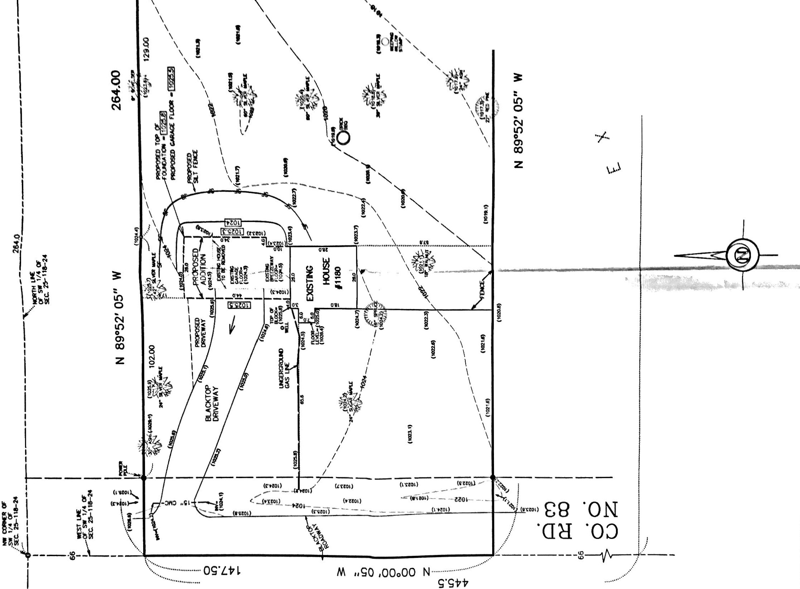
\. .

<.)

l'EllJ I EXISTINcS

-= 8=== 88 888
..,:: -...::
D

ml :+
I I I I 1 1
8
DO 8 8

c == == ================ TS===
CQNC -=>!IT FOOT 3'6" HIN FfiC1t1 GRADE 11.lfil WOOD TO [AATHSEPARATIONIr

@ T EVATION

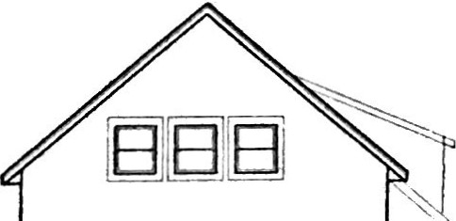EXISTIN<>

"
I NEW
If\

"""""-
C::C' "'PO&nlGlN. eM

888
8 B8 B8J n

v9IT 0,.,.,,.

Wit WOCO TOEARTH SEPARATlON&"
8 8 8 8
- eGO'RT "" CON1'.

MIN.WOOD 10 EARlH SEPAAATION6

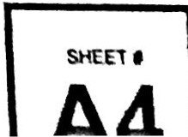

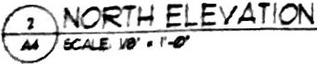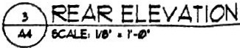
ISSUE
PERMIT SET
l-6-17

$"1"\
faflS0A Sievers variance at 1180 county rd.83

I Mike Ferrell at 1212 Co Rd 83 don't have a problem with the Sievers building an attach garage 15' from the south property line of my property. And see no problem with them get a variance from the city.
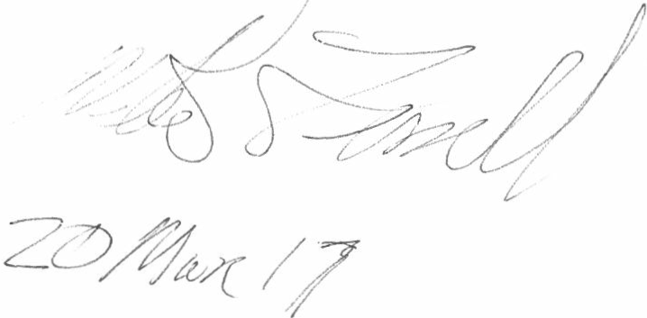

City of Independence

Ordinance Adoption – Predatory Offenders Ordinance

To: City Council

From: Mark Kaltsas, City Administrator
Meeting Date: May 9, 2017

Discussion:

Predatory Offenders Ordinance
Many metropolitan area cities have recently contemplated adopting certain residency location restrictions for predatory offenders. Cities that have adopted local legislation have typically found that such residency location restrictions would be prudent to protect the local health, safety and welfare of their residents.
Cities have adopted a relatively standard and consistent model ordinance language as an amendment to local zoning codes.

- Most ordinances restrict Level II and III offenders.
- The model ordinance defines “protected areas” such as schools, playgrounds, parks, and other places children are known to regularly congregate.
- Level II and III predatory offenders would be prohibited from living a certain distance from those protected areas (e.g. 750 feet measured lot line to lot line).
- Ordinances exempt residences which were established by Level II and III offenders prior to adoption of the ordinance.
- Typically, an offender is also allowed to move into a residence with certain relatives (e.g. parents, siblings, spouses, children etc.) regardless of the proximity to a protected location.

The City of Independence Attorney has prepared an ordinance based on the model language used by other similar communities. While these residency restriction ordinances can be further customized by cities, there are two factors that are typically needing to pertain to the specific city. Independence will need to consider the type of protected area (i.e. parks, daycare facilities, schools, etc.) and the restricted distance that offenders will be prohibited from living from protected areas.

Types of Protected Areas:
The types of protected areas are typically those areas where children commonly congregate. Most cities identify schools, public parks and licensed daycare facilities. Some cities have found other similarly used areas as needing to be defined in the ordinance. Staff did not identify any similar use areas that appear to need further definition in the ordinance.

Page 1

Restricted Distance:
The City can determine the distance from restricted areas that residency of predatory offenders would be restricted. The distances established by the City cannot purposefully restrict the entire City. The general standard adopted by most Cities is 2,000. The 2,000 feet is measured from the outer edge of the restricted properties to the property line of the residential properties. If any portion of a residential property falls within the distance, the entire property becomes prohibited.

Council discussed this ordnance at the last City Council Meeting. Council directed staff to prepare the final ordinance for adoption.

Recommendation:
The City Council is being asked to consider adoption of ORDINANCE NO. 2017-01.

Attachments: Predatory Offender Ordinance - ORDINANCE NO. 2017-01

Page 2

CITY OF INDEPENDENCE ORDINANCE NO. 2017-01

ORDINANCE AMENDING CHAPTER 9 OF THE CITY CODE
TO REGULATE THE RESIDENCE LOCATION OF PREDATORY OFFENDERS

THE CITY COUNCIL OF THE CITY OF INDEPENDENCE, MINNESOTA, HEREBY ORDAINS:

SECTION 1. Chapter 9 of the Independence City Code shall be amended by adding the following as section 920:

  - Predatory Offenders Residency – Prohibited Conduct

Subd. 1. Finding and intent. Repeat predatory offenders present an extreme threat to the public safety. Predatory offenders are likely to use physical violence and to repeat their offenses, and most predatory offenders commit many offenses, have many more victims than are ever reported, and are prosecuted for only a fraction of their crimes. This makes the cost of predatory offender victimization to society at large, while incalculable, unmistakably steep.

It is the intent of this Section to serve the city’s compelling interest to promote, protect, and improve the health, safety, and general welfare of Independence citizens by creating areas around locations where children are known to regularly congregate in concentrated numbers wherein certain predatory offenders are prohibited from establishing temporary or permanent residence.

Subd. 2. Definitions. The following words, terms, and phrases, when used in this Section, shall have the meanings ascribed to them in this subdivision, except where the context clearly indicates a different meaning:

    - “Designated predatory offender” means any person who has been categorized as a Level III predatory offender under Minnesota Statutes Section 244.052, a successor statute, or a similar statute from another state in which that person’s risk assessment indicates a high risk of re- offense;

    - “Permanent residence” means a place where a person abides, lodges, or resides for 14 or more consecutive days;

    - “Temporary residence” means a place where a person abides, lodges, or resides for a period of 14 or more days in the aggregate during any calendar year and which is not the person’s permanent address, or a place where the person routinely abides, lodges, or resides for a period of four or more consecutive or non-consecutive days in any month and which is not the person’s permanent residence;

    - “School” means a public or nonpublic elementary or second school;

1

    - “Licensed child care center” means a group child care center currently licensed by the applicable County or State of Minnesota;

    - “Public playground” means a city-owned, improved park or other outdoor area designed, equipped, and set aside primarily for children’s play.

Subd. 3. Prohibited Location of Residence

- It is unlawful for any designated predatory offender to establish a permanent or temporary residence within 2,000 feet of any school, licensed child-care facility, public playground, or any other place where children are commonly known to regularly congregate.

- Measurement of distance. For purposes of determining the minimum distance separation required by this Section, the requirement shall be measured by following a straight line from the outer property line of the permanent or temporary residence of the designated predatory offender to the nearest outer property line of the protected facility in subdivision 2.

- Penalties. Any person who violates this Section shall be guilty of a misdemeanor and shall be punished by a fine of an amount not exceeding $1,000.00 and/or imprisoned for a period not to exceed 90 days. Each day that a person maintains a permanent or temporary residence in violation of this Code shall constitute a separate offense.

Subd. 4. Exceptions

- A designated predatory offender residing within a prohibited area as described in subdivision 3 does not commit a violation of this Section if any of the following apply:

  - The person established the permanent residence or temporary residence and reported and registered the residence pursuant to Minnesota Statutes Sections 243.166 and 243.167 or a successor statute, prior to June 1, 2015;

  - The person was a minor when they committed the offense and they were convicted as an adult;

  - The person is a minor;

  - The school, licensed child care center, or public playground within 2,000 feet of the person’s permanent residence was opened after the person established the permanent residence or temporary residence and reported and registered the residence pursuant to Minnesota Statutes Sections 243.166 and 243.167, or a successor statute;

  - The residence is also the primary residence of the person’s parents, grandparents, siblings, or spouse; or

  - The residence is a property purchased, leased, or contracted with and licensed by the Minnesota department of corrections prior to June 1, 2015.

461521v1 AMB PN155-1

SECTION 2. This ordinance shall take effect and be in force immediately after its passage and publication in accordance with applicable law.

Dated the 9th day of May, 2017.

ATTEST:
Marvin Johnson, Mayor

Mark Kaltsas, City Administrator

461521v1 AMB PN155-1

