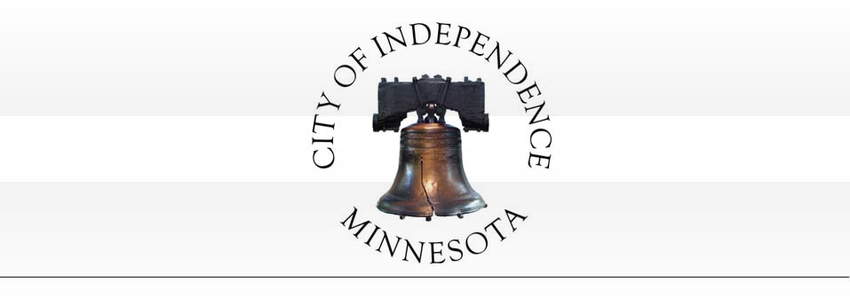
CITY COUNCIL MEETING AGENDA REGULAR MEETING
TUESDAY, JUNE 13, 2017

CITY COUNCIL MEETING TIME: 7:30 PM

- Call to Order

- Pledge of Allegiance

- Roll Call

- ****Consent Agenda****

All items listed under Consent Agenda are considered to be routine by Council and will be acted on by one motion. There will be no separate discussion of these items. If discussion is desired, that item will be removed from the Consent Agenda and will be considered separately.

  - Approval of City Council minutes from the May 9, 2017 Regular City Council Meeting.
  - Approval of City Council minutes from the June 7, 2017 City Council Workshop.
  - Approval of Accounts Payable; Checks Numbered 17140-17219.
  - Approval of Third Quarter Financial Report.
  - Approval of Release from Development Agreement for that Portion of Lot 1, Block 2 (as legally described in the agreement) Independence Ridge Subdivision.
  - Approval of the Large Assembly Permit and Associated Minnesota Lawful Gambling.
  - Approval of Professional Financial Services Contract with AEM Financial Solutions, LLC.
  - Exempt Permit for Twin Cities Polo Club Annual Polo Classic Event to be Held August 4-6, 2017.
  - Approval of Amended Stormwater Pond Maintenance Agreement for Franklin Hills 3rd Addition.

- Set Agenda – Anyone Not on the Agenda can be Placed Under Open/Misc.

- Reports of Boards and Committees by Council and Staff.

763-479-0527 (Phone) 1920 County Road 90 763-479-0528 (Fax)
Independence, MN 55359 http://independence.govoffice.com

- Director Gary Kroells, West Hennepin Public Safety - Activity Report for the Month of April 2017.

- PUBLIC HEARING: Ordinance Amendment to Section 915 - Regulation of Lake Sarah Surface Use.

  - ORDINANCE 2017-02: An amendment relating to the removal of the no-wake provision to be consistent with the ordinance regulating Lake Independence.

- Dean Fowser (Applicant/Owner) requests that the City consider the following actions for the property located at 8875 Highway 12 (PID No. 18-118-24-11-0001) in Independence, MN:

  - RESOLUTION NO. 17-0613-01 - recommending approval of an amendment to the conditional use permit to expand the commercial building located on the property.

- Presentation by Clifton Larsen Allen - 2016 Financial Audit and Year End Financials.

- Annual Opportunity for Public to Comment on MS4 Permit.

- Change of City Council Meeting Dates/Times.

- Open/Misc.

- Adjourn.

MINUTES OF A REGULAR MEETING OF THE INDEPENDENCE CITY COUNCIL TUESDAY, MAY 9, 2017 –7:30 P.M.

- CALL TO ORDER.

Pursuant to due call and notice thereof, a regular meeting of the Independence City Council was called to order by Mayor Johnson at 7:30 p.m.

- PLEDGE OF ALLEGIANCE.

Mayor Johnson led the group in the Pledge of Allegiance.

- ROLL CALL

PRESENT: Mayor Johnson, Councilors Betts, Grotting, Spencer and McCoy ABSENT: None
STAFF: City Administrative Assistant Horner, City Administrator Kaltsas, City Attorney Kyle Hartnett (in for Bob Vose)
VISITORS: Sarah Borchers, Jason Sievers, Richard Sievers

- ****Consent Agenda****

All items listed under Consent Agenda are considered to be r by Council and will be acted on by one motion. There will be no separate discussion of hese items. If discussion is desired, that item will be removed from the Consent Agenda and will be considered separately.

  - Approval of City Council minutes from the April 25, 2017 Regular City Council Meeting.
  - Approval of minutes from the April 25, 2017 Board of Appeal and Equalization Meeting.
  - Approval of Accounts Payabl Checks Numbered 17103-17139.
  - Approval of MnDOT Master Partnership Contract for the Highway 12 Light Maintenance.
    - RESOLUTION NO. 17-0509-01.

Motion by McCoy, second by Betts to approve the Consent Agenda. Ayes: Johnson, Grotting, McCoy, Spencer and Betts. Nays: None. Absent: None. MOTION DECLARED CARRIED.

- SET AGENDA – ANYONE NOT ON THE AGENDA CAN BE PLACED UNDER OPEN/MISC.

- REPORTS OF BOARDS AND COMMITTEES BY COUNCIL AND STAFF

Spencer attended the following meetings:
- Highway 12 Coalition Meeting
- City Clean Up Day

Grotting attended the following meetings:
- Highway 12 Coalition
1
City of Independence
City Council Meeting Minutes 7:30 p.m., May 9, 2017

- City Clean Up Day

McCoy attended the following meetings:

Betts attended the following meetings:

Johnson attended the following meetings:
- Sensible Land Use Committee Meeting
- WeCan Community Action Partnership Board Meeting
- Mayors Conference in Brainerd
- Loretto Fire Department Breakfast
- Hamel Prayer Breakfast
- Orono Healthy Youth Committee Meeting
- Highway 12 Coalition Meeting
- MN Watershed Meeting
- Regional Council of Mayors Meeting
- Orono School Board Meeting
- West Hennepin Chamber of Commerce Meeting
- Senior Center Volunteer Appreciation Dinner

Horner attended the following meetings:
- MCFOA training
- City Clean-Up Day

Kaltsas attended the following meetings:

- DIRECTOR GARY KROELLS, WEST HENNEPIN PUBLIC SAFETY - ACTIVITY REPORT FOR THE MONTH OF MARCH, 2017.

Kroells said March was a very busy month with lots of crashes due to weather. Kroells highlighted a few incidents.

*For a complete report see the City Council packet*

Kroells noted everyone did a great job controlling the large swamp fire. The properties surrounding the area were well protected. Kroells said it burned out by the time it hit Pioneer Creek. Kroells noted there are various theories as to how the fire started. He said they may never know but he does not believe it was intentional.

Grotting noted the changes being proposed to make the intersection at County Road 90 and Highway 12 safer. He wanted to know if there was anything the City should be communicating to MnDOT to help those efforts. Kroells said it was announced that the funding for that intersection has been approved and is part of their plan for 2021.
Grotting asked about the relationship between WHPS and the Vinland Center. Kroells noted WHPS works with them and because they are a treatment facility there are quite a few calls from them. He noted the Vinland Center is charged $90/ hour for police services which is billed on a quarterly basis.

2
City of Independence
City Council Meeting Minutes 7:30 p.m., May 9, 2017

- PUBLIC HEARING: JASON SIEVERS (APPLICANT/OWNER) REQUESTS THAT THE CITY CONSIDER THE FOLLOWING ACTIONS FOR THE PROPERTY LOCATED AT 1180 COUNTY ROAD 83 (PID NO. 25-118-24-32-0001) IN INDEPENDENCE, MN:

  - RESOLUTION NO. 17-0509-02 - recommending denial of a variance to allow a reduced side yard setback for the subject property.

Kaltsas stated the subject property is located at 1180 County Road 83. The property is on the east side of County Road 83 and south of the intersection of Timber Trail and County Road 83. There is an existing home and one small detached accessory structure on the subject property.

Kaltsas said the applicant is seeking approval to construct an addition onto the existing home. The addition includes living space as well as a larger garage. The applicant is proposing to remove a portion of the existing house which includes the existing garage. It was noted by the applicant that the existing garage was connected to the home via an enclosed space at some point and used to be a detached garage. The applicant would like to construct an addition (new garage and living space) onto the portion of the existing home to remain. The existing home is currently in compliance with all applicable setbacks for this property (the existing home is setback 30 feet from the north property line).

The applicant is asking the City to consider granting a variance r the side yard setback (north property line) to allow expansion of the existing home. The City requires a side yard setback of 30 feet for properties zoned RR-Rural Residential. The applicant is proposing to construct the home addition so that it is setback
17.6 feet from the side property line rather than 30 feet as required.

There are several factors to consider relating to granting a variance. The City’s ordinance has established criteria for consideration in granting a variance.

  - Standards for granting variances. Subdivision1. The City Council may grant a variance from the terms of this zoning code, including restrictions laced on nonconformities, in cases where: 1) the variance is harmony with the general purposes and intent of this zoning code; 2) the variance is consistent with the comprehensive plan; and 3) the applicant establishes that there are practical difficulties in complying with the zoning code (Amended, Ord. 2011-08)

Subd. 2. An applicant for a variance must demonstrate that there are practical difficulties in complying with the zoning code. For such purposes, “practical difficulties” means:

    - The propert owner proposes to use the property in a reasonable manner not permitted by the zoning code;

    - the plight of the property owner is due to circumstances unique to the property not created by the landowner;

    - the variance, if granted, will not alter the essential character of the locality.

Economic considerations alone do not constitute practical difficulties. Practical difficulties include, but are not limited to, inadequate access to direct sunlight for solar energy systems. (Amended, Ord. 2011- 08)

3
City of Independence
City Council Meeting Minutes 7:30 p.m., May 9, 2017

Subd. 3. The City Council shall not grant a variance to permit a use that is not allowed under the zoning code based on the zoning classification of the affected property. (Amended, Ord. 2011-08)

  - Conditions and restrictions. The board of adjustments may recommend and the City Council may impose conditions on a variance. Conditions must be directly related to and must bear a rough proportionality to the impact created by the variance. (Amended, Ord. 2011-08)

Consideration of the criteria for granting a variance:
    - Residential use of the property is consistent with the Rural Residential District.

    - The City would need to find that the plight of the property owner is due to circumstances unique to the property that are not created by the landowner.

    - The character of the surrounding area is residential. There are several properties in the vicinity that do not meet all applicable building setbacks. The proposed expansion for a single-family home is i n keeping with the City’s comprehensive plan.

Kaltsas noted there are several additional items that could be considered by the City:

      - The required detached accessory structure setback from the side yard is 15 feet. The applicant could locate a detached accessory structure on this property and meet applicable setbacks.
      - The property directly north of this property has several detached accessory buildings which do not meet applicable setbacks. The wner of he property directly north did provide a note to the City stating that they found the requested variance to be acceptable.
      - The applicant could rotate the proposed addition degrees and meet all applicable setbacks.

      - There are many properties in the City of Independence that have similar conditions to that of the subject property. The City would need to find that the property has unique conditions that can be noted as the basis for granting the variance.
      - Several properties directly west of the subject property appear to have reduced front yard setbacks.
      - The proposed home/garage addition is a two-story addition which will be taller than the portion of the existing structure that is being removed.

Kaltsas said ultimately the City will need to find that the criteria for granting a variance have been met by the applicant. Commissioners reviewed the requested variance and asked questions of staff and the applicant.
Commissioners reviewed the proposed setback and asked for clarification relating to the portion of the home that was going to remain versus the portion of the home that was going to be removed. Commissioners confirmed that the existing home meets applicable setbacks. Commissioners reviewed the criteria for granting a variance. Planning Commissioners asked for clarification relating to the criteria for granting a variance and whether or not all criteria needed to be considered. Commissioners discussed that the City has many similarly sized parcels with existing homes. Commissioners discussed the characteristics of the subject parcel and noted that there was a substantial amount of area that could accommodate a home/garage expansion. There was an initial motion to approve the variance request as presented. That motion did not receive a second and did not proceed. There was then a motion to deny the variance as requested. That
4
City of Independence
City Council Meeting Minutes 7:30 p.m., May 9, 2017

motion did not initially receive a second until there was additional discussion. Commissioners ultimately recommended denial of the variance to the City Council with the following findings:

- Commissioners could not make the finding that the plight of the property owner is due to circumstances unique to the property not created by the landowner. Commissioners did not find unique circumstances or characteristics of the property that warranted a variance. Commissioners noted that this property is similar to many others in the City and that granting a variance without unique characteristics would establish a precedent for allowing reduced setbacks.

The City received a letter from the neighboring property owner located at 1212 County Road 83 supporting the requested variance. The Planning Commission recommended denial of the requested variance with the following findings and conditions:

  - The proposed Variance request does not meet all applicable conditions and restrictions stated in Chapter V, Section 520.19, Procedures on variances, in the City of Independence Zoning Ordinance.

  - The Applicant’s variance request is denied because it does not meet criteria established for granting a variance due to the lack of unique conditions or characteristics of the subject property.

  - The Applicant shall pay for all costs associated with the City’s review of the requested variance.

Sievers said it will be difficult to turn into the proposed area with the setbacks. Betts asked if the breezeway would disappear. Sievers said it would not. Spencer said the point was that in order to be granted a variance the applicant would have to show hardship concerns and design challenges are not that. Sievers said he wants it to be attached. Kaltsas asked if Sievers would be willing to look at a smaller variance. Johnson said it could be tabled for 60 days so Sievers had an opportunity to think about it.

Motion by Spencer, second by Betts to table pending a letter from the applicant for 60 days. Ayes: Johnson, Grotting, McCoy, Spencer and Betts. Nays: None. Absent: None. MOTION DECLARED CARRIED.

- Consideration of Adopting an Ordinance Amendment Pertaining to Public Safety:

  - ORDINANCE NO. 2017-01 – Adoption of a predatory offender dwelling location restriction ordinance.

Kaltsas noted many metropolitan area cities have recently contemplated adopting certain residency location restrictions for predatory offenders. Cities that have adopted local legislation have
typically found that such residency location restrictions would be prudent to protect the local health, safety and welfare of their residents.

Cities have adopted a relatively standard and consistent model ordinance language as an amendment to local zoning codes.

- Most ordinances restrict Level II and III offenders.

5
City of Independence
City Council Meeting Minutes 7:30 p.m., May 9, 2017

- The model ordinance defines “protected areas” such as schools, playgrounds, parks, and other places children are known to regularly congregate.
- Level II and III predatory offenders would be prohibited from living a certain distance from those protected areas (e.g. 750 feet measured lot line to lot line).
- Ordinances exempt residences which were established by Level II and III offenders prior to adoption of the ordinance.
- Typically, an offender is also allowed to move into a residence with certain relatives (e.g. parents, siblings, spouses, children etc.) regardless of the proximity to a protected location.

The City of Independence Attorney has prepared an ordinance bas on the model language used by other similar communities. While these residency restriction ordinances can be further customized by cities, there are two factors that typically need to pertain the specific city. Independence will need to consider the type of protected area (i.e. parks, e facilities, schools, etc.) and the restricted distance that offenders will be prohibited from living from protected areas.

Types of Protected Areas:
The types of protected areas are typically those areas where children commonly congregate. Most cities identify schools, public parks and licensed daycare facilities. Some cities have found other similarly used areas as needing to be defined in the ordinance. Staff did not identify any similar use areas that appear to need further definition in the ordinance.

Motion by Spencer, second by McCoy to approve Ordinance No. 2017-01 with the recommended changes to II and III being Ayes: Johnson, Grotting, McCoy, Spencer and Betts. Nays: None. Absent: None. MOTION DECLARED CARRIED.

- Discussion of City Council Meeting Dates/Times.

Discussion around ongoing meeting dates and time It was decided that the next May City Council meeting will be May th instead of May 23rd due to schedule conflicts.

Motion by McCoy, second by Betts to move the next May City Council meeting to May 30th instead of May 23rd. Ayes: Johnson, Grotting, McCoy, Spencer and Betts. Nays: None. Absent: None. MOTION DECLARED CARRIED.

- Open/Misc.

- Adjourn.

Motion by McCoy, second by Spencer to adjourn at 8:30 p.m. Ayes: Johnson, Grotting, McCoy, Spencer and Betts. Nays: None. Absent: None. MOTION DECLARED CARRIED.

Respectfully Submitted,

Trish Bemmels/ Recording Secretary

6
City of Independence
City Council Meeting Minutes 7:30 p.m., May 9, 2017

MINUTES OF A WORK SESSION OF THE INDEPENDENCE CITY COUNCIL WEDNESDAY, JUNE 7, 2017, 2017 –7:00 A.M.

- CALL TO ORDER.

Pursuant to due call and notice thereof, a work session of the Independence City Council was called to order by Mayor Johnson at 7:02 a.m.

- PLEDGE OF ALLEGIANCE.

Postponed until regular meeting.

- ROLL CALL

PRESENT: Mayor Johnson, Councilors Betts, Fisher, Grotting, pencer and McCoy ABSENT: None
STAFF: Interim City Administrator Kaltsas, Administrative Assistant Beth Horner, VISITORS: Steve McDonald (ABDO)

- GENERAL ADMINISTRATION

  - 2017 1st Quarter Budget Report Staff has reviewed the 1st Qtr. Report and found that the City is in line with respect to most expenditures and revenues ear to date. Legal continues to be above due to the trial that was held in January. The City also pa for the majority of the annual
insurance premiums during the 1st quarter. The report is presented for information only at this time and will be included on the next City Council

*for complete report see the workshop packet*

McDonald outlined the report for the first quarter. He noted it was a little off-track but no red flags.

  - AEM contract renewal- The City has utilized AEM for all financial services during the past three years under a financial services contract. That contract ended in 2016. At that time, AEM was transitioning a new employee into the City and the City was transitioning from internal payroll to direct deposit. Staff has been working with AEM to revise the professional services contract to include an accurate scope of services. The proposed contract would be similar to the last contract and have a three-year time frame. The services provided to the City include all financial services (accounting, ccounts payable, payroll, utility billing, budgeting and audit preparation and assistance). The contract amount for 2016 was $58,350. The proposed 2017 contract amount is
$62,500 (see attached contract proposal). The City has budgeted $61,100 for 2017.

In order to match the financial consulting services provided by AEM, the City would need to employ a full-time employee, plus retain additional high-level accounting services. The full cost to the City for a mid-range finance employee would range between $70,000-$85,000 (salary plus benefits) and the additional consulting hours would range between $12,000-$25,000 annually. The services provided by AEM have served the City well over the past three years. The City’s accounting accuracy and record keeping has continued to improve. Staff is seeking direction pertaining to the proposed contract renewal and would anticipate that a formal action would be taken at the next City Council Meeting.

Spencer noted that if the City hired a bookkeeper there would still be a need for some services through ABDO or a similar company. He said he liked the outsourcing model. Betts noted ABDO has history with
1
City of Independence
City Council Work Session Minutes 7:00 a.m. June 7, 2017

the City. McCoy asked if the new payroll system had an approval process. Kaltsas said the Administrative group comprised of three is supervised by him and the Public Works side is supervised by Ende. Kaltsas noted hours are reviewed and errors are eliminated.

  - JPA Maple Plain Services- The City has a draft agreement that we have been working on with Maple Plain. It is anticipated that this agreement will be finalized over the next few months. Staff had been working to find other examples of how to break down costs relating to maintenance and operations. In addition, staff has been working on the development of a sustainable way to break down the responsibility and costs associated with the maintenance and ownership of the infrastructure. More information pertaining to this issue will be forthcoming.

Kaltsas noted Maple Plain was still getting appraisals and that they were probably going to have to increase their city share of the assessable portion. He noted it would not affect the City of Independence as the amount has been agreed upon already for the portion of the road Independence is covering.

  - Financial Software Upgrade Needs – The ity was notified last fall that our current financial software provider will no longer be sup our version of the software. They have already begun to phase out support for the software, but ill have limited support for an undesignated amount of time moving forward. The City has researched options for upgrading the software. There are essentially two companies that serve the public sector and are commonly used by cities; Banyon and Civics Systems. We received pricing from both co to provide softwar packages which would replace our current system The City has also discussed the software upgrade with AEM who operates the software for the City. Based on the discussions, pricing and the ability to fill the City’s needs, staff is leaning towards utilizing Banyon. Banyon would provide the City with the software necessary to meet our current and future needs. The total cost of the software is approximately
$11,000.

In order to provide a “clean” transition of the software, it is anticipated that City would switch over to the new platform at year end. This may require that the City purchase the software towards the end of 2017 so that there ould be time to make the transfer so that it is running on January 1, 2018.

More information will be forthcoming relating to this issue as we move closer to the end of 2017.

McDonald noted that 75% of cities use Banyon. He said the support is better and cost is way cheaper to go with Banyon. McDonald said the City could double in size and would still be able to use Banyon. Grotting asked if there would be any security issues. McDonald said it is a hosted model and security is not an issue. Johnson said with Banyon coming down in price it is a no-brainer.

  - Website Update – One of staff’s goals is to continue improving communication with and how the City provides information to our residents. This includes providing easily searchable and useable information. Over the last two years staff has been working on updating files, forms and other information into digital formats that can be filled out and submitted digitally online. It is staff’s belief that our current website could be updated to provide a fresh, welcoming and more intuitive interface. Staff has been researching and soliciting quotations to upgrade the City’s website. The City received three quotations from website development companies to update the City’s current website. The estimated costs for updating the City’s website ranges from approximately $2,500-$7,500.

Staff is seeking City Council discussion and direction relating to the possibility of updating the City’s website. Based on the feedback and direction from the Council, staff would need to fully vet the proposals and bring back a formal action item to the City Council. Funding for the website update

2
City of Independence
City Council Work Session Minutes 7:00 a.m. June 7, 2017

would need to be determined depending on the actual amount. It is anticipated that the funding could be found within the 2017 budget.

Kaltsas said it would be a complete blow up/ redesign and have mobile capabilities as well. He said staff would do more research but presented three different options to gauge the Council’s interest in moving forward. Spencer said he would be happy to sit in on meetings as providers are brought in to quote and describe the scope of the project. Kaltsas noted that we are working digitizing forms so they may be submitted electronically.

  - Sunday Liquor Sales – Minnesota legislature adopted a new law allowing off-sale liquor on Sundays. The City has one off-sale liquor sales business (Ox Yolk). The special session yielded an update to the law which will allow cities to determine if they want to amend their own ordinances to allow Sunday liquor off-sales. The City can decide if it wants to allow Sunday off-sale. If the City were to allow the Sunday off-sale, it would need to specify the hours of sale which can be anywhere between 11:00am and 6:00pm. Ox-Yolk has reached to the City regarding Sunday off-sale liquor sales. Staff is seeking direction from the City Council relating to the Sunday sales. Based on the direction, staff would anticipate bringing back a ordinance amendment.

Johnson said that Ox Yoke should make an application. Spencer said all the other local establishments would be able to sell so he did not see why they should not be able to as well.

  - City Council Meeting Schedule – Staff would like to continue the meeting time discussion with Council and will present information at the workshop.

Kaltsas said Vose is a finalist for White Bear. The Council would need to switch to the 1st and 3rd Tuesdays in order to keep Vose should he get the position with White Bear. Kaltsas noted the 1 and 3rd Tuesdays would work better for him as well. He said 6:30 would be a better starting time instead of 7:30. Spencer said it would make sense to start earlier so it does not go so late at night. LMCC would also need to be switched. Kaltsas said the Comp Plan meeting could be pushed to the 2nd meeting in July. pencer said it would allow more newsletters to be collected. A push for more responses could be printed in the June newsletter as well. The change in Council meeting nights could also be published in the newsletter in June.

- ADJOURN

Motion by Johnson, second by Betts to adjourn the meeting at 8:32 a.m. Ayes: Johnson, Spencer, McCoy, Betts and Grotting. Nays: None. Absent: None. Abstain: None. MOTION DECLARED CARRIED.

Respectfully submitted,

Trish Bemmels, Recording Secretary

3
City of Independence
City Council Work Session Minutes 7:00 a.m. June 7, 2017

City of Independence
First Quarter 2017 Financial Summary

To: City Council
From: Mark Kaltsas, Administrator
Meeting Date: June 13, 2017

Summary:
The City Council receives quarterly financial reports detailing the current financial status of the City. The reports are typically presented for information to the Council. The 2017 first quarter report shows that the City is in good standing following a review of the first quarter revenues and expenditures.

Staff’s overall review of the budget shows that we are in line with spending and on track to be on budget for the year. Typically, the first quarter shows some larger expenditures for insurance and public works related to paying annual premiums and purchasing the majority of materials for public works.

Attachments:
1. First Quarter Financial Report

Page 1

1st Quarter Report

City of Independence
Independence, Minnesota

As of March 31, 2017

ACCOUNTANT’S COMPILATION REPORT
May 23, 2017

Honorable Mayor and City Council City of Independence Independence, Minnesota

Management is responsible for accompanying financial statements of the City of Independence, which comprise the budget to actual statement of revenues and expenditures for the General and enterprise funds as of March 31, 2017 in accordance with accounting principles generally accepted in the United States of America. We have performed a compilation engagement in accordance with Statements on Standards for Accounting and Review Services promulgated by the Accounting and Review Services Committee of the AICPA. We did not audit or review the financial statements nor were we required to perform any procedures to verify the accuracy or completeness of the information provided by management. Accordingly, we do not express an opinion, a conclusion, nor provide any form of assurance on these financial statements.

Management has elected to omit substantially all of the disclosures and the statement of cash flows required by accounting principles generally accepted in the United States of America. If the omitted disclosures and the statement of cash flows were included in the financial statements, they might influence the user’s conclusions about the City’s financial position, results of operations, and cash flows. Accordingly, the financial statements are not designed for those who are not informed about such matters.

Sincerely,

AEM FINANCIAL SOLUTIONS, LLC

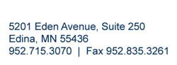

Honorable Mayor and City Council City of Independence Independence, Minnesota

Dear Honorable Mayor and City Council:

May 23, 2017

We have reconciled all bank accounts through March 31, 2017 and reviewed activity in all funds. The following is a summary of our observations. All information presented is unaudited.

Cash and Investments

The City’s cash and investment balances are as follows:

Increase/ 03/31/2017 12/31/2016 (Decrease)

Checking
$ 1,121,684 $
1,830,967 $
(709,283)

Investments (at market value) 191,198 189,097 2,101

Total cash and investments
$
1,312,882
$
2,020,064
$
(707,182)

Investment Type
Increase/ 03/31/2017 12/31/2016 (Decrease)

Checking Money Market Negotiable CDs
$ | 1,121,684 |  | $ | 1,830,967 |  | $ | (709,283)
 | - 191,198 |  |  | - 189,097 |  |  | - 2,101
$ | 1,312,882 |  | $ | 2,020,064 |  | $ | (707,182)

Total investments

General Fund Cash Balances 2014-2017

$1,300,000

$1,100,000

$900,000

$700,000

$500,000

$300,000

$100,000

January 1 January February March April May June July August September October November December

2014 2015 2016 2017 50% reserve Prior year average

General Fund
Receipts | YTD  Budget | YTD  Actual | Percent of YTD Budget |  | Disbursements | YTD  Budget |  | YTD  Actual |  | Percent of YTD Budget
Taxes | $ 595,484 | $ - | - | % | Legislative | $ 4,878 |  | $ 4,737 |  | 97.1 | %
Licenses and permits | 38,220 | 31,465 | 82.3 |  | Election | 808 |  | - |  | -
Intergovernmental | 3,625 | - | - |  | City Clerk/finance | 91,850 |  | 13,726 |  | 14.9
Charges for services | 9,693 | 4,057 | 41.9 |  | Legal services | 8,888 |  | 10,408 |  | 117.1
Fines and forfeitures | 11,588 | 9,841 | 84.9 |  | Planning and zoning | 7,564 |  | 1,932 |  | 25.5
Miscellaneous revenue | 5,233 | 4,244 | 81.1 |  | General government building | 18,809 |  | 7,395 |  | 39.3
 |  |  |  |  | Public safety | 356,275 |  | 311,552 |  | 87.4
 | $ 663,843 | $ 49,607 | 7.5 | % | Building inspector | 25,548 |  | 23,535 |  | 92.1
 |  |  |  |  | Public works | 130,920 |  | 80,601 |  | 61.6
Key |  |  |  |  | Solid waste | 12,563 |  | 12,293 |  | 97.9
Varies more than 15% than budget positively |  |  |  |  | Recreation/community service | 1,885 |  | 1,500 |  | 79.6
Varies more than 15% than budget negatively |  |  |  |  | Park maintenance | 3,273 |  | 1,911 |  | 58.4
Within 15% of budget |  |  |  |  | Insurance | 585 |  | 1,700 |  | 290.6

$ 663,846
$ 471,290
71.0 %

Current short-term rates being offered by financial institutions are very low as evidenced by the table of U.S. Treasury rates below. The U.S. Treasury rates provide a benchmark perspective for rate of return.

Treasury yields
Date 1 mo 3 mo 6 mo 1 yr 2 yr 3 yr 5 yr 7 yr 10 yr

12/31/2010 | 0.07 | 0.12 | 0.19 | 0.29 | 0.61 | 1.02 | 2.01 | 2.71 | 3.30
12/30/2011 | 0.01 | 0.02 | 0.06 | 0.12 | 0.25 | 0.36 | 0.83 | 1.35 | 1.89
12/31/2012 | 0.02 | 0.05 | 0.11 | 0.16 | 0.25 | 0.36 | 0.72 | 1.18 | 1.78
12/31/2013 | 0.01 | 0.07 | 0.10 | 0.13 | 0.38 | 0.78 | 1.75 | 2.45 | 3.04
03/31/2014 | 0.03 | 0.05 | 0.07 | 0.13 | 0.44 | 0.90 | 1.73 | 2.30 | 2.73
06/30/2014 | 0.02 | 0.04 | 0.07 | 0.11 | 0.47 | 0.88 | 1.62 | 2.13 | 2.53
09/30/2014 | 0.02 | 0.02 | 0.03 | 0.13 | 0.58 | 1.07 | 1.78 | 2.22 | 2.52
12/31/2014 | 0.03 | 0.04 | 0.12 | 0.25 | 0.67 | 1.10 | 1.65 | 1.97 | 2.17
03/31/2015 | 0.05 | 0.03 | 0.14 | 0.26 | 0.56 | 0.89 | 1.37 | 1.71 | 1.94
06/30/2015 | 0.02 | 0.01 | 0.11 | 0.28 | 0.64 | 1.01 | 1.63 | 2.07 | 2.35
09/30/2015 | 0.00 | 0.00 | 0.08 | 0.31 | 0.64 | 0.92 | 1.37 | 1.75 | 2.05
12/31/2015 | 0.14 | 0.16 | 0.49 | 0.65 | 1.06 | 1.31 | 1.76 | 2.09 | 2.27
03/31/2016 | 0.18 | 0.21 | 0.39 | 0.59 | 0.73 | 0.87 | 1.21 | 1.54 | 1.78
06/30/2016 | 0.20 | 0.26 | 0.36 | 0.45 | 0.58 | 0.71 | 1.01 | 1.29 | 1.49
09/30/2016 | 0.20 | 0.29 | 0.45 | 0.59 | 0.77 | 0.88 | 1.14 | 1.42 | 1.60
12/31/2016 | 0.44 | 0.51 | 0.62 | 0.85 | 1.20 | 1.47 | 1.93 | 2.25 | 2.45
03/31/2017 | 0.74 | 0.76 | 0.91 | 1.03 | 1.27 | 1.50 | 1.93 | 2.22 | 2.40

Budget Summary

A more detailed analysis of funds is included as Attachment A.

Cash Balance Summary

A detailed view of department totals compared with budget is included as Attachment B.

Investment Summary

A detailed summary of current investments is included as Attachment C.

Enterprise Fund Summary

A detailed summary of enterprise fund financial results is included as Attachment D.

Revenue and Expenditures

A detail of revenues and expenditures can be provided upon request.

* * * * *

This information is unaudited and is intended solely for the information and use of management and City Council and is not intended and should not be used by anyone other than these specified parties.

If you have any questions or wish to discuss any of the items contained in this letter or the attachments, please feel free to contact us at your convenience. We wish to thank you for the continued opportunity to be of service and for the courtesy and cooperation extended to us by your staff.

Sincerely,

AEM FINANCIAL SOLUTIONS, LLC

CITY OF INDEPENDENCE, MINNESOTA STATEMENT OF REVENUE AND EXPENDITURES -
BUDGET AND ACTUAL - GENERAL FUND (UNAUDITED) FOR THE THREE MONTHS ENDED MARCH 31, 2017

REVENUES

Budget Actual Variance -
Annual Thru Thru Favorable Budget 3/31/2017 3/31/2017 (Unfavorable)
Percent Received or Expended Based on Budget Thru 3/31/2017

Taxes | * $ 2,381,936 | $ 595,484 | $ - | $ (595,484) (1) | - | %
Licenses and permits | 152,880 | 38,220 | 31,465 | (6,755) | 82.33
Intergovernmental | 14,500 | 3,625 | - | (3,625) | N/A
Charges for services | 38,770 | 9,693 | 4,057 | (5,636) | 41.85
Fines and forfeitures | 46,350 | 11,588 | 9,841 | (1,747) | 84.92
Miscellaneous revenue | 20,930 | 5,233 | 4,244 | (989) | 81.10

TOTAL REVENUES 2,655,366 663,843 49,607 (614,236) 7.47

EXPENDITURES

Legislative | 19,510 | 4,878 | 4,737 | 141 |  | 97.11
Election | 3,230 | 808 | - | 808 |  | -
City Clerk/finance | 367,400 | 91,850 | 13,726 | 78,124 | (2) | 14.94
Legal services | 35,550 | 8,888 | 10,408 | (1,520) |  | 117.10
Planning and zoning | 30,254 | 7,564 | 1,932 | 5,632 |  | 25.54
General government building | 75,234 | 18,809 | 7,395 | 11,414 | (3) | 39.32
Public safety | 1,425,098 | 356,275 | 311,552 | 44,723 |  | 87.45
Building inspector | 102,190 | 25,548 | 23,535 | 2,013 |  | 92.12
Public works | 523,680 | 130,920 | 80,601 | 50,319 | (4) | 61.57
Solid waste | 50,250 | 12,563 | 12,293 | 270 |  | 97.85
Recreation/community service | 7,540 | 1,885 | 1,500 | 385 |  | 79.58
Park maintenance | 13,090 | 3,273 | 1,911 | 1,362 |  | 58.39
Insurance | 2,340 | 585 | 1,700 | (1,115) |  | 290.60

TOTAL EXPENDITURES 2,655,366 663,846 471,290 192,556 70.99

Transfers In - - - - N/A
Transfers Out - - - - N/A

EXCESS REVENUES
(EXPENDITURES)

$ -

$ (3)

$ (421,683)

$ (421,680)

* Taxes are paid 40% in June, 30% in July and the remainder is paid in December.

Item

Explanation of items percentage received/expended less than 80% or greater than 120% and $ variance greater than $10,000.

- Tax Settlements not yet received.
- Interim City Administrator invoices not yet received for 2017.
- City Planner invoices not yet received for 2017.
- Workers Compensation Insurance paid in April. Funds budgeted for projects work is anticipated to start in second and third quarters.

CITY OF INDEPENDENCE, MINNESOTA UNAUDITED CASH BALANCES BY FUND MARCH 31, 2016 AND MARCH 31, 2017

Fund
YTD Change
Balance Balance Balance From
3/31/2016 12/31/2016 3/31/2017 12/31/2016

100 | General | $ 560,700 | $ 1,144,606 | $ 661,085 | (1) | $ (483,521)
200 | Water resource department | 41,767 | 76,582 | 45,522 | (2) | (31,060)
309 | 2001 lease revenue bonds | 48,455 | 53,620 | 53,170 |  | (450)
311 | Drake Drive road improvement | 11,352 | 11,390 | 11,390 | (3) | -
312 | 2007 equipment certificate | 36,560 | 36,682 | 36,682 |  | -
314 | 2015A G.O. Bond | - | 148,816 | 8,260 | (4) | (140,556)
414 | 2015 street improvement | 340,857 | 35,986 | 35,933 |  | (53)
501 | Park | (2,057) | 24,759 | 59,343 | (5) | 34,584
602 | Sewer | 49,110 | 110,196 | 29,124 | (6) | (81,072)
801 | Building capital | 119,943 | 108,634 | 102,909 |  | (5,725)
802 | Road capital improvement | 12,674 | 12,717 | 12,717 |  | -
803 | Equipment capital improvement | (21,361) | 100,186 | 100,186 |  | -
804 | Administrative capital | (1,371) | 39,523 | 39,523 |  | -
806 | City Projects | 178,334 | 116,367 | 117,038 |  | 671

Total
$ 1,374,963 $
2,020,064
$ 1,312,882
$ (707,182)

Item Explanation of items percentage received/expended less than 80% or greater than 120% and $ variance greater than $25,000.

(1)
The increase is an expected result from excess of revenues over expenditures which is the typical cash flow pattern of the City. Additional detail can be obtained on the statement of Revenues & Expenditures.

(2) First half of Pioneer-Sarah Watershed expenses ($25,000) paid during the first quarter.

(3)
(4)
Bond Payment ($40,000) has not been made
This debt service fund was established in 2016. The bond payment ($140,000) made in the first quarter.

- Park Dedication Fees being paid
- Bond payments ($85,000) made during the first quarter

$700,000

Cash Balance by Fund Compared to Prior Year

$600,000

$500,000

$400,000

$300,000

$200,000

$100,000

$-

$(100,000)

General Water Resource Dept Debt Service Park Sewer Capital Projects City Projects

3/31/2016 3/31/2017

Fund
General Park
Water resource dept Sewer
Debt service Capital projects
City Projects

Key
Balance increased more than 10% over prior year Balance decreased more than 10% over prior year Balance within 10% of prior year

Unadjusted
 |  |  | Market Value | Deposits - | Expenditures - |  |  | Market Value | Market Value | Unrealized
Institution | Description | Type | 1/1/2017 | Purchases | Sales | Transfers | Interest | 3/31/2017 | 3/31/2017 | gain / loss
Bank of Maple Plain | Checking | Checking | $ 609,495.90 | $ 687,684.68 | $ (1,298,215.22) | $ 600,000.00 | $ 216.44 | $ 599,181.80 | $ 287,452.82 | $ (311,728.98)
Bank of Maple Plain | Money Market | Money Market | 1,379,865.66 | 69,386.75 | (500,000.00) | (600,000.00) | 1,858.56 | 351,110.97 | 950,796.61 | 599,685.64
Bank of Maple Plain | Brokered CD | Brokered CD | 191,198.03 | - | - | - | - | 191,198.03 | 191,198.03 | -
 |  |  | 2,180,559.59 | 757,071.43 | (1,798,215.22) | - | 2,075.00 | 1,141,490.80 | 1,429,447.46 | 287,956.66
 |  | Total cash a | $ 2,180,559.59 | $ 757,071.43 | $ (1,798,215.22) | $ - | $ 2,075.00 | $ 1,141,490.80 | $ 1,429,447.46 | $ 287,956.66

$1,400,000
$1,200,000
$1,000,000
$800,000
$600,000
$400,000
$200,000
$-
Maturities

Current < 1 year 1-2
years

2-3
years

3-4
years

5+ years
Unadjusted
 | Market Value |  | Market Value |  | Variance
Maturity | 3/31/2017 |  | 3/31/2017 |  | 3/31/2017
Current | $ 950,292.77 |  | $ 1,238,249.43 |  | $ 287,956.66
< 1 year | 191,198.03 |  | 191,198.03 |  | -
1-2 years | - |  | - |  | -
2-3 years | - |  | - |  | -
3-4 years | - |  | - |  | -
5+ years | - |  | - |  | -
 | $ 1,141,490.80 |  | $ 1,429,447.46 |  | $ 287,956.66
Weighted average Rate of return | 0.55% |  | 3/31/2017
Average Maturity (years) | 0.04 |  | 3/31/2017
Market Value
Investment Type |  |  | 3/31/2017
Money Market |  |  | $ 950,796.61
Brokered CD |  |  | 191,198.03
Savings |  |  | -
Government Securities |  |  | -
Municipal Securities |  |  | -
Checking |  |  | 287,452.82
$ 1,429,447.46

Market Value Market Value

0%
20%
13%
67%
Money Market Brokered CD Savings
Government Securities Municipal Securities
Checking

0%
0%

CITY OF INDEPENDENCE, MINNESOTA STATEMENT OF REVENUE AND EXPENSES -
MARCH 31, 2016 AND MARCH 31, 2017
FOR THE THREE MONTHS ENDED MARCH 31, 2017

REVENUES

Annual Actual Actual Variance - Budget Thru Thru Favorable 3/31/2017 3/31/2016 3/31/2017 (Unfavorable)
Percent Received or Expended Based on Actual Thru
3/31/2017

Charges for services | $ - | $ 41,357 | $ 44,668 | $ 3,311 | N/A | %
Property taxes | 13,652 | - | - | - | N/A
Special assessments | - | 9,823 | - | (9,823) | N/A
Connection fees | - | - | - | - | N/A
Interest income | - | 63 | - | (63) | N/A
TOTAL REVENUES | 13,652 | 51,243 | 44,668 | (6,575) | N/A
EXPENSES
Personal Services | 82,330 | 18,413 | 15,587 | 2,826 | 84.65
Supplies | 1,060 | - | - | - | -
Repairs and maintenance | 21,220 | 9,820 | 3,459 | 6,361 | 35.22
Other services and charges | 97,190 | 7,446 | 12,301 | (4,855) | 165.20
Insurance | 3,920 | 2,871 | - | 2,871 | -
Capital outlay | 56,760 | - | - | - | N/A
Debt service | 75,000 | 70,000 | 75,000 | (5,000) | N/A
Utilities | 21,220 | 5,704 | 2,091 | 3,613 | 36.66
Depreciation | 127,310 | 30,900 | 31,828 | (928) | 103.00
Interest expense | 20,491 | 11,671 | 10,786 | 885 | 92.42
TOTAL EXPENSES 506,501 156,825 151,052 (5,773) 96.32

Transfers In - - - - N/A
Transfers Out - - - - N/A
EXCESS REVENUES
(EXPENSES) (492,849) (105,582) (106,384) (802) 100.76

CONVERT TO CASH
127,310
30,900
31,828
-
-
Depreciation Bond Principal

NET ESTIMATED CASH EFFECT

$ (365,539) $

(74,682) $

(74,556) $

(802)

99.83 %

Item None.
Explanation of items percentage received/expended less than 80% or greater than 120% and $ variance greater than $10,000.

$180,000
Sewer Sales Comparison 2014-2017

$160,000

$140,000

$120,000

$100,000

$80,000

$60,000

$40,000

$20,000

$-
January February March April May June July August September October November December

2014 2015 2016 2017

City of Independence
Partial Release of Contract for Development – Lot 1, Block 2, Independence Ridge

To: City Council
From: Mark Kaltsas, City Administrator
Meeting Date: June 13, 2017

Discussion:
The City received a request for a partial release of the contract for development on a property located at off of Kuntz Drive and known by PID 2811824340002. This development contract was recorded in February of 1999 in association with the Independence Ridge Subdivision. The City does not have any indication or record of outstanding items/payments relating to this development and in particular to this one property.
The attorney for the property owner has provided the City with a release document. Paragraph 5.04 of the Development Agreement provides for the release of the property if all conditions of the agreement are satisfied.

It is recommended that the City approve the release of the contract for development for that portion of Lot 1, Block 2, Independence Ridge as legally described in Exhibit A of the Release of Development Agreement.

Attachments: Release of Development Agreement

Subject Property
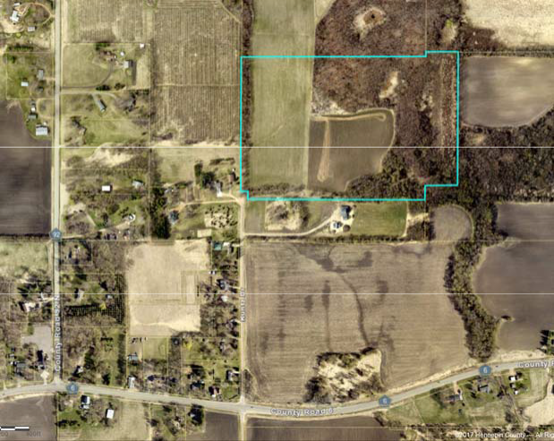

Page 1

(Reserved for Recording Information)

RELEASE OF DEVELOPMENT AGREEMENT

Date: May _, 2017

FOR VALUABLE CONSIDERATION, the following real property in Hennepin County, Minnesota, legally described on Exhibit A attached hereto is hereby released from the lien of that certain Development Agreement by and between CITY OF INDEPENDENCE , a Minnesota municipal corporation, and GARY V. KIRT, a single person, dated February 9, 1999, and recorded in the Office of the Hennepin County Registrar of Title February 22, 1999, as Document No. 3124564.

CITY OF INDEPENDENCE

STATE OF MINNESOTA )
)ss.
COUNTY OF HENNEPIN )

The foregoing instrument was acknowledged before me this day of May, 2017, by

------------
and , the ---------

and , respectively, of the City of Independence, Minnesota municipal
corporation, on behalf of the corporation.

Notary Public

THIS INSTRUMENT WAS DRAFTED BY:
Lindquist & Vennum, P.L.L.P. (ANM) 2000 IDS Center
80 S. Eighth Street Minneapolis, MN 55402-2205

EXHIBIT A

Legal Description

That part of Lot 1, Block 2, Independence Ridge, which lies north of a line 290.00 feet north of, measured at a right angle to and parallel with the most southerly line of said Lot 1 and its extensions, Hennepin County, Minnesota.

Torrens Certificate of Title No. -

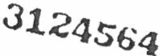.y---..#."'

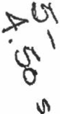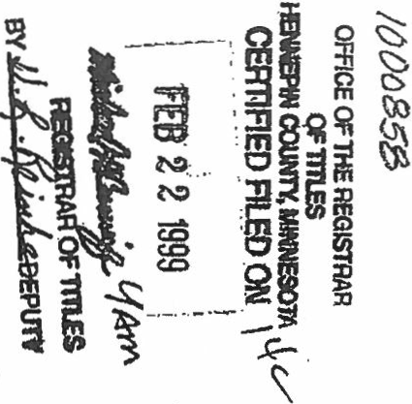

    - ox 198
Kennedy & Graven,Chartered

DEVELOPMENT CONTRACT
Execution Copy

nns AGREEMENT is made this · P- day of 1f;drµ,y,, , 1999, by and between the CITY OFINDEPENDENCE, a·Minnesota municipal corporatioty), and GARY V.KIRT,
a single person (Developer). ". . . . ··. .

Recitals

      - Developer is the fee owner of certain real estate located in Hennepin County, Minnesota. legally described on the attached Exhibit A (the "Property';).

B. Developer proposes .to develop the Property for residential land use.

- Developer has presented and received preliminary plat approval from the city council of the City for subdivision of the Property, by Resolution No. 98-0908-02, adopted on September 8, 1998 and has received final plat approval by Resolution No. 98-1221-03, adopted on December 21, 1998. The subdivision is to be called INDEPENDEN RIDGE.

- In consideration of City approval of the prel.iri\inary and final plat for the Property, Developer agrees toperfo all of the acts required and to conform to all of the conditions set forth as follows:
DEVELOPMENT CQNTRACT ARTICLE ONE
CONSTRUCTION OF IMPROVEMENTS

1.01. Agreement to Construct Improvements. Developer agrees to construct all public improvements (Improvements) required for development of the Property, as described in plans and specifications prepared by Otto Associates, dated October 13, 1998 and approved by of the City's consulting engineer, Loucks & Associates, Inc. (City Engineer) (the Approved Plans). The Improvements include construction of the public street dedicated as Wild Oiik Trail and the construction of a storm water drainage ponding facility on Lot 5, Block 1of the subdivision (the "Drainage Facility''). A copy of the Approved Plans must be filed with the city clerk-treasurer prior to commencement of construction of the Improvements. All labor and work will be done and

CAH-155516
1.·
NDllS-42

·------·------------

...

performed in the be.st and most workerlike manner and in strict conformance with the Approved Plans. Any deviation from the Approved Plans must be approved inwriting by the City Engineer.

1.02. Staking, Surveving and Inspections. Developer, through its engineer, must provide all staking, swveying and resident inspection for the Improvements in order to ensure that the completed Improvements conform to the Approved Plans. The City will provide for general inspection. Developer must notify the City Engineer of all tests to be pelformed. ·

  - Unsatisfactory Labor or Material. In the event that the City Engineer or its designated representative rejects as defective or unsuitable any material or labor supplied by the Developer, then the rejected material must be removed and replaced with approved material and the rejected labor must bedone again to the specifications and approval of the City Engineer and at the solecost and expense of the Developer.

  - Time for Develo.pefs Performance. The Developer agrees that it will commence work on the Improvements on or before May l, 1999 and will have all work done and the Improvements completed to the satisfaction and approval of the City Council of the City on Qr before November 30, 1999, except that site restoration work is not required to be completed itntil June 1, 2000. The city council may at its discretion extend the date(s) specified for completion upon receipt of written notice from the Developer of the exisnce of causes over which the Developer has no control that will delay the completion of the work. Whenever an extension of the date of completion is granted by the city council, the Developer must continue the bond or financial guaranty required by this Contract to cover the work during the extension of time.

  - Recoros. Copies of all bids, change orders, suppliers, subcontractors, et.c., relating to the work to beperformed by the Developer must beprovided to the City Engineer for its files.

1.06. Street Signs. The Developer shall be financially responsible for·the cost and installation of street identification signs. The number and location of signs to be instaned will be at the direction of the City. ·

l.Crl. Maintenance of Improvements. Developer shall be responsible for allmaintenance,upkeep and repair (including snow plowing and grading) of all public streets contained within the subdivision until said streets are completed and accepted by the City. Developer shall be responsible for all maintenance, upkeep and repair (including dredging) of the Drainage Facility until saidfacility is completed and accepted by the City. Developerhereby agrees to indemnify and hold the City harmle.ss from any and all claims for damages of any nature whatsoever arising out of Developer's acts or omissions in performing the obligations imposed upon Developer by this · paragraph.

  - Restoration. The Developer shall clear any soil, earth or debris from the street Improvements within the subdivision that is placed thereon as a result of construction on the land within the addition by the Developer or its agents, successors or assigns. The Developer shall restore any gravel base for the street Improvements if said gravel base is contaminated by mixing construction or excavation debris or earth in the gravel base and repair any damage to bituminous surfacing and/or concrete curbing of the street Improvements resulting from the authorized or unauthorized use of construction equipment The work described in this paragraph shall be

C.AH-155516
2
ND11S-42

completed within fifteen (15) days of notice by the City to Developer that repair or restoration is
required pursuant to this paragraph.

  - Additional Work or Mat.erials. All work covered by this Contract shall be done at no expense to the City. The Developer shall not do any work or furnish any materials not covered by the Approved Plans and this Contract, for which reimbursement is expected from the City, unless such work is first ordered and reimbursement is approved by the city council. Any such work or materials that may be done or furnished by the Developer or its contractor without prior written order are fwnished at the Developer's or contractor's own risk, cost and expense; the Developer agrees that it will make no claim for compensation for work or marials so done or furnished.

1.10. Final Inspection/Acceptance. Upon completion of all work required by the City Engineer or designated representativ the City Engineer and representatives of the Developer's contractor and/or engineer will make a fmal inspection of the work. Before fmal payment is made to the contractor by the Developer, the City Engineer shall be satisfied that all work is satisfactorily completed in accordance with the Approved Plans, and the Developer's engineer shall submit a written statement attesting to the same. The final approval and aeceptance of the development and Improvements shall take the f9rm of aresolution dulypassed by the city council of the City, on the advice of the City Engineer.

1.11. As-built Plans. Upon completion of the work, the Developer shallprovide the City with a
full set of as-built plans for City records.

1.12. Maintenance Bond. Upon completion of the work, the Developer and/or its contractor shall
berequired to furnish the City atwo-year maintenance bond guaranteeing said work to the City.

ARTICLE TWO
FINANCIAL GUARANTY AND REQUIRED PAYMENTS

  - Park Dedication and Fees in Lieu of De.di.cation. Jn fulfillment of park dedication requirements established by city ordinance, the Developer agrees to grant to the City of Independence an easement for equestrian trail pwposes over aportion of the Propercy, as indicated in the preliminary and final plat submissions made by the Developer and on file with the City. The easement shall be in a form reasonably acceptable to the City. The Developer shall record the easement against the Property promptly after the recording of the plat for INDEPENDENCE RIDGE and this Contract. Inaddition, the Developer agrees to pl,ty a fee inlieu of dedication in the amount of $49,748.49, prior tothe release by the City of the executed fmal plat

  - Payment of City Costs. Upon execution of this Contract, the Developer shall pay to the city clerk-treasurer a deposit in the amount of $5,000, to be used by the City to pay its out-of-pocket costs in:(a) preparing and administ.ering this Contract; (b) processing the Developer's development proposals for the Property; and (c) preparing and reviewing an environmental assessment worksheet (EAW) and environmental impact statement (EIS), if required. The out-of-pocket costs to be paid shall include, but not be limited to, aomeys' fees, engineering fees, and other technical or profes­
sional assistance, including the work of the city staff and employees. Whenever the balance remg in the fund is less than $1,000, the Developer shall, upon request by the city clerk.­ treasurer,deposit the amount required to re-establish the fund balance at $5,000. Upon completion

CAH-155516
3
NDllS-42

r
.

of all work required by this Contract, any balance remaining shall be refunded to the Developer.

  - Financial Guarantv. Prior tocommencement of construction, the Developer will furnish the City a corporate surety bond, certified check, certificate of deposit or irrevocable letter of credit (the Security), approved by the City Attorney.inthe amount of 150% of the City Engineer's estimated project costs for the Improvements. The City Engineer's estimated project costs for the Improve.. ments are set forth in Exhibit B to this Contract. H the Security is a letter of credit or bond, the Security must contain a provision that prohibits the issuer or surety from terminating the Security without first giving 30 days' written notice to the City of the proposed termination or expiration of the Security. Failure of the Developer to post a substitute Security within 5 days after notice by the City shall constitute a default that shall be grounds for drawing on the letter of credit or making a claim on the bond. The City Council may grant areduction inthe Security upon written request by the Developer based upon the value of the completed work at the time of the requested reduction: The Security may not bereduced to less than 20% of the original amount until all work required of the Developer by this Contract has been completed and accepted by the City. Upon failure of the
Developer to perform, the City may declare the Contract to be in default d the amount of the
Security shall be paid over to the City. From the proceeds of the Security, the City shall be reimbursed for any attorneys' fees, engineering fees or other technical or professional assistance, including the work of the City staff and employees, and the remainder thereof shall be used by the City to complete the Contract. The Developer shall be liable to the City to the extent that the Securlty isinadequate to reim'f?urse the City its costs and pay for the completion of the work.

ARTICLE THREE
OTHER lmQUIREMENTS

  - Indemnification. Notwithstanding anything to the contrary in this Contract, the City, its officials, agents and employees shall not be personally liable or responsible inany manner to the Developer, the Developer's contractor or subcontractor,material suppliers, laborers or to any other person or persons for any claim, demand, damages, actions or causes of action of any kind or character arising out of or by reason of the execution of this Contract or the performance and completion of the work required by this Contract to be performed by'the Developer. The Developer wm save the City, its officials, agents and employees harmless from all such claims, demands, damages, or causes of action and the costs, disbursements, and expenses of defending the same, including but not limited to, attorneys' fees, consulting engineering services, and other technical or professional assistance, including the work of City staff and employees.

  - Insurance. The Developer shall furnish proof of insurance acceptable to the City,covering any public liability or property damage by reason of the operation of the Developer's equipment. laborers, and hazard caused by the Improvements. The Developer must keep the insurance in force
at alltimes that construction on the development is in progress. The insurance must name the City as an additional insured and must provide that the insurer will give the City not less than 30 days• written noticeprior to cancellation or termination of the insurance policy.

  - Building Pennits and Occupancy. No building pennits will be issued for construction of dwelling units on 1...-0ts 6,7, 8, 10, 11and 12 of Block 1in the subdivision. until Class V gravel base for streets is inplace. Up to two (2) building permits may be issued when Cl&Ss V gravelbase is in place, and the remaining building permits may be issued after the final wear course is in place. No

CAJf-155516
4
ND115-42

occupancy of any newly constructed building in said plat shall occur until Class V gravel base for streets isinplace. The Developer shall maintain reasonableaccess to any occupied house or houses within said addition, including necessary street maintenance such as grading and graveling and snow removal priorto permanent street surfacing and acceptance of the streets by the City.

  - Drainage Facility Maintenance Agreement. The Developer agrees to execute an agreement concerning the maintenance of the Drainage Facility. The agreement shall be ina fonn reasonably acceptable to the City. The City will not accept the completed Drainage Facility improvements and will not issue a building permit for any structure on Lot 5, Block l, INDEPENDENCE RIDGE, until the Developer provides to the City clerk treasurer proof that tf1,e maintenance agreement has been recorded inthe land records of Hennepin County and that the agreement has beenjoined inby the fee owners of record and any mortgagees of said Lot 5.

  - Underground Utilities. The Developer shall contact the electric, telephone and cable companies that are authorized to provide service to the property for the .purpqse of ascertaining whether any of those utility providers intend to install underground lines within the development. The Developer agrees to comply with applicable requirements of franchise ordinances in effect in the City, copies of which are availablefrom thecity clerk-treasurer. ·

ARTICLE FOUR DEFAULT AND REMEDIES

  - Default by Developer. Inthe event of default by the Developer as to any of the work to be performed hereunder by the Developer, its successors or assigns. the City is granted the right to declare the entire sum set forth in this Contract due and payable in full, and the City may immediately bring legal action against the Developer to collect the sums covered by this Contract and/or draw upon the financial guaranty posted in conformance with paragraph 2.03 of this Contract. ·

  - Denial of Permits: Breach of any term of this Contract by the Developer or failure to comply with City ordinances shall be grounds for denial of building or occupancy permits for buildingswithin the subdivision until such breach is corrected by the Developer.

  - Rights eumulative. No remedy conferred inthis Contract is intended to be exclusive and each shall be cumulative and shall be in addition to every other remedy. The election of any one or more remedies shall not constitute a waiver of any other remedy. ·

  - Attorneys' Fees. The Developer will pay the City's costs and expenses, including attorneys' fees. inthe event a suit or action is brought to enforce the terms of thi$ Contract

ARTICLE FIVE MISCELLANEOUSPROVISIONS

5.0l. Amendment. Any amendment to this Contract must be in writing and signed by both parties.

  - Assignment. The Developer may not transfer or assign any of its o_bligations under this

CAH-155516
5
.ND11S-4

·, ..

Contract without the prior written consent of the City, which shall not be unreasonably withheld.

  - Agreement to Run with Land. The Developer agrees to record this Contract among the land records of Hennepin ·County, Minnesota immediately prior to recording the plat of INDEPENDENCE RIDGE. The provisions of this Contract shall run with the land and be binding upon the Developer and its successors in interest. Notwithstanding the foregoing, no conveyance of the Property or any part thereof shall relieve the Developer of its personal liability for full performance of this Contract unless the City expressly so releases the Developer in writing.

  - Releases. Upon sale of a platted lot by to an owner/occupant, the owner/occupant may provide to the City an instrument in recordable form that releases the lot from this agreement The City agrees to · execute the instrument, provided that at least 25 percent of the lots in INDEPENDENCE RIDGE must remain subject to this Contract until the Developer has completed all work and satisfied all of the Developer's obligations under this Contract Notwithstanding the foregoing, the City may withhold execution of the instrument if the Developer is in default of any of its obligations under this Contract at the time the request is considered. All costs of recording the partial releases arethe responsibility of the Developer orits assi or successors ininterest. .

  - Severability. The provisions of this Contract are severable, and in the event that any provision of this Contract is.found invd, the remaining provisions shall remain in full force and effect

  - Notices. All notices, certificates or other communications required to be given to City and Developer hereunder shall be sufficiently given and shall be deemed given hen delivered or when deposited in the United States mall, first class, with postage fullyprepaid and addressed asfollows:

To City:
City of Independence 1920 County Road 90 Maple Plain, MN 55359

To Developer: Gary V. Kirt
1000 Shelard Patkway, Suite 500
Minneapolis, MN 55426

With copy to: S.Todd Rapp, Esq.
15025 Glazier Avenue.Suite 401 Apple Valley,MN 55124

The City and the Developer, by notice given hereunder, may designate different addresses to which subsequent notice, certificate or other communications should be sent.
5.<11. No Third Party Beneficiarv. This Contract and any financial guarantees required pursuant to its nns are not intended for the benefit of any third party.
5.08. Applicable Law. This Contract shall be governed by and construed inaecordance with the laws of the State of Minnesota.

CAH-155516 NPUS-42
6

..

JN WITNESS OFTHE ABOVE, the parties have caused this Contract to be executed on the
date and year written above.

CITY OF INDEPENDENCE
By'yJ] J)J/..,._ .
Its Mayor ti

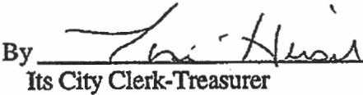

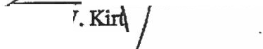

CAH•1S5516 7
ND115-42

ACKNOWLEDGEMENT FOR CITY

STAIB OF MINNESOTA )
)SS.
COUNTY OF HENNEPIN )
The foregoing inStrument · was acknowledged before me this ..2_ ay of
P . 1999, by Marvin Johnson and Toni Hirsch, the mayor and city clerk­
treasurer:respeptively, of the City of Independence, a Minnesota municipal corporation, on behalf
I NOTA P'i:s c': sorA I -
of the corporation.. 11M·•••••
•vvvvv·/\M1\NVVV M
0
'ti. WRIOHT COUNTY --.ii.- .;..;;;;.;:......;......;;.;..;;.;;.;::=-- --
N tary Public
My Comm.Expires Jan.31 2000
1
vVVINl/VVVVVWl/W •
llVVVl/INWVVINV VINI.

ACKNOWLEDGEMENT FOR DEVELOPER

STATBOFMINNESOTA )
· , )ss.
1
COUNTY OF tt"uv )
The foregoing instrument was acknowledged before me this 411 day of l=' br-11f11•
1999,by Gary V.Kllt, a single person.
MMI'
.

llOTARY PUBUc-MltlllE&OI'- N tary UbliC
H!NffEPIN coum
< '4W Comlll,E1<PlmJaa. llt2000
1vvvvr

CAH-155516 ND115-4;a
8
J

EXEilBIT A
(Legal Description of Property)

Parcel A (Abstract Property)

The Northeast Quarter of the Southeast Quarter of Section 28, Township 118, Range 24, Hennepin County, Minnesota;

The West 82 feet of the Northwest Quarter of the Southwest Quarter of Section 27, Township 118, Range 24,Hennepin County,Minnesota.

Parcel B (Registered Property, as evidenced by Certificate of Title No.1000858)

The East Half of the Southwest Quarter of Section 28, Township 118,Range 24, except that
. part of said East Half of the Southwest Quarter lying Southerly of a line drawn from a point on the South line of said Southwest Quarter distant 16.50 feet West from the Southeast comer of said Southwest Quarter to a point on the East e of said Southwest Quarter distant 16.50feet North from said Southeast comer.

Parcel C (Registered Property, as evidenced by Certificate of Title o. 1000858)

,( The west 231.00 feet of the north 942.86 feet of the Southwest Quarter of the Southeast '\ Quarter of Section 28, Township 118, Range 24, as measured along the north and west
lines,respectiyely,of said Southwest Quarter of the Southeast Quarter.

Parcel E (Abstract Property)

That part of the Southeast Quarter of the Southeast Quarter of Section 28,Township 118, Range 24, Hennepin County, Minnesota, that lies north of the south 833.78 feet thereof.

Parcel F (Abstract Property)

That part of the Northwest Quarter of the Southwest Quarter of Section 27, Township 118, Range 24, contained in the east 540 feet of the west 622 feet, Hennepin County, Minnesota

Parcel G (Abstract Property)

That part of the Northwest Quarter of the Southwest Quarter of Section 27, Township 118, Range 24, lying east of the west 622 feet, Hennepin County, Minnesota

Parcel H (Abstract Property)

The Southwest Quarter of the Southwest Quarter of Section 27, Township 118, Range 24 West, Hennepin County, Minnesota.

CAH-155Sl6
1
ND11S-42

A-1

..,.
...

Parcel I (Abstract Property)

The West one-half of the Northwest Quarter of Section 34, Township 118 North, Range 24 West of the Fifth Principal Meridian, except that part lying South of County Road No.·6, according to the United States Government Survey thereof, Hennepin County,Minnesota. ·

Parcel J (Abstract Property)

All that part of the Northeast Quarter of the Northeast Quarter of Section 33,Township 118 North, Range 24 West of the Sth Principal Meridian, Hennepin County, Minnesota, lying North of the centerline of Watertown Road and east of the west 10 rods thereof, except those parts described as follows:

Beginning at the point of intersection of the West line of the East 1155 feet (70 rods) of said Northeast Quarter of the Northeast Quarter with the centerline of the Watertown Road (County Road No. 6); then North along said West line of the East 1155 feet a distance of 198 feet; thence East parallel with said centerline a distance of 286.03 feet; thence South parallel with said West line to said centerline; thence West along said centerline tothe point of beginning;

That part of the West 300 feet of the East 625 feet of said Northeast Quarter of the Northeast Quarter lying South of the North 800 feet of said Northeast Quarter of the Northeast Quarter and Northerly of the centerline of Watertown Road (County Road No. 6).

CAH-155516 ND115-42

2

A-2

EXIIlBIT B
(F.stimated Costs)
Item description | Amount
Grading | 20,000.00
Subgrade preparation | 2,580.00
Class 5 Aggregate Base | 41,250.00
Class 2 Limestone Shoulder | 5,100.00
Type 31Bituminous Base Course | 26,400.00
Type 41Bituminous Wear Course | 14,694.00
Bituminous Tack Coat | 780.00
Subgrade Stabilization Fabric | 8450.00
Rock Construction Entrance | 500.00
Silt FenceErosion Control | 1,500.00
12"RCP Storm Sewer Cl. ill | 600.00
12"RCP FES w/ Trash Guard &Rip Rap | 600.00
6"PVC SDR 35 | 120.00
15"CMP | 800.00
15"CMP FES | 200.00
Outlet Control Structure (Complete) | 3,000.00
Site Restoration | 4.500.00
TOTAL ESTIMATED IMPROVEMENTS | $131,074.00
 | x 150%
GUARANTY FOR IMPROVEMENTS | $196.611.00 .

CAH-155516
NDllS-42

B-1

PERMIT #------

NON-CITY ASSEMBLY PERMIT APPLICATION
Fees & Definitions:

(Double fee for apphcat1on received less than 10 business days prior to event).
- 200+ Attendees (Large Assembly) = $250 | - 50+ Attendees (Small Assembly) = |  |  | $50
- 100+ Attendees (Medium Assembly) = $100 | • | Non-profit | Organizations = $25 | J

Event Location: 6755 Turner Road Maple Plain MN 55359
Type of event: Polo Classic Weekend Number of people attending: 3500 Date: _
o Residential o Corporate D Partnership o Group or Association Other
Weekend of August 4, 5, 6, 2017

Event Holder's Name: Polo for Philanthropy, Address: 4332 Brookside Ave Minneapolis MN 55436
Contact Person: Adam Southam Home Phone:-----Cell Phone: 612-998-5608
2nd Contact Person: 888-471-9355 x 701 Home Phone: Cell Phone: _

Security Plans: Teams of patron check-in, ticketing, security, first aid as prior years.
Date West Hennepin Public Safety was notified of the event:_T_o_be_d_o_ne _

Severe Weather Plans (in the event of): Evacuate to nearest Severe Weather Shelters if needed

Sound Plans - amplification and sound control: Game commentary , singers, MC, background music
Outdoor Music Yes o No - Starting Time AM/PM, Ending Time AM/PM
Friday August 4, 2017 - 5:30 pm - 11:59 PM. Sunday August 6, 2017 - 11:00 am - 5:30 pm

Food and Concessions Plans: CRAVE Catering for the majority of catering; some food trucks TBD Vendor's name, address, and license number (copies of vendor license, insurance and permits must be provided) Pauline hoogmoed, COO, 2100 Summer Street NE, Suite 50, Minneapolis, MN 55413

Vendor Work #:
l'l'leegmeed@eraveeateriflg. eeffi
Vendor Cell #
612 998 5455

763-479-0527 (Phone) 1920 County Road 90 Independence, MN 55359
http://independence.govoffice. com
763-479-0528 (Fax)

Serving Alcohol: Yes: _x Selling Alcohol: Yes: _x
No: ---
No: --- (If selling alcohol contact the City for a Permit)

Alcohol sales/service provided through CRAVE.
Restroom Provisions: How many? 1 per 1oo guests Location: skattered near dining areas

Predominately decorative LED table lights with emergency 1500w halogen construction lights Lighting - Type: How many? _ Location of lights: Throughout area where guests may be after sunset. Friday event only

$1,000,000 Certificate of Liability Insurance-provide a copy: Forthcoming. Please make approval
contingent upon receipt.
Parking Plan: Please provide a site plan showing 1 parking space for each vehicle per 4 guests. If using adjacent property, written permission from property owners must be obtained. Parking on grounds adjacen to fields as prior years Attaching 2016 site plan for reference; tent and spos r nfmes are different but site generally the same
June ?, 2017 . .S7
Date Signature of ap licant

Date Signature of applicant

Office Use Only
Appl ication Received: ----
-
Application Fee: _
Date Fee Paid: _
Date $1,000,000 certificate of liability insurance received: _
Signature of City Official
Date
Signature of West Hennepin Public Safety
Date

inneapolis
'
City of Lakes

License Number License Type

Licenses & Consumer ::terv1ct!:io
350 South 5th Street - Room 1 Minneapolis, MN 55415--1391
Office 612 -673-3000 or 311,Fax 612-673 -3399,TIY 612-673-3300

License Certificate
Expires

LIC58593
Food licenses
4/1/2018

CRAVE CATERING CRAVE CAF E
2100 SUMMER ST NE MINNEAPOLISQ, MN 55413

Location
2100 SUMMER ST NE

Endorsement Ll59 - Restaurant
Square Footage
1

POST IN A CONSPICUOUS PLACE

..i

Minnesota Department of Public Safety Alcohol and Gambling Enforcement
HAS BEEN ISSUED nns LICENSFJPERMIT BY THE STATE OF MINNESOTA PURS IANT TOMINNESO: STATUTES CHAPTBR 340A AND RELATED REGULATIONS I
ALCOHOL CATERER' SPERMIT

_. . 'i.<.. .'.·
. ,
Crave Hospitality MOA LLC
Crave
368 sAvenue/MOA
Bloomington | MN | 55425

,t1." '··'
.·-·· . ....,,.

EXPIRES
Alcohol & Gambling Enforcement Director_

_.

MINNESOTA LAWFUL GAMBLING
LG220 Application for Exempt Permit

4/17
Page 1of 2

An exempt permit may be issued to a nonprofit Application Fee (non-refundable)
org.anization that: Applications are processed in the order received. If the application
. conducts lawful gambling on five or fewer days, and is postmarked or received 30 days or more before the event, the awards less than $50,000 in prizes during a calendar application fee is $100; otherwise the fee is $150.
year.
If total raffle prize va lue for the calendar year will be Due to the high volume of exempt applications, payment of
$1,500 or less, contact the Licensing Specialist assigned to additional fees prior to 30 days before your event will not expedite your county by calling 651-539-1900. service, nor are telephone requests for expedited service accepted.
ORGANIZAnON INFORMATION
Organization . Previous Gambling
Name: This Old Horse , nc . Permit Number: none
Minnesota Tax ID Federal Employer ID
Number, if any: 091914370 Number (FEIN), if any: 45-4234611

Mailing Address: 1 9025 Coates Bl vd.
City: Hastings State: MN Zip: 55033 County : Dakota Name of Chief Executive Officer (CEO): Nancy Turner
Daytime Phone: 6128399868 Email: nturner@thiso ldhorse.org
NONPROFIT STATUS
Type of Nonprofit Organization (check one):
DFraternal DReligious DVeterans [{] Other Nonprofit Organization
Attach a copy of one of the following showing proof of nonprofit status:
(DO NOT attach a sales tax exempt status or federal employer ID number, as they are not proof of nonprofit status.)
DA current calendar year Certificate of Good Standing
Don't have a copy? Obtain this certificate from:
MN Secretary of State, Business Services Division Secretary of State website, phone numbers: 60 Empire Drive, Suite 100 "ff.WW .:iO:i,stat . mn,YS
St. Paul, MN 55103 651-296-2803, or toll free 1-877-551-6767
[{]IRS income tax exemption (501(c)} letter in your organization's name
Don't have a copy? To obtain a copy of your federal income tax exempt letter , have an organization officer contact the IRS toll free at 1-877-829-5500.
DIRS - Affiliate of national, statewide, or international parent nonprofit organization (charter}
If your organization falls under a parent organization, attach copies of QQth of the following:
1. RS Jetter showing your parent organization is a nonprofit 501(c) organization with a group ruling, and 2 . the charter or letter from your parent organization recognizing your organization as a subordinate.
GAMBLING PREMISESINFORMATION
Name of premises w here the gambling event will be conducted . .
(for raffles, list the site where the drawing will take place): Twin City Polo Club

Physical Address (do not use P.O. box): 6755 Turner Road Maple Plain MN 55359

City or Township: Maple Plan Zip: 55359 County: Hennepin
Date(s) of activity (for raffles,  indicate the date of the draw ing): August 6, 20 17  Check each type of gambling activity that your organization will conduct:  DBingo C]Paddlew heels 0Pull-Tabs DTipboards  [{]Raffle (total value of raffle prizes awarded for the calendar year, including this raffle:$  Gambling equipment for bingo paper, bingo boards, raffle boards, paddlewheels, pull-tabs, and tipboards must be obtained from a distributor licensed by the Minnesota Gambling Control Board. EXCEPTION: Bingo hard cards and bingo ball selection devices may be borrowed from another organization authorized to conduct bingo. To find a licensed distributor, go to www.mn. gov/gcb and click on Distributors under List of Licensees, or call 651-539- 1900. | l

LG220 Application for Exempt Permit
4/ 17
Page 2 or 2

LOCAL UNIT OF GOVERNMENT ACKNOWLEDGMENT (required before submitting application to the Minnesota Gambling Control Board)
CITY APPROVAL COUNTY APPROVAL
for a gambling premises for a gambling premises
located within city limits located in a township
DThe application is acknowledged with no waiting period. Drhe application is acknowledged with no waiting period.
DThe application is acknowledged with a 30-day waiting Orhe application is acknowledged with a 30-day waiting period, and allows the Board to issue a permit after 30 days period, and allows the Board to issue a permit after (60 days for a 1st class city). 30 days.
DThe application is denied. Dhe application is denied.

Print City Name: Print County Name:

Signature of City Personnel: Signature of County Personnel :

Title: Date: Title: Date:
TOWNSHIP (If required by the county)
On behalf of the township, Iacknowledge that the organization is applying for exempted gambling activity within the township limits. (A township has no statutory authority to approve or deny an application, per Minn. Statutes, section 349.213.)
The city or county must sign before submitting application to the Gambling Control Board.
Print Township Name: Signature of Township Officer:
Title: Date:

CHIEF EXECUTIVE OFFICER'S SIGNATURE (required)
The information provided in this application Is complete and accurate to the best of my knowledge. Iacknowledge that the financial report will be completed and returned to the Board within 30 days of the event date.

Chief Executive Officer's Signature: Date:
{Signature must be CEO's signature; deslgnee may not sign)

Print Name:

REQUIREMENTS MAIL APPLICATION AND ATTACHMENTS
Complete a separate application for: Mall application with:
- all gambling conducted on two or more consecutive days, or a copy of your proof of nonprofit status, and

- all gambling conducted on one day.
application fee (non-refundable). If the application is

Only one application is required if one or more raffle drawings are postmarked or received 30 days or more before the event, conducted on the same day. the application fee is $100; otherwise the fee is $150.
Financial report to be completed within 30 days after the Make check payable to State of Minnesota. gambling activity Is done: To: Minnesota Gambling Control Board
A financial report form will be mailed with your permit. Complete 1711 West County Road B, Suite 300 South
and return the financial report form to the Gambling Control Roseville, MN 55113 Board.
Questions?
Your organization must keep all exempt records and reports for Call the licensing Section of the Gambling Control Board at 3-1/2 years {Minn. Statutes, section 349.166, subd. 2(f)). 651-539-1900.

Data privacy notice: The Information requested on this form (and any attachments) will be used by the Gambling Control Board (Board) to determine your organization's qualifications to be Involved In lawful gambling activities In Minnesota. Your organization has the right to refuse to supply the Information; however, If your organization refuses to supply this Information,the Board may not be able to
determine your organization's qualifications and, as a consequence, may refuse to Issue a permit.
If your organization supplies the Information requested, the Board will be able to process the
application. Your organization's name and address will be public Information when received by the Board. All other Information provided will be private data about your organization until the Board Issues the permit. When the Board Issues the permit, all Information provided will become public.If the Board does not Issue a permit,all Information provided remains private, with the exception of your organization's name and address which will remain public. Private data about your organization are available to Board members, Board staff whose work requires access to the Information; Minnesota's Depart-
ment of Public Safety; Attorney General; Commissioners of Administration, Minnesota Management & Budget,and Revenue; Legislative Auditor, national and International gambling regulatory agencies; anyone pursuant to court order; other Individuals and agencies specifically authorized by state or federal law to have access to the Information; Individuals and agencies for which law or legal order authorizes a new use or sharing of Information after this notice was
given; and anyone with your written consent.

This form will be made available In alternative format { I.e. large print,braille) upon request.

An equal opportunity employer

City of Independence
Approval of Professional Financial Services Contract with AEM Financial Solutions, LLC

To: City Council
From: Mark Kaltsas, City Administrator
Meeting Date: June 13, 2017

Discussion:
The City has utilized AEM for all financial services during the past three years under a financial services contract. That contract ended in 2016. At that time, AEM was transitioning a new employee into the City and the City was transitioning from internal payroll to direct deposit. Staff has been working with AEM to revise the professional services contract to include an accurate scope of services. The proposed contract would be similar to the last contract and have a three-year time frame. The services provided to the City include all financial services (accounting, accounts payable, payroll, utility billing, budgeting and audit preparation and assistance). The contract amount for 2016 was $58,350. The proposed 2017 contract amount is $62,500 (see attached contract proposal). The City has budgeted $61,100 for 2017.

In order to match the financial consulting services provided by AEM, the City would need to employ a full- time employee, plus retain additional high-level accounting services. The full cost to the City for a mid- range finance employee would range between $70,000-$85,000 (salary plus benefits) and the additional consulting hours would range between $12,000-$25,000 annually. The services provided by AEM have served the City well over the past three years. The City’s accounting accuracy and record keeping has continued to improve.

Summary:
Staff is seeking City Council consideration for approval of the proposed contract.

Attachments: Proposed Contract

Page 1

Proposal

City of Independence
Independence, Minnesota
Submitted December 20, 2016

AEM Financial Solutions, LLC
Grandview Square
5201 Eden Avenue, Suite 250
Edina, Minnesota 55436
952.835.9090

Contact Persons
Steven R. McDonald, CPA 952.715.3002
steven.mcdonald@aemcpas.com

Jean D. McGann, CPA 952.715.3059
jean.mcgann@aemfinancialsolutions.com

TABLE OF CONTENTS
Letter of Transmittal 2
Welcome to ABDO, EICK & MEYERS, LLP 3
Firm Qualification and Experience
Governmental Client Services 4
Personnel 4
Agreement for Financial Services 5
Scope of Services 8
Similar Engagements with Other Governmental Entities 10
Agreement for the Provision of Professional Services 11
Appendix
A Professional Biographies

LETTER OF TRANSMITTAL

Mark Kaltsas
City of Independence 1920 Cty Rd 90
Independence, Minnesota 55359 Dear Mark,
Thank you for the opportunity to submit this proposal to the City of Independence, Minnesota (the City) for financial management services. Based on our past experience with cities of comparable size and complexity, we believe our structured contract with defined outcomes offered through AEM Financial Solutions, LLC (AEMFS) would provide the City with excellent financial management services.

We believe our solution will continue to result in the City receiving high level information, continual improvement of processes and allow the City to keep overall costs stable. Our proposal is based on the past work we have done, the needs of the City, and the experiences we have had working with other cities. The proposal outlines the scope of services we believe will address the needs of the City.

The term of this contract shall be from January 1, 2017 through December 31, 2019 with a performance review at six months.

An AEMFS representative will be in the City offices as necessary to perform responsibilities as noted on the Scope of Services page. Services will also be performed remotely as necessary.

Investment by the City for services is indicated in the financial page.

AEMFS would like to thank the City for the opportunity. We look forward to exceeding your expectations and continuing our long-term, mutually beneficial relationship.

Sincerely,

AEM Financial Solutions, LLC
an Abdo, Eick & Meyers, LLP Company

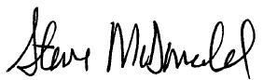

Steven R. McDonald, CPA Jean D. McGann, CPA
CEO President, AEM Financial Solutions, LLC
Partner, Abdo, Eick & Meyers, LLP

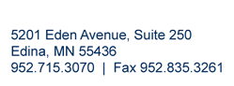

Welcome to ABDO, EICK & MEYERS, LLP

“The investments into our People and Process make a difference foryou,ourvaluedclient. Wefocusonthechallengesandneedsthat are relevant to your business or government agency. This allows us to be thoughtful in our approach in providing you with the best solutions, and leaves you assured in the value of our deliverable.”

Steve McDonald - Managing Partner

People

Hire
We focus recruiting efforts on Minnesota state colleges and universities. Innovative recruiting strategies, including a strong social media presence, allow us to attract top talent.
Train
We’ve invested in a state-of-the-art, on-site training facility and a full-time Learning Director to ensure our team is prepared to exceed your expectations.
Reward
We focus on client results and reward our team based on specific goals, not hours billed.

Process

Listen
Our process begins with listening. We invest time to better understand your goals and challenges.
Engage
Active engagement with DFK International and domestic industry associations allows us to provide maximum value to your organization.
Deliver
Combing our internal expertise and technological resources with what we’ve learned about you allows us to deliver a solution that exceeds your expectations.

Going Beyond the Numbers

FIRM QUALIFICATIONS AND EXPERIENCE
For over 50 years, we’ve helped local governments throughout Minnesota serve their communities more efficiently. As the leading governmental auditing firm in the state, we provide accounting, financial, and audit services to over 200 governmental entities. In 2009, we established AEM Financial Solutions, LLC (AEMFS) a company dedicated to providing day-to-day accounting and financial management services for local governments. The success of AEMFS stems from having over 17 years of government finance and audit experience, six years of Big Four accounting Firm, and over 50 years of providing governmental services in Minnesota.

As an integral part of your team, we work with you to deliver one-of-a-kind solutions for improving best practices in your entire organization. You can expect to work with our partners and managers to resolve issues ranging from operational effectiveness to long term planning and workflow.

AEMFS is a division of Abdo, Eick & Meyers, LLP (the Firm). Overall the Firm has a professional staff of more than 131 in its Edina and Mankato offices. AEMFS specializes in the governmental industry. The following summarizes the type of services we provide.

Governmental Client Services
Our governmental client base is composed of cities, municipalities and other public entities. They are as follows:
  - Finance director services for approximately 17 cities.
o 2 municipal clients receive the GFOA’s certificate of achievement for excellence in financial reporting
  - Process evaluation studies and recommendations
  - Operational effectiveness
  - Work flow implementation
  - Request for proposal development
  - Project feasibility analysis
  - Rate studies, long term strategic planning and capital improvement planning
  - Budget development and analysis

Personnel
AEMFS has a tremendous level of expertise and experience in providing Governmental services. Detailed biographies can be found in Appendix A. This detail will demonstrate that when combined, we have over 55 years of providing solutions to governmental entities along with over 25 years of private sector experience.

Our substantial governmental client base and commitment of staff to governmental services has provided our firm with the competence to serve your professionally and efficiently.

AGREEMENT FOR FINANCIAL SERVICES
THIS AGREEMENT, is made and entered into on January 1, 2017 by and between the City of Independence, Minnesota (hereinafter referred to as the “City”), and AEM Financial Solutions LLC (hereinafter referred to as the “Contractor”).

Articles of Agreement & Recitals

WHEREAS, the City is authorized and empowered to secure from time to time certain professional services through contracts with qualified consultants; and

WHEREAS, the Contractor understands and agrees that:

- The Contractor will act as an Independent Contractor in the performance of all duties under this Agreement. Accordingly, the Contractor shall be responsible for payment of all taxes, including federal, state and local taxes and professional/business license fees arising out of the Contractor’s activities;

- The Contractor shall have no authority to bind the City for the performance of any services or to obligate the City. The Contractor is not an agent, servant, or employee of the City and shall not make any such representations or hold himself/herself out as such;

- The Contractor shall be the exclusive outsourced accounting service provider for the City during the term of this Agreement;

- The Contractor shall perform all professional services in a competent and professional manner, acting in the best interests of the City at all times.

- The Contractor shall not accrue any continuing contract rights for the services performed under this contract. NOW THEREFORE, in consideration of the mutual covenants and promises contained herein, it is agreed as follows:

INCORPORATION OF RECITALS
ARTICLE I

The recitals and agreement set forth above are hereby incorporated into this Agreement.

LIABILITY INSURANCE
ARTICLE II

Section 1 Liability Insurance: The Contractor shall obtain professional liability insurance, at their expense with liability insurance coverage minimums in the amount of $2,000,000, which Contractor must secure and maintain during the term of this Agreement. Contractor will provide City with proof of liability insurance coverage under this Agreement in writing upon request by the City.

AGREEMENT FOR FINANCIAL SERVICES - CONTINUED
ARTICLE III
DURATION OF THE AGREEMENT

Section 1 Duration: This Agreement shall commence upon date of execution by all parties and will remain in effect until December 31, 2019 unless earlier terminated as provided in Sections 2 and 3.

Section 2 City’s Termination Rights: City may terminate this Agreement upon sixty (60) days written notice in the event the City determines in its sole discretion that it is not in the City’s best interest to continue using Contractor’s services. The City may terminate on ten (10) days written notice of the Contractor fails to perform its obligations under this Agreement.

Section 3 Contractor’s Termination Rights: Contractor may terminate this Agreement upon thirty (30) days written notice to City in the event City does not pay Contractor compensation as required under Article 5, Section 9 within fifteen (15) days after invoice is received by City. In the event of non-payment within thirty (30) days, Contractor shall give City an opportunity to cure the default by giving a notice of such non-payment and an additional five (5) days after the City’s receipt of the notice to remit such payment, prior to giving a notice of termination. Contractor can also terminate the Agreement with one hundred twenty (120) days written notice if the Contractor believes it is in its best interests to terminate the Agreement.

RENEWAL OF THE AGREEMENT
ARTICLE IV

Section 1 Renewal Period: Not less than ninety (90) days prior to the expiration of this Agreement, the City may provide written notice of intent to renew this Agreement for an additional term of up to three years upon terms and conditions agreed upon by both parties to the Agreement. If no such renewal agreement is executed by the parties, the Agreement terminates without further action of either party on December 31, 2019.

GENERAL
ARTICLE V

Section 1 Authorized City Agent: The City’s authorized agent for the purpose of administration of this Agreement is the City Administrator. Said agent shall have final authority for approval and acceptance of the Contractor’s services performed under this Agreement and shall further have responsibility for administration of the terms and conditions of this Agreement. All notices under this Agreement shall be sent to the person and address indicated below on the signature lines.

Section 2 Amendments: No amendments or variations of the terms and conditions of this Agreement shall be valid unless in writing and signed by the parties.

Section 3 Assignability: The Contractor’s rights and obligations under this Agreement are not assignable or transferable.

Section 4 Data: Any data or materials, including, but not limited to, reports, studies, photographs, negatives, or any and all other documents prepared by the Contractor or its outside consultants in the performance of the Contractor's obligations under this Agreement shall be the exclusive property of the City, and any such data and materials shall be remitted to the City by the Contractor upon completion, expiration, or termination of this Agreement. Further, any such data and materials shall be treated and maintained by the Contractor and its outside consultants in accordance with applicable federal, state and local. Further, Contractor will have access to data collected or maintained by the City to the extent necessary to perform Contractor's obligations under this Agreement. Contractor agrees to maintain all data obtained from the City in the same manner as the City is required under the Minnesota Government Data Practices Act, Minnesota Statutes Chapter 13 or other applicable law (hereinafter referred to as the "Act"). Contractor will not release or disclose the contents of data classified as not public to any person except at the written direction of the City. Upon receipt of a request to obtain and/or review data as defined in the Act, Contractor will immediately notify the City. The City shall provide written direction to Contractor regarding the request within a reasonable time, not to exceed fifteen (15) days. The City agrees to indemnify, hold harmless and defend Contractor for any liability, expense, cost, damages, claim, and action, including attorneys' fees, arising out of or related to Contractor's complying with the City's direction. Subject to the aforementioned, Contractor agrees to defend and indemnify the City from any claim, liability, damage or loss asserted against the City as a result of Contractor's failure to comply with the requirements of the Act. Upon termination and/or completion of this Agreement, Contractor agrees to return all data to the City, as requested by the City.

AGREEMENT FOR FINANCIAL SERVICES - CONTINUED
ARTICLE V - CONTINUED
GENERAL - CONTINUED

Section 5 Entire Agreement: This Agreement is the entire agreement between the City and the Contractor and it supersedes all prior written or oral agreements. There are no other covenants, promises, undertakings, or understandings outside of this Agreement other than those specifically set forth. Any term, condition, prior course of dealing, course of performance, usage of trade, understanding, or agreement purporting to modify, vary, supplement, or explain any provision of this Agreement is null and void and of no effect unless in writing and signed by representatives of both parties authorized to amend this Agreement.

Section 6 Severability: All terms and covenants contained in this Agreement are severable. In the event any provision of this Agreement shall be held invalid by any court of competent jurisdiction, this Agreement shall be interpreted as if such invalid terms or covenants were not contained herein and such holding shall not invalidate or render unenforceable any other provision hereof.

Section 7 Contractor Fiscal Decision Waiver: Contractor is responsible for providing the City with timely and accurate financial recommendations and information that allows City Council the ability to make final financial decisions. Contractor will provide final financial recommendations, but is not responsible for the final decisions made regarding financial matters.

Section 8 City Employment of Contractors Employees; Should the City desire to employ the Contractors employee that is assigned to the City during the term of this Agreement, it must have the written consent of the Contractor to enter into a City employee contract with the Contractors employee. Should the Contractor agree to such arrangement, the agreement will include a payment equal to 50% of the annual contracted cost, in addition to the annual contracted cost already paid to the Contractor. This restriction on employment applies only during the term of this agreement.

Section 9 Compensation: The parties agree that the Contractor shall be paid compensation for the services provided hereunder, payable for work performed in accordance with this Agreement, based on the fees indicated in Table 1 and under the attached scope of services. Additional fees will not be incurred without prior approval of the City.

Table 1

Services Period | Monthly Fee | Annual Fee
January 1, 2017 - December 31, 2017 | $ 5,208 | $ 62,500
January 1, 2018 - December 31, 2018 | 5,333 | 64,000
January 1, 2019 - December 31, 2019 | 5,500 | 66,000

Initial invoice will be sent within 10 days of the execution of this agreement. Monthly installment fees will be invoiced throughout the remainder of this contract.

Section 10 Additional Services: Should the City request additional services in addition to the Contracted Services, the Contractor will provide the City with proposed fees for the services to be provided. The City shall provide a written or electronic confirmation prior to the proposed services implementation.

Section 11 Outside Contractors: It shall be the responsibility of Contractor to compensate any other outside consultants retained or hired by Contractor to fulfill their obligations under this Agreement and shall be responsible for their work and Contractor, by using outside contractors, shall not be relieved of its obligations under this Agreement.

Scope of Services

Contract Task

Planned Time
City Responsibility Frame

1. Cash and Investment monitoring
Reconcile cash and investments Monthly
Review Monthly to ensure timely and accurately balance Monthly
Verify bank has proper amount of collateral pledged to City's account Request monthly collateral statement
from the bank Monthly
Review cash flow to ensure proper amounts are available for operations Monthly
- Payroll
Compile time sheets Bi-monthly
Process payroll Bi-monthly
Process payroll tax reports Monthly and
Quarterly
941 reconciliation Quarterly
- Accounts Payable
Prepare batch A/P for City Council approval Administrator to review and approve
Monthly
Prepare recap for City Council approval at council meetings Monthly
Review coding of invoices done by department heads Monthly
Issue vendor checks Monthly
Review monthly budget to actual reports for coding errors Review and provide input Monthly
- Utility Billing
Manage rate changes in billing system Annual
Process utility billing Quarterly

- Annual Reporting
Complete Financial Reporting Form to the Office of the State Auditor June

Ensure Tax Increment Finance District Reports to the Office of the State Auditor are completed
Provide prior year Tax increment
Financing District Reports August

Property Tax Levy Report to the Minnesota Department of Revenue December

PT Form 280 to the Minnesota Department of Revenue (if required) September
- Audit Preparation

Prepare work papers and gather support for the annual audit of the financial statements
Cooperation in location supporting
documentation as needed February

Prepare the Management Discussion and Analysis for the audit report Administrator to review February
- Annual Budget Preparation
Preliminary meeting with City management on budget objectives and
strategy April
Prepare a City management's recommended property tax levy along with a general outline of the City Budgeted fund including any potential budget funding gaps. This will include the all funds summary and preparation of
all budget documents May - August
Assist in presenting preliminary budget to Council prior to the deadline of
September 30 August

Update the long term financial plan and present to Council in June. This includes debt analysis and one version update.
Assist in the certification of the final of the tax levy to the County and
Work with Council and department
heads to develop plan June

Minnesota Department of Revenue December
- Miscellaneous Tasks
Provide oversight in recording/accounting for transaction Weekly
Attend Council meetings for quarterly reports and budget discussions As needed
Update Council, Administrator and staff of new accounting standards On-going
Provide assistance in reporting and closing out grant programs Monthly Respond to surveys and information requests as they are received from
outside sources such as the League of MN Cities and Government Finance
Officers Association On-going
Monitor compliance for assigned activities On-going
Prepare Sales Tax Reports On-going

SIMILAR ENGAGEMENTS WITH OTHER GOVERNMENTAL ENTITIES
We have long-term relationships with many cities in Minnesota and have provided a sample of references of those we serve as their Finance Director. Additional references are available upon request.

City of New Hope
Kirk McDonald | 763.531.5112 Engagement Partner - Steve McDonald

City of Pine City
Ken Cammilleri | 320.629.2575 Engagement Partner - Jean McGann

City of Forest Lake
Aaron Parrish | 651.209.9750 Engagement Partner - Jean McGann

City of Le Sueur
Jenelle Teppen | 507.665.6401 Engagement Partner - Jean McGann

City of Oak Grove
Loren Wickham | 763.404.7075 Engagement Partner - Jean McGann

AGREEMENT FOR THE PROVISION OF PROFESSIONAL SERVICES CITY OF INDEPENDENCE, MINNESOTA
WHEREFORE, this Agreement was entered into on the date set forth below and the undersigned, by execution hereof, represent that they are authorized to enter into this Agreement on behalf of the respective parties and state that this Agreement has been read by them and that the undersigned understand and fully agree to each, all and every provision hereof, and hereby, acknowledge receipt of a copy hereof.

City of Independence 1920 Cty Rd 90
Independence, Minnesota 55359

Name

Title

Name

Title

Date

AEM Financial Solutions, LLC 5201 Eden Ave. Suite 250
Edina, Minnesota 55436

Name

Title CEO

Date December 20, 2016

Appendix A

Steven McDonald, CPA

Mr. McDonald joined the Firm in 1991 after graduating from Minot State University with a Bachelor of Science Degree in Accounting. He currently serves as Managing Partner and during his tenure the firm has grown to a top 20 Minnesota accounting firm and a top 200 firm in the United States. Steve’s vision of continuous improvement and responsiveness to client needs has resulted leading the firm through several strategic mergers and acquisitions, new service line and industry segment development, and annual double digit growth.

When not at work, Steve enjoys cooking, reading, sports of all types and being involved in his three kids’ activities.

Managing Partner
Direct line 952.715.3002 steven.mcdonald@aemcpas.com

Qualifications
  - Advising clients on strategies that ensure sustainability and profitability
  - Structuring merger and acquisition transactions
  - Identify new business opportunities and structures that maximize growth
  - Develop process improvements that lead to greater communication and efficiencies
  - Regional and national speaker on topics relating to strategic planning, business development and internal controls
  - 26 years of experience with local governments and nonprofit organizations

Professional Memberships
  - American Institute of Certified Public Accountants (AICPA)
  - Minnesota Society of Certified Public Accountants
  - Minnesota Association of School Business Officials
  - Minnesota Government Finance Officers Association

Affiliations
  - Young Presidents Organization
  - Performance Excellence Network - Treasurer
  - Edina Community Foundation - Treasurer

Education
  - Bachelor of Science in Accounting, Minot State University
  - Continuing professional education as required by AICPA and Government Accountability Office

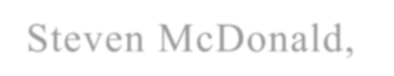

Jean McGann, CPA

Mrs. McGann joined the Firm in 2013. She is licensed to practice as a CPA in Minnesota. Jean leads the Financial Solutions group providing financial management services, day-to-day accounting and customized solutions for local governments and nonprofit agencies.

Outside of work Jean enjoys spending time with family and friends. Jean resides in Twin Cities with her husband and their 2 children.

Partner and President
Direct line 952.715.3059 jean.mcgann@aemfinancialsolutions.com

Qualifications
- 18 years of experience in government finance and auditing
- Over 7 years of experience in operations management
- Experienced in strategic planning and financial forecasting
- Experienced in identifying and implementing cost containment processes
- Policy development, internal control evaluation and project management experience

Professional Memberships
- American Institute of Certified Public Accountants (AICPA)
- Minnesota Society of Certified Public Accountants
- Minnesota Government Finance Officers Association
- Government Finance Officers Association of the United States and Canada

Education
- Bachelor of Arts, Buena Vista University, Storm Lake, Iowa
- Continuing professional education as required by AICPA and Government Accountability Office

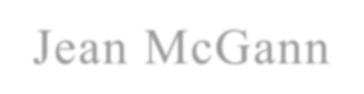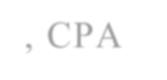

Jackie Thoennes

Jackie Thoennes joined the firm in September of 2016 as a Client Services Accountant. Jackie has over 20 years working in local government finance.
She specializes in working with utility billing, payroll, fund accounting, and point-of-sale along with various accounting functions.

When not working, Jackie enjoys spending time with her family and attending her daughters sporting events. Some of her favorite pastimes include being at the lake and cheering on the MN Vikings/Twins.

Client Services Accountant
Direct line 952.715.3066 jackie.thoennes@aemfinancialsolutions.com

Qualifications
- 20 years of experience working with local governments in finance
- Works extensively with Utility Billing, Accounts Payable, Accounts Receivable, Payroll, Point of Sale, and Budget Process
- Payment Service Network (PSN)

Professional Memberships
- American Payroll Association Northstar Chapter

Education
- Minnesota Certified Municipal Clerk
- Continuing professional education

City of Independence
Amendment to Stormwater Pond Maintenance Agreement

To: City Council
From: Mark Kaltsas, Administrator
Meeting Date: June 13, 2017

Discussion:
The City approved the Franklin Hills Third Addition Subdivision and associated documents in 2015. The developer recently approached the City requesting an amendment to the stormwater pond maintenance agreement. The developer originally agreed to place the responsibility for the stormwater pond on his own property (Lot 5, Block 1) and the property upon which the pond was located (Lot 4, Block 1). The developer is now asking that the City amend the maintenance agreement to include four lots within the development rather than two lots. The lots with just an “X” where originally included in the agreement. The lots with a circle around the “X” would be added to the agreement and become proportionality responsible for the agreement.

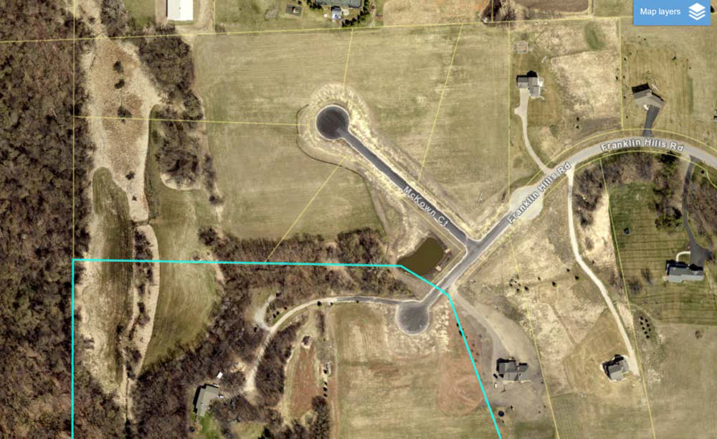

Page 1

Lots 2,3,4 and 5, Block 1 would be included in the agreement. Staff is supportive of the requested amendment to the agreement. The City attorney prepared the proposed amendment to the agreement.

Summary:
The City Council is being asked to consider approval of the amendment to the Stormwater Maintenance Agreement.

ATTACHMENTS: Franklin Hills Third Addition Final Plat

Page 2

Torrens
Certificate of Title Nos. 1397604, 1397605, 1397606 and 1397607

AGREEMENT TO MAINTAIN STORMWATER POND

THIS AGREEMENT is made and entered into as of the
day of
, 2017,

by and between James D. Franklin and Lynda L. Franklin, as Trustees of the James & Lynda Franklin Family Trust (“Owner”), and the City of Independence, a Minnesota municipal corporation (“City”).

WITNESSETH:

WHEREAS, the Owner owns certain real property located in the City of Independence, County of Hennepin, State of Minnesota, legally described as:

Lot 2, Block 1, Franklin Hills Third Addition; Lot 3, Block 1, Franklin Hills Third Addition;
Lot 4, Block 1, Franklin Hills Third Addition; and Lot 5, Block 1, Franklin Hills Third Addition.

(together, the “Properties”)

WHEREAS, the City approved the subdivision and platting of Franklin Hills Third Addition subject to the Owner establishing certain drainage and utility Easement over Lots 4 and 5, Block 1, Franklin Hills Third Addition suitable for temporary ponding of storm runoff as depicted in Exhibit A (the “Easement”), and entering into this Agreement with the City governing operation and maintenance of the pond and associated runoff facilities in the Easement.

WHEREAS, the Easement and this Agreement shall be recorded in the County’s real estate records.

NOW, THEREFORE, in consideration of mutual covenants of the parties set forth herein and other valuable consideration, the receipt and sufficiency of which are hereby acknowledged, the parties agree as follows:

495172v3 CBR ND115-7

- Maintenance of the Pond. The Owner, and its successor or assigns as fee owner(s) of the Properties, shall be responsible for maintaining the pond in the Easement and observing all applicable laws governing the operation and maintenance of such runoff facilities. The Owner shall provide the City with a schedule acceptable to the City for inspection of the pond and outlet control structure. The Owner, and its successor or assigns as fee owner(s) of the Properties, shall make all such scheduled inspections, keep record of all inspections and maintenance activities, and submit such records annually to the City. The cost of all inspections and maintenance, including skimming and cleaning of the pond, shall be the obligation of the Owner, and its successors or assigns as the fee owner(s) of the Properties.

- City’s Maintenance Rights. The City may enter the Easement and maintain the pond if the City reasonably believes that the owner(s) of the Properties have failed to maintain in accordance with this Agreement or applicable law. In such case, the City shall reasonably endeavor to give thirty (30) days’ notice of such failure to such owner(s) prior to undertaking maintenance activities. In the event of an emergency as determined by the City Administrator, no advance notice of failure to maintain shall be required. If maintenance is not completed within thirty (30) days, the City may make access over the Properties and enter the Easement to perform maintenance. In such case, the City shall send an invoice of its reasonable maintenance costs to the Owner, or its successors or assigns.

- Assessment of Costs. The Owner, and any successors or assigns as fee owner(s) of the Properties, shall reimburse the City for all costs incurred to maintain the pond and enforce this Agreement, including reasonable attorneys’ fees, within thirty (30) days of receipt of an invoice as provided in paragraph 2. If the City is not promptly reimbursed in full, the Owner consents to the City levying special assessments against the Properties in a total amount not to exceed the City’s actual invoiced costs, all in accordance with Minnesota Statutes Section 429.061. The Owner waives notice of hearing and hearing on the special assessments authorized by this Agreement, waives the right to appeal such special assessments, and agrees that all requirements of Minnesota Statutes Chapter 429 are waived by the Owner. Any special assessments levied against the Properties shall be payable over a reasonable period of time to be determined by the City, commencing at a time determined by the City, bearing interest at a rate determined by the City Council with such interest accruing from the date levied. Nothing herein shall preclude the City from levying additional special assessments against the Property for public improvements.

- Hold Harmless. The Owner, and any successors or assigns as fee owner(s) of the Properties, agree to indemnify and hold harmless the City and its agents and employees against any and all claims, demands, losses, damages, and expenses (including reasonable attorneys’ fees) arising out of or resulting from their, or their agents or employee’s, negligent or intentional acts, or any violation of any safety law, regulation or code in the performance of this Agreement, without regard to any inspection or review made or not made by the City, its agents or employees or failure by the City, its agents or employees to take any other prudent precautions. In the event the City performs maintenance under this Agreement, the Owner, and any successors or assigns as fee owner(s) of the Properties, shall indemnify and hold harmless the City, its employees, agents and representatives for its own negligent acts in the performance of work under this Agreement.

- Notice. All notices required under this Agreement shall either be personally delivered or be sent by certified or registered mail and addressed as follows:
495172v3 CBR ND115-7 2

To the Owner:
James D. and Lynda Franklin
6615 Franklin Hills Road Independence, MN 55359

To the City:
City of Independence City Administrator
1920 County Road 90
Independence, MN 55359

Upon the sale of any of the Properties, the Owner shall provide updated notice and contact information to the City. All notices shall be deemed given when personally delivered or two (2) business days after being placed in the mail properly addressed as provided herein.

- Successors. All duties and obligations of Owner under this Agreement shall also be duties and obligations of Owner’s successors and assigns.

- Effective Date. This Agreement shall be binding and effective as of the date hereof.

James D. Franklin and Lynda L. Franklin, as Trustees of the James & Lynda Franklin Family Trust

James D. Franklin

Lynda L. Franklin

STATE OF MINNESOTA )
) ss.
COUNTY OF HENNEPIN )

The foregoing instrument was acknowledged before me this
day of
, 2017,

by James D. Franklin and Lynda L. Franklin, as Trustees of the James & Lynda Franklin Family Trust.

Notary Public
(Notary Public Seal)

495172v3 CBR ND115-7 3

City of Independence, a Minnesota Municipal Corporation

By:
Marvin Johnson
Its: Mayor

By:
Mark Kaltsas
Its: City Administrator

STATE OF MINNESOTA )
) ss.
COUNTY OF HENNEPIN )

The foregoing instrument was acknowledged before me this
day of ,

2017, by
and
, the Mayor and City

Administrator of the City of Independence, a Minnesota municipal corporation, on behalf of said municipal corporation.

Notary Public

(Notary Public Seal)

This instrument drafted by: Kennedy & Graven, Chartered 470 US Bank Plaza
200 South Sixth Street Minneapolis, MN 55402

495172v3 CBR ND115-7 4

EXHIBIT A
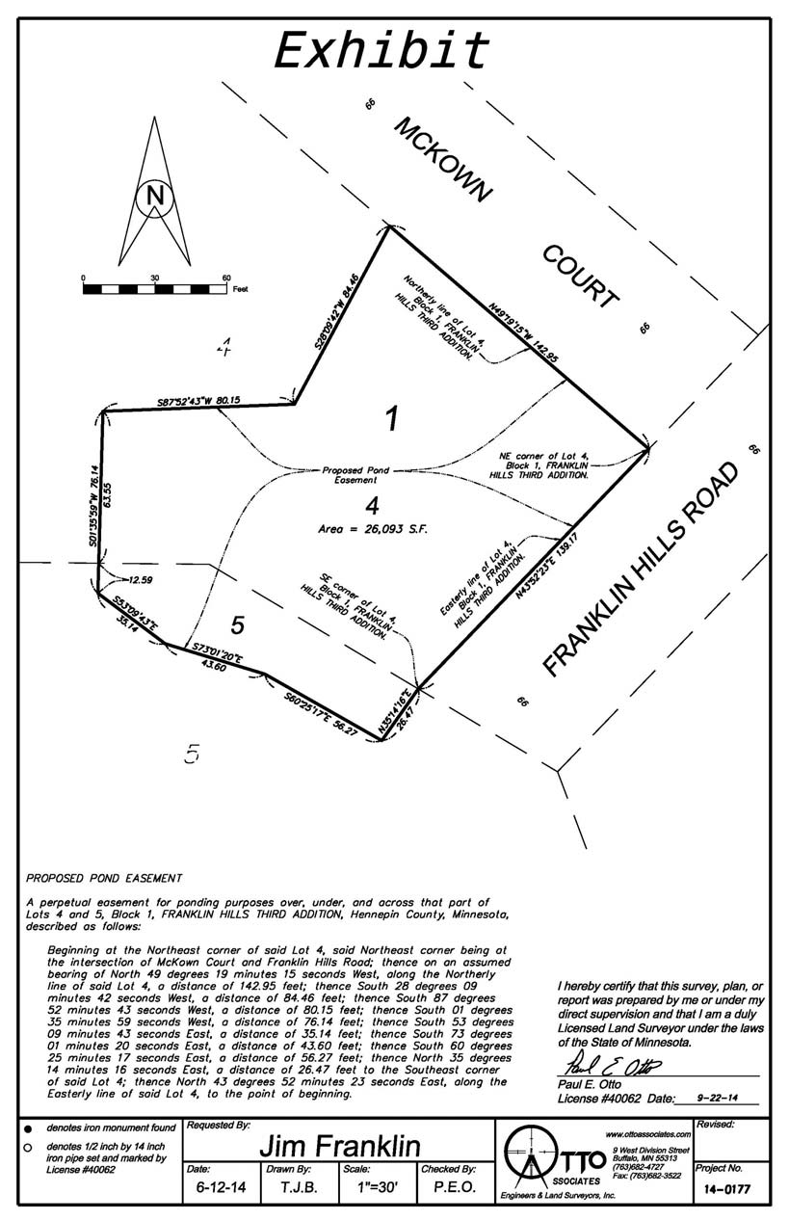
495172v3 CBR ND115-7 5

Date: May 9, 2017

To:

From: SUBJECT:
Public Safety Commissioners
City of Independence Council Members City of Maple Plain Counci e· mbers Director Gary Kroells LY·\ 11
' ( 7
APRIL 2017 ACTIVITY REPORT

The purpose of this report is to give the reader a quick overview of the activities of the Public Safety Department each month. It also compares monthly and year-to-date informat ion to the reader.

The report is broken down into five categories , as defined by the Criminal Justice Reporting System.

CRIMINAL-- Criminal is broken down into Part I and Part II crimes.

Part I includes crimes against persons versus crimes against property ; c:-iminal homicide, forcible rape, robbery assault , aggravated assault , burglary -break ing or entering, larceny-theft , larceny ana lysis , motor vehicle theft and arson.

Part II includes other assaults , forgery and counterfeiting, fraud, embezzlement , stolen property, buying, receiving, possession; vandalism , weapons , carrying, possessing, etc.; prostitution and commercialized vice, sex offenses; drug abuse violations, gambling, offenses against the family and children, driving under the influence, liquor laws , drunkenness , disorderly conduct , vagrancy , all other offenses , suspicion, curfew and loitering laws - persons under 18; and runaways - persons under 18.

TRAFFIC-- Includes violations of the road and driving laws.

PART Ill-- Lost and Found: Includes lost and found persons, anima ls, and property , and stalled and abandoned vehicles.

PART IV-- Casualties: Includes all motor vehicle accidents , boating, and snowmobile; public home occupational accidents, fires, suicides , sudden deaths , burning permits, and burning violations.

PART V-- Miscellaneous Public: Includes open doors, gun permit applications, susp1c1ous activities, animal complaints, motorist assists, alarm calls, parking complaints, house checks, driving complaints, civil matters, family disputes , department assists.

The balance of the report shows the total number of incidents handled, miles driven and how the Public Safety Department received calls. If anyone should desire more detailed statistical data , please contact my office.

\\WHPS#O\share\monthlyactiv1tyreport\2017/lettertocouncilmonthlyreport docx

\Vest Hennepin Publi c Safel y Depa rtment
1918 County Road 90 I Maple Pla 111 , M innesota 55359
Phone. (763 J 479-0500 I Fax· (763) 479 0504
Web Add ress: http:/ I wuw.u·esthe11nep111 com E-maii: u esthurnepin@west hennep111.com

Monthly Activity Report April 2017
This I Same Month I  Offense I Month Last Year | This Year I ILast Year  To Date To Date
I I I
I
City Of I ndependence I I I I
I I l
! I I I
Criminal I 9" 10i 30 1 31
I I I
Traffic 167 1871 709 , 730
Part Ill I 7 1 12 26 j 50
I I I
Part IV l 30 32 I 131 130
1
Part V I I 132 155[ 539 j 559
' : I i I i
I
Total City of Independence ; 345 396 1,435 1,500
! I I J I
City Of Maple Plain I I l I I
I I l
I
Criminal I I 71 51 I 13j I 20
1
Traffic 84 62 365j 240
Part Ill j 5 al 15 1 19
Part IV I I 17! 17 55 ' l 93
I I l I
Part V 100 133 477 1 481
1 I ' I I
I
-
Of Maple Plain I 213 226 925 853
Total City
I I I I
Grand Total Both Cities I 558 622 2,360 2,353
Agency Assists I I 3:1 2 l I
TZD 24 j 0
I 180 I 64
r
otal ICR Reports 597 643 2,540 2,417
I
I I I I 48,0321 I
I I

Mileage 11,380 11,691 46,718
l j l ' I i.
r l I
How Received I I
Fax i 11 171 l 51 ' i 57
l • I 1 2 l 7 I 7
In Person 21 44 101 182
Mai
Other 3 3 I 11 24
I
31 36 102 130
Phone
Radio 188 210 6791 I 756
I j
Visual 321 304 1,435 1,104
Email ' I 3 4 ' I 121 I 16
Lobby Walk In 18 23 I 142' I 141
Total I 5971 6431 | 2,540 1 I 2,417

MonthlyActivityReport2017 .xlsx

April2017 Criminal Part I& II
City of Independence Grid #'s 3-5

AGN | ICR | Title | Create Date |  |  | Grid # | Reported  Date | MOC  range
WHPS | 17001977 | 4th Degree DWI | 4/1/2017 |  |  | 3 | 4/1/2017 | JG501
WHPS | 17001982 | Damage to Property I Mailbox | 4/2/2017 |  |  | 4 | 4/2/2017 | P3119
WHPS | 17002070 | 4th Degree DWI | 4/7/2017 |  |  | 3 | 4/7/2017 | JGWOl
WHPS | 17002094 | Domestic Assault I DANCO Violation  (Domestic Assault No Contact Order) | 4/8/2017 |  |  | 3 | 4/8/2017 | N3380
WHPS | 17002176 | Driving after Cancel - IPS I Open Bottle
WHPS | 17002292 | 3rd Degre CSC | 4/19/2017 |  |  | 3 | 4/19/2017 | 5003
WHPS | 17002387 | Theft Motorcycle - Dirt Bike and  Snowmobile Trailer | 4/24/2017 |  |  | 3 | 4/24/2017 | TB029
WHPS | 17002408 | Fraud/Identity Theft | 4/25/2017 |  |  | 3 | 4/25/2017 | U3730
WHPS | 17002534 | 4- liquor Underage Consumption of Alco hol I Liquor - Juvenile - Alcohol Offender under 18 years |  | 4/30/2017 |  | 3 | 4/30/2017 | M4140

City of Maple Plain Grid # 1-2

AGN | ICR | Title | Create Date | Grid # | Reported  Date | MOC  range
WHPS | 17001964 | Possess Small Amount of Marij uana I  Driving after Revocation | 4/1/2017 | 2 | 4/1/2017 | DA540
WHPS | 17002030 | Theft | 4/5/2017 | 2 | 4/5/2017 | TGOll
WHPS | 17002158 | Minor Consumption of Alcohol  /Possession of Drug Paraphenalia | 4/12/2017 | 2 | 4/12/2017 | M4140
WHPS | 17002278 | Attempted Burglary/Criminal Damage  to Property | 4/18/2017 |  | 1 4/18/2017 | TR999
WHPS | 17002279 | Attempted Burglary/Criminal Damage to Property | 4/18/2017 | 1 | 4/18/2017 | TR999
WHPS | 17002342 | Shoplifting/Theft | 4/21/2017 |  | 1 4/21/2017 | U1280
WHPS | 17002351 | Theft/Fraud Report | 4/22/2017 | 2 | 4/22/2017 | T0019

April 2017 Criminal Part I& II Towards Zero Death Grant Shift
AGN | ICR | Tit le | C reate Dat e | Grid # | Reported  Date | MOC  range
WHPS | 17002304 | 3rd Degree DWI | 4/20/2017 | 72 | 4/20/2017 | JFWOl

1000
THREE YEAR COMPARISON OF POLICE CALLS FOR SERVICE & ACTIVITY

900

800

700

600

500

400

300

200

100

0

Jan Feb Mar Apr May June Julv Aug Sept Oct Nov Dec

•15 Total 16 Total
17 Total

DIRECTOR'S NEWS & NOTES
WEST HENNEPIN PUBLIC SAFETY
April 2017 Activity Report

Year to Date Activity Report

At the end of April 30, 2017 West Hennepin Public Safety (WHPS) handled a total of 2,540 incident complaints, 925 incidents in Maple Plain and 1,435 in Independence. For the month of April 2017, WHPS handled 217 incidents in Maple Plain and 383 in Independence. This is an increase of 123 incidents compared to the same time frame last year.

The Criminal Part Iand Part II cases for both cities have been highlighted for your review on the attached documents.
Recent Highlighted Cases: 4th Degree OWI
April 1 11:39 p.m. At Highway 12 I Co Rd 92N, Independence . Motorist was stopped for failing to dim the vehicle headlights. Anthony Christopher Polman, 25 from Buffalo submitted a breath test which resulted in .09 breath alcohol concentration. Polman was arrested, charged with 4th Degree DWI and released to a family member.

Personal Injury/ Motor Vehicle Crash
April 3 6500 Highway 12, Independence. Driver of a vehicle westbound on Highway 12 turned in front of an eastbound vehicle, striking the rear passenger side. The WB driver believed she had enough time to turn and did not realize how close the eastbound vehicle was. EB driver had an injury to her left hand, it was swelling and she refused medical attention. WB driver was issued a citation for "Failure to Yield"

Business Alarm
April 4 Kitchen fire in the Discovery Center, 5050 Independence Street, Maple Plain. Staff was able to extinguish the active flame and no damages were noted. All school students, staff, and city employees had evacuated the building. MPFD responded and ventilated the kitchen and hallways with fresh air to remove the smoke. After MPFD cleared the building of smoke; the school students, staff and city employees were allowed back into the building.

Narcotics Complaint
April 4 Client at Vinland Center, Independence reported his roommate was doing meth in their bedroom and had a meth pipe. The room was searched and neither the meth nor the pipe was found.

Mutual Aide
April 4 Vinland Center, 3675 lhduhapi Trail, Independence . Olmstead County Probation Officer reported an Authorization to Apprehend for a client that had violated probation by admitting use of drugs. Before Police arrival; the client and another female had left the facility by taxi and were dropped off at the Ridgedale Mall in Minnetonka. They were not located and Minnetonka PD was notified they were in their area.

Theft
April 5 1500 Wyman Ave., Maple Plain. Reported theft of cash, mostly in coins stolen from a resident. Case is under investigation.

Suspicious Activity I Burglary Attempt
April 5 4200 Woodhill Dr, Independence . Homeowner reported during the night his dog woke him up with his barking. The next day he discovered the sliding door on the back of the house was open. Nothing was missing. Case under investigation.

Grass Fire
April 6 Caller reported a lot of smoke coming from the Fieldstone area. Found at 6100 Stone Court, Independence an approved DNR and WHPS burn permit for a 3 acre running grass fire. All was ok.

Fraud Attempt
April 6 1400 Rainbow Ave., Maple Plain. Resident advertised a couple of chairs on Craig's List. A buyer from Ml answered the ad and sent a check for payment of the chairs and for the resident to pay the shipping company he was arranging to pick them up. The check
was deposited in the bank and 2 days later the resident's bank advised him the check was fraudulent and no good. The resident had not shipped the chairs, he was not out any money and his bank wanted it reported to the Police.

Crash I 4th Degree DWI
Apr 7 Police responded to a single car crash Baker Park Rd I Perkinsville Rd, Independence .
The driver Laura Ursula Dimler, 40 from Watertown was found under the influence of alcohol. Dimler submitted a breath test which resulted in .12% breath alcohol concentration. Dimler was arrested for 4th Degree DWI and was released to a sober person.

Suspicious Alarm
Apr 7 10:59 p.m. 5100 Pioneer Creek Drive, Maple Plain. Business owner called Police requesting to check his business as someone had accessed the building and disabled the alarm. Police made contact with two persons inside the business who were fixing a tire. The owner was advised of the findings and said it was ok for them to be there.

Barking Dog
Apr ? 11:51 p.m. Police responded to a complaint of a dog that have been barking for over an hour at 5800 Maple Ridge Dr, Maple Plain. The residence with the barking dog was located and the owner was not at home.The homeowner was called who said he would be home as soon as he could. The caller was advised of the findings who decided to shut her windows for the night.

Suspicious Person
Apr 8 9:09 p.m. 5800 Highway 12, Maple Plain. Business owner found a male and vehicle were at the rear of his property. The male driver had a headlamp strapped to his hat, stated he had stopped to urinate and then left. The property was checked and did not find anything missing.

Domestic I DANCO Violation
Apr 8 10:23 p.m. Reported a domestic in the 900 Co Rd 19, Independence. Reported a male was intoxicated and had pushed a female. The female had a DANCO order (Domestic Abuse No Contact Order) against the male. A warrant was issued for his arrest.

Agency Assist I Theft
Apr 9 5:16 a.m. WHPS responded to a call of theft of rims and tires stolen in the city of Minnetrista. Police stopped the described truck at Co Rd 6 I Co Rd 92, Independence. The occupants and truck were turned over to Minnetrista PD for investigation.

Dog Complaint
Apr 9 5000 Highway 12, Maple Plain. Caller reported a dog was in her yard being aggressive towards her dog. The dog was impounded and the owner was issued a letter for potentially dangerous dog.

Abandoned Vehicle
Apr 10 1500 Howard Ave. Maple Plain. Business reported a vehicle had been abandoned in their parking lot for a week. Contact with the registered owner who stated he had left his vehicle in the parking lot in the a.m. to car pool to a construction site. He was advised
to use the Park N Ride off of Baker Park Rd, Maple Plain for carpooling.

Dog Complaint
Apr 11 7300 Co Rd 11, Independence . Reported two dogs were running around. The dog owner was not located. One dog was found and taken to Cross Roads. Later it was reported the second dog that had been running was discovered in a pool and had drowned .

Chimney Fire
Apr 12 6900 Pagenkopf Rd, Independence . Police and Maple Plain Fire responded to a chimney fire and excessive smoke coming from the chimney. MP Fire extinguished the fire that had started in the chimney. No injuries.

Suspicious Act I Minor Consumption I Drug Paraphernalia
Apr 12 8:42 p.m. 5100 Highway 12, Maple Plain. Employees reported an occupied vehicle was parked in the business parking lot. Police had contact with the 19 year old male driver from Maple Grove and 21 year old passenger from Wayzata. The driver was found to be in possession of drug paraphernalia and under the influence of alcohol; submitted a breath test of .014% Breath Alcohol Concentration. He was issued a citation for Minor Consumption and Possession of Drug Paraphernalia.

Fall
Apr 14 4:36 p.m. Police responded to a male who had fallen 6500 Genaker Way, Independence . Police found the male lying on the sidewalk. He was heavily intoxicated,
submitted a preliminary breath test which resulted in .33% breath alcohol concentration . He was transported by ambulance to the hospital.

Warrant Arrest
Apr 15 6:20 p.m. Reported there was an Anoka County 2nd Degree Narcotics Warrant for a 35 year old female at Vinland Center, Independence . The female was arrested and transported to Hennepin County Jail.

Medical
Apr 15 9:40 p.m. Responded to Vinland Center, Independence for a 24 year old patient who attempted to harm herself by cutting herself. She was transported to the hospital by ambulance.

Missing Person
Apr 16 Vinland Center, Independence reported a male had left the facility after he asked to get out of treatment for Easter was told no. He was not located and was entered into NCIC

as a missing person. On Apr 191
h
the male called stating he was okay. He was removed

from NCIC.

Pain
Apr 17 4:35 a.m. Male at Vinland Center, Independence reported he had a migraine and asked for an ambulance. Upon arrival the male was not interested in talking with the Police.
North Memorial Ambulance arrived and the male refused transport by ambulance.

Walk Away
Apr 18 2:07 p.m. Vinland Center, Independence reported a patient said he did not want to be there and left on foot, stating his brother was going to pick him up. He was not located and his probation officer issued a warrant for him.

Theft I Property Damage
Apr 18 5300 Pioneer Creek Drive, Maple Plain. Padlocks from two storage units were cut off and the units accessed. Preliminary check of the units, nothing was found missing I stolen.

Car Theft Recovery
Apr 19 7900 Co Rd 11, Independence . Resident reported his vehicle had been stolen from his residence and he had an idea who had it. Police investigation found the vehicle in Bloomington. Theft charges pending; Resident deciding if he wants to pursue charges for the vehicle theft.

Welfare Check-Warrant Arrest
Apr 19 10:51 p.m. Police were dispatched for a welfare check for a sister who is living in her car. Police found the vehicle was found parked with its lights off, behind a boat in the back of 5100 Industrial Street, Maple Plain. The male passenger argued with the Police, refused to ID himself and follow directions. He was removed and handcuffed until he could be identified. He was identified as Zachary Todd Smith, 31, Big Lake who had a Warrant out of Chisago County for Obstructing Legal Process and a Probation Violation and an unserved Order for Protection. Smith was served the OFP and was
transported to Hennepin County Jail on the Warrant. The driver, 24 year old female from Harris was released and told to make arrangements for a place to stay.

3rd Degree DWI
Apr 20 12:56 a.m. Police were on their way the back from Hennepin Co Jail when a vehicle was approaching the squad car from behind at a high rate of speed of 85 mph at Highway 12 I Ferndale Rd, Wayzata . Driver Nellie Juniper Marshall, 27 of Minnetonka submitted a breath sample which resulted in .20% Breath Alcohol Concentration .
Marshall was arrested for 3rd Degree DWI and transported to Hennepin County Jail.

Shoplifting I Theft
Apr 21 Theft of liquor from M & M Wine & Spirits. A male and female leaving the store were stopped by the store owner who found and removed a bottle of alcohol from the females hand bag. After they left; the store video was reviewed and showed the male had removed a bottle from a shelf, concealed it under his clothing and left the store. Chris Larry Fundingland, 53 from Long Lake was cited for Theft - Shoplifting and Driving after Revocation; Female, Grace Ann Remington, 50 Montrose was cited for Shoplifting.

Crash
Apr 22 Baker Park Rd I Highway 12, Maple Plain. Motorist was about to stop for another vehicle ahead of her when her vehicle was rear ended. The striking driver stated she saw the light turn green and thought the other vehicles ahead of her started moving. Both drivers were wearing their seatbelts, no injuries. Moderate damage to vehicles and they were driven from the scene.

Illegal Dumping
Apr 23 Pioneer Creek Rd I Quaas Cutoff, Independence . Resident reported a silver SUV with a trailer had dumped two full size bed mattresses in the ditch. The caller did not see it happen, described the SUV as possibly a Mitsubishi Montero occupied by three white males. Photos were taken of the mattresses, tire tracks and foot prints left behind.

Community Relations
Apr 23 Prairieland I Clayton, Maple Plain. Police observed a dad and son playing catch in the street and offered to run radar on the youngsters pitching speed. The juvenile threw 32 mph, 36 mph and then 38 mph.

Landlord I Tenant
Apr 24 1500 Howard Ave., Maple Plain. Tenant felt she was being held hostage and not being

allowed to move-out of her apartment when she wanted on June 151
.
Management

advised all she has to do is provide a 30 days' notice on her intention to move out. Police helped mediate the conversation and the Tenant understood what is required to move out and thanked the Police for their help.

Theft
Apr 24 1200 Co Rd 19, Maple Plain. Reported theft of a motorcycle and trailer. The case is under investigation.

Assisted Hennepin County Sheriff's Office I Vehicle Locked Child Inside
Apr 29 8400 Greenfield Rd, Greenfield. Police responded to a report of a vehicle lockout with a child inside the car. Police found a child inside the locked vehicle. While Police attempted to unlock the vehicle, the driver contacted OnStar. OnStar remotely unlocked the vehicle.

Disturbance/ Minor Consumption
Apr 30 7:03 a.m. Reported a male and female were arguing alongside a stalled car at 4800 Co Rd 6, Independence . Police contact with the male and female who are in a relationship and were arguing because the male was talking to another girl. The male was going to leave, nothing physical happened.While talking with all persons, Police found several occupants of the car had been drinking. Several of them were cited for consuming alcohol under 21; Jeffrey Lee Sample, 20 Columbia Heights, Devon Allen James Brandt, 20 from Big Lake, Trenton William Mutchler, 18 from Elk River. A 17 year old female from Elk River submitted breath test which resulted in .07% Breath Alcohol Concentration was cited for Under the Influence of Alcohol. Her mother was contacted and picked her up.

City of Independence
Consider Amendment to the City’s “No Wake” Ordinance – Section 915

To: City Council
From: Mark Kaltsas, City Administrator
Meeting Date: June 9, 2017

Discussion:
The City adopted an amended ordinance last fall to match the language incorporated by the City of Greenfield. The City submitted a draft to the DNR for review following adoption last fall. It was noted by the DNR that both cities would need to hold a public hearing prior to adoption of the ordinance amendment. The proposed amendment has not changed from last fall. Greenfield will also be holding a public hearing in June to review the amendment.

In an effort to maintain the “same” ordinance, staff is recommending that the City adopt a revised ordinance which would be identical to that which was recently adopted by the City of Greenfield. The ordinance numbers would not change as a result of the new adopted language. A copy of the proposed changes is attached to this report.

Summary:
The City has prepared an ordinance for adoption by the City Council. Following adoption of the ordinance, further coordination will be made with Greenfield, Hennepin County and the Department of Natural Resources.

ATTACHMENTS: City of Independence Ordinance 2017-02
Greenfield Ordinance 2016-03

Page 1

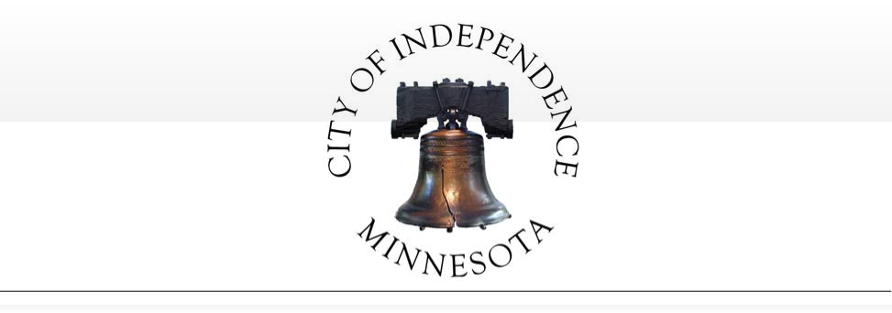

CITY OF INDEPENDENCE COUNTY OF HENNEPIN STATE OF MINNESOTA

ORDINANCE NO. 2017-02
AMENDING CITY CODE SECTION 915 -REGULATION OF LAKE SARAH AND LAKE INDEPENDENCE SURFACE USE

THE CITY COUNCIL OF THE CITY OF INDEPENDENCE, HENNEPIN COUNTY, MINNESOTA, ORDAINS:
Section 1. Section 915 of the City Code is amended as follows (additions shown as bold/double underline; deletions shown as strikethrough):

Section 915 - Regulation of Lake Sarah and Lake Independence Surface Use

Subd. 2. No-wake at high water level. Whenever the waters of Lake Sarah reach or
exceed 981.1 feet above sea level, for a period of three consecutive days or more, as measured by the water level gauge set by the State Department of Natural Resources on Lake Sarah, the city administrator-clerk or designee may, at their discretion, upon notifying the Hennepin county sheriff, establish a slow no-wake zone on those portions of the lake within the city. The no wake restriction shall become effective upon a date specified by the city administrator-clerk and shall remain in effect until the water level for the lake has receded below 981.1 feet above sea level. Both the implementation and removal of these restrictions must be done in coordination with similar actions by the city of Greenfield. The city administrator-clerk or designee shall notify the public of both the implementation and removal of the no-wake restriction by publishing a notice in the official newspaper, posting the restriction at all public lake access points prior to and during the time the restriction is in place, and posting the restriction at city hall, and by such other means as the administrator-clerk determines to be reasonable.

Subd. 3. No-wake regulation. No person shall operate a water craft, including aircraft, in excess of slow no-wake speed 24 hours per day when the high water slow no-wake restrictions in subdivision 2 are in effect. Such restrictions shall become effective upon publication in a local daily newspaper as a news item or on a specified date, whichever is later. (Added, Ord. No.
2002-09)

Subd.4. Effective Date of slow no-wake regulation. A slow no-wake restriction shall become effective upon the date specified by the city administrator-clerk and shall remain in effect until the water level for the lake has receded below 981.1 feet above sea level for at least three consecutive days.

  - Notification. The city administrator-clerk or designee shall notify the public of both the implementation and removal of the no-wake restriction by posting the restriction at all public lake access points prior to and during the time the restriction is in place, and posting the restriction at city hall, and by such other means as the administrator-clerk determines to be reasonable. The city is responsible for providing adequate notification to the public,. which
shall include p. Placement of a sign at each public watercraft access outlining essential elements of this section, as well as the placement of necessary buoys and signs shall be the responsibility of the Lake Sarah Improvement Association.

Section 2. The City Administrator is hereby directed to amend the City of Independence City Code in accordance with the foregoing amendment.

Section 3. Effective date. This ordinance shall be and is hereby declared to be in full force and effect after its passage and publication according to law.

Adopted this 13th day of June, 2017.

Marvin D. Johnson, Mayor

ATTEST:

Mark Kaltsas, City Administrator

City of Independence

Request for an Amendment to the Conditional Use Permit Allowing a Kennel on the Property located at 8875 Highway 12

To: City Council
From: Mark Kaltsas, City Planner
Meeting Date: June 13, 2017 Applicant: Dean Fowser Owner: Dean Fowser
Location: 8875 Highway 12

Request:
Dean Fowser (Applicant/Owner) requests that the City consider the following actions for the property located at 8875 Highway 12 (PID No. 18-118-24-11-0001) in Independence, MN:

    - An amendment to the conditional use permit to reconstruct and expand the commercial building located on the property.

Property/Site Information:
The property is located on the south side of Highway 12 and just west of Copeland Road. The property has an existing residence and three detached accessory buildings. The property has a significant wetland on the west and south sides. The property has the following characteristics:

Property Information: 8875 Highway 12 Zoning: Agriculture
Comprehensive Plan: Agriculture
Acreage: 5.32 acres

8875 Highway 12 CUP Request – City Council 6.13.2017
Page 1

8875 Highway 12
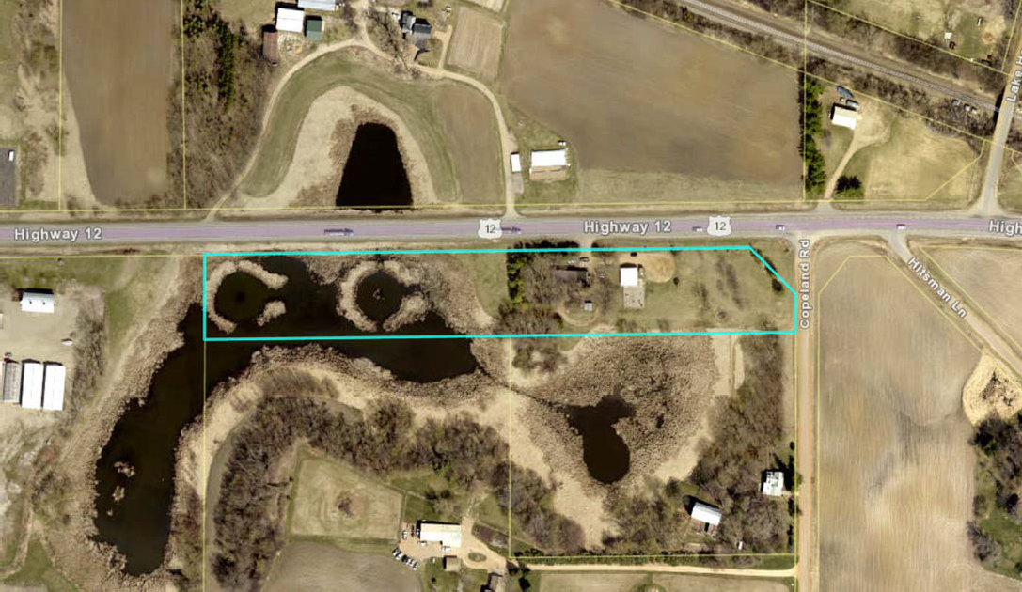

Discussion:
The subject property was granted a conditional use permit to allow a dog kennel in 1977. In 1993, the City amended the conditional use permit to allow and outside dog run in association with the conditional use permit. The conditional use permit has the following key conditions (see attached City copy of minutes for CUP):

1. Metal pole building can be up to 36’ x 82.5’. Expansion of the building can occur without further City Council review.
2. 55-60 dogs.
- Boarding and impounding of dogs from 8:00am – 7:00pm 7 days a week.
- An outdoor fenced exercise area up to 2,400 square feet is permitted. A kennel is defined as follows:
"Kennel." Any structure or premises on which four or more dogs over six months of age are kept.

The City was contacted by the owner (Dean Fowser) last year to discuss the possibility of expanding the existing building. Dean currently leases the building to Abby Lake Kennel. The kennel would like to improve the existing facility in order to stay competitive and potentially attract new clients. The existing kennel currently houses approximately 15-20 dogs at any given time. Abby Lakes has noted that they are

8875 Highway 12 CUP Request – City Council 6.13.2017
Page 2

not expecting to increase the number of dogs kept on the premise, but rather improve the facilities for their current clients.

The original conditional use permit allows for 55-60 dogs to be kept on the premise and an expansion of the building up to 36’ x 80’. When discussing the expansion of the building with the owner, he noted that he would like to turn the building 90 degrees and construct a new building rather than trying to expand the existing building. The City informed him that this would require an amendment to the conditional use permit. Turning the building appears to fit better on the property and would avoid potential conflicts with the adjacent wetlands.

The proposed building would be 36’ x 80’ in size with a small 12’ x 12’ vestibule. The proposed building would be a one-story metal pole building similar in design to the existing building. The building would have the interior kennel space, a grooming area, reception area and then a separate storage garage.

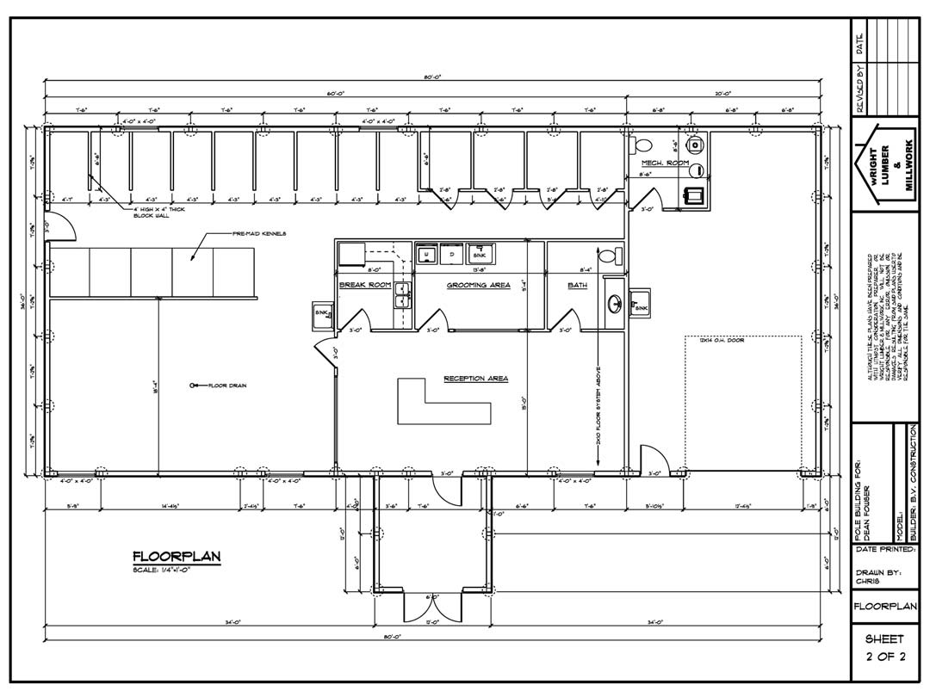

8875 Highway 12 CUP Request – City Council 6.13.2017
Page 3

The kennel is accessed off of Highway 12 via a gravel driveway. It is proposed that the kennel will continue to utilize the existing Highway 12 access. The applicant will need to modify the existing driveway and parking area to accommodate the new building. The applicant has prepared a site plan which indicates the revised parking and drop-off area based on the proposed building. The proposed setback from Highway 12 is 72 feet from the property line. The City will require one (1) handicap accessible parking space to be signed and delineated in the parking lot.

The outdoor fenced kennel area will remain following the construction of the new building. The area will be connected along the rear of the building and cannot exceed 2,400 square feet.

The applicant just recently updated the on-site septic system. The newly installed system will accommodate the proposed new building with no further modifications necessary.

The criteria for granting an amendment to the conditional use permit are the same as granting a new conditional use permit and are clearly delineated in the City’s Zoning Ordinance (Section 520.11 subd. 1, a-
- as follows:

  - The conditional use will not adversely affect the health, safety, morals and general welfare of occupants of surrounding lands.
  - The proposed use will not have a detrimental effect on the use and enjoyment of other property in the immediate vicinity for the proposes already permitted or on the normal and orderly development and improvement of surrounding vacant property for uses predominant in the area.
  - Existing roads and proposed access roads will be adequate to accommodate anticipated traffic.
  - Sufficient off-street parking and loading space will be provided to serve the proposed use.
  - The proposed conditional use can be adequately serviced by public utilities or on-site sewage treatment, and sufficient area of suitable soils for on-site sewage treatment is available to protect the city form pollution hazards.
  - The proposal includes adequate provision for protection of natural drainage systems, natural topography, tree growth, water courses, wetlands, historic sites and similar ecological and environmental features.
  - The proposal includes adequate measures to prevent or control offensive odor, fumes, dust, noise, or vibration so that none of these will constitute a nuisance.
  - The proposed condition use is consistent with the comprehensive plan of the City of Independence.
  - The proposed use will not stimulate growth incompatible with prevailing density standards.

The proposed facility has been in existence since 1977. The City does not have a history of complaints or concerns relating to the use of the property as a kennel. The natural features of the property and its geographic relationship to the surrounding properties and Highway 12 minimize potential impacts to the adjacent properties. As the proposed Conditional Use Permit relates to the criteria for granting a CUP, the following items should be noted:

8875 Highway 12 CUP Request – City Council 6.13.2017
Page 4

The conditional use permit granted in 1977 allows for the expansion of the building up to 36’ x 80’ without further City approval. The applicant is proposing to reconstruct the entire building rather than add on to the existing. The total square footage proposed is consistent with the already approved expansion. The front vestibule would be in addition to the square footage allowed under the 1977 CUP. Turning the building allows the building to “fit” on the site better than if expanded to the south.

The number of dogs kept in the kennel is not anticipated to increase. The kennel operates well under the 55-60 dogs permitted by the conditional use permit.

Hours of operation will remain the same as previously approved.

The applicant will need to modify the parking area and driveway. The applicant will need to submit the driveway plan with the building permit application. The City will require one (1) handicap accessible parking space.

The City can prescribe any additional conditions that are deemed necessary in order to ensure that the conditional use permit does not impact surrounding properties and complies with all applicable criteria.

Staff is seeking discussion and direction from the City relating to the request for a conditional use permit amendment.

Planning Commission Comments:
Planning Commissioners reviewed the requested amendment to the conditional use permit. Commissioners asked about the proposed layout of the new building and how the parking area would be revised. Commissioners asked how the pet waste is handled. The applicant explained that the waste is put into a holding tank on the property and then pumped out. Commissioners discussed that the applicant has approval to expand the existing building and that building a new building would be a better solution. Commissioners asked for clarification relating to the setback from Highway 12. Staff noted that the proposed setback met the 85 feet requirement, but that it would be added to the final survey. Commissioners found that the proposed amendment met the requirements and recommended approval to the City Council.

Neighbor Comments:
The City has not received any written or oral comments regarding the proposed amendment to the conditional use permit.

Recommendation:

8875 Highway 12 CUP Request – City Council 6.13.2017
Page 5

The Planning Commission recommended approval of the request for an amendment to the Conditional Use Permit with the following findings and conditions:
- The proposed Conditional Use Permit amendment request meets all applicable conditions and restrictions stated Chapter V, Section 510, Zoning, in the City of Independence Zoning Ordinance.
- All conditions of the 1977 approved conditional use permit and 1993 amended conditional use permit shall remain in full force.
- The Conditional Use Permit will be reviewed annually by the City to ensure conformance with the conditions set forth in the resolution.
- The proposed breeding facility is permitted as shown on the approved site plan. Any expansions, additions or other changes to the proposed site plan will require an amendment to the Conditional Use Permit.
- The applicant shall obtain a building permit from the City to allow the construction of the new building.
- The applicant shall provide the City with a updated site plan indicating the location of the driveway and parking areas. The plan shall identify the location of a handicap accessible parking space. The applicant shall be required to install the requisite space at the time the building is constructed.
- The applicant shall be responsible to pay all fees associated with the consideration and review of the conditional use permit amendment.
Attachments:
- RESOLUTION 17-0613-01 Property Pictures
- Application
- Site Survey
- Building Floor Plan

8875 Highway 12 CUP Request – City Council 6.13.2017
Page 6

Attachment #1

8875 Highway 12 (Looking south)
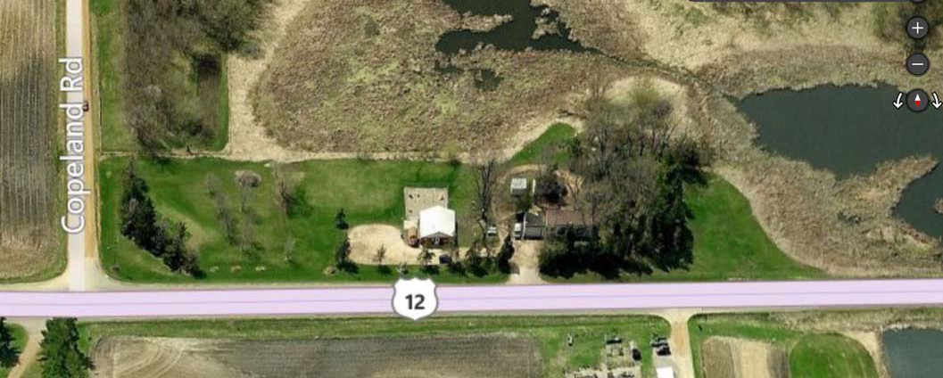

8875 Highway 12 (Looking west)
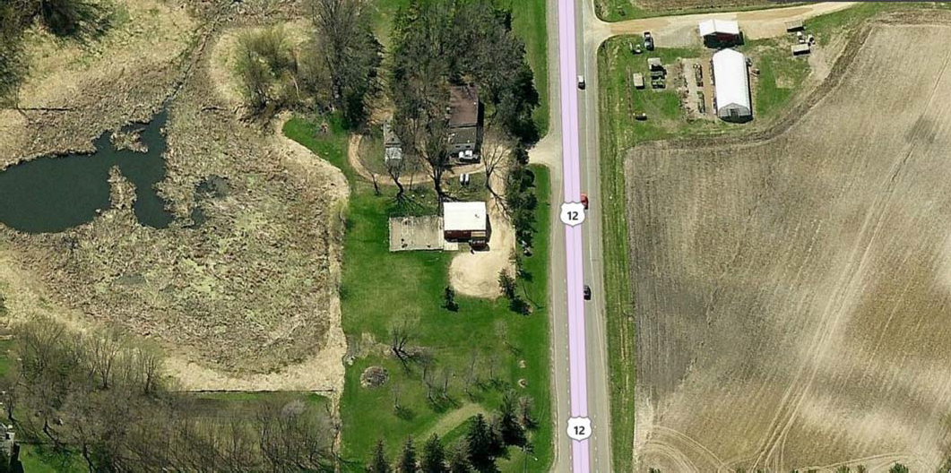

8875 Highway 12 CUP Request – City Council 6.13.2017
Page 7

RESOLUTION NO. 17-0613-01

A RESOLUTION GRANTING APPROVAL OF AN AMENDMENT TO THE CONDITIONAL USE PERMIT AS REQUESTED BY DEAN FOWSER FOR THE PROPERTY
LOCATED AT 8875 HIGHWAY 12

WHEREAS, the City of Independence (the “City) is a municipal corporation under the laws of Minnesota; and

WHEREAS, the City adopted a comprehensive plan in 2010 to guide the development of the community; and

WHEREAS, the City has adopted a zoning ordinance and other official controls to assist in implementing the comprehensive plan; and

WHEREAS, Dean Fowser, (the “Applicant”) submitted a request for an amendment to the Conditional Use Permit to allow a new building to be constructed on the property located at 8875 Highway 12 (PID No. 18-118-24-11-0001) (the “Property”); and

WHEREAS, the Property is zoned Agriculture; and
WEHREAS, the Property is legally described on Exhibit A attached hereto; and WHEREAS the requested amendment to the Conditional Use Permit meets all
requirements, standards and specifications of the City of Independence zoning ordinance for Agriculture lots; and

WHEREAS the Planning Commission held a public hearing on May 16, 2017 to review the application for an amendment to the Conditional Use Permit, following mailed and published noticed as required by law; and

WHEREAS, the City Council has review all materials submitted by the Applicant; considered the oral and written testimony offered by the applicant and all interested parties; and has now concluded that the application is in compliance with all applicable standards and can be considered for approval; and

NOW, THEREFORE BE IT RESOLVED BY THE CITY COUNCIL OF THE CITY OF
INDEPENDENCE, MINNESOTA, that it should and hereby does approve the application by Dean

Fowser for an amendment to the Conditional Use Permit per the City’s zoning regulations with the following conditions:

  - The proposed conditional use permit amendment request meets all applicable conditions and restrictions stated in Chapter V, Section 510, Zoning, in the City of Independence Zoning Ordinance.

  - All conditions of the 1977 approved conditional use permit and 1993 amended conditional use permit shall remain in full force.

  - The Conditional Use Permit will be reviewed annually by the City to ensure conformance with the conditions set forth in the resolution.

- The proposed breeding facility is permitted as shown on the approved site plan. Any expansions, additions or other changes to the proposed site plan will require an amendment to the Conditional Use Permit.

- The applicant shall obtain a building permit from the City to allow the construction of the new building.

- The applicant shall provide the City with an updated site plan. The plan shall identify the location of a handicap accessible parking space. The applicant shall be required to install the requisite space at the time the building is constructed.

- The applicant shall be responsible to pay all fees associated with the consideration and review of the conditional use permit amendment.

This resolution was adopted by the City Council of the City of Independence on this 13h

day of June, 2017, by a vote of
ayes and
nays.

ATTEST:
Marvin Johnson, Mayor

Mark Kaltsas, City Administrator

(SEAL)

...

Planning & Zoning Department: Applicationfor Planning Consideration (2016)

City of Independence

The Independence City Code was established to protect both current and future residents from the negative impacts of improper development and to ensure a positive future for the city. The land use application review is the mechanism that allows the city to examine proposed uses to ensure compatibility with the surrounding environment, natural or otherwise. It is important to understand that a proposed use may be acceptable in some circumstances, but unacceptable in others-all applications are viewed on a case-by-case basis.
• • • • • • • • • •• • • • • • •• • • • • • • • ••• • • • •• • • • • Request: B,e. o ck \ -6'("\· ;'"" b b'-"' ,\J.,lr<y
D Appeal

D Comprehensive Plan Amendment
D Co11cept Plan
- M Conditional Use Permit
'jt ./ Residential
_ Commercial/Light Industrial Telecommunication s
_ Agriculture
_ Home Occupation
_ Non-Conforming Use
Guest/Bunk House •
""J V\dc\ o," C0V\.bi-o .-1 -H\(
a-'"'-t1r:v sf : L-\. 11\c <£ 0 X ':] 6
Vv- r ('0 (\ t s+, //\ l t I.A/(_ 3ox 3 D

Institutional
CUP Amendment

D E1e11si011 Request
D Final Plat
D /11terim Use Permit
•
•
••
•• Site Address or Property Identification Number(s) :
•

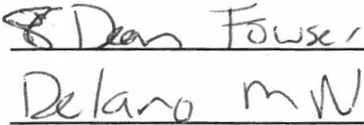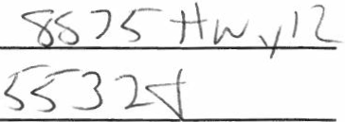D Lot Consolidation NOTE: Minnesota State Statute 15.99 requires local governments to review an application within 15 days of its

- D Minor Subdivision (Survey)
••• Lot Subdivision Lot Combination
•• _ Lot Line Rearrangement
••• D
•• Movi11g Buildings
- D Preliminary Plat
•
•
:D Rezoning
submission to determine if an application is complete and/or if additional information is needed to adequately review the subject request. To e11sure an expedited review, applicants shall schedule apre-application meeting with the City Planner/Administrator at least one week prior to submittal. Most applications have a review period of 60 days, with the City's ability to extend an additional 60 days if necessary
due to insufficient information or schedule.

• r •••·•••·· ••····················.....................................

•
:D Site Plan Review (Commercial)
••
·o Vacation
0 Variance
_ Subdivision Regulations
_ Zoning
_ Road Frontage
Office Use Only
I,2- 50

Ai}plicati on Amount
750
- 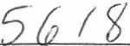.,kid
heck #
tJ lf a rif-

Accepted By

Date
5 I f
Application Check #

D Zoning Text Amendment
*Please check all that apply
l I Date Accepted by Planne<

  - 1 City Planner
: I

• • • • • • • • • • • • • • • • • • • • • • • • • • • • • • • • • • • • • • i

***Note: Allpa rties with af ee interest in the real estate must sign this application before the City will reviewfo r consideration!

Applica n t Information: Owner Information (if different than applicant)
·'\'\ -

Name: y .cAC> t'OLrJ /

Address: 1 'b 1 ±\ c, J / City, State, Zip: QJ000
I
Phone: (rJ I 1 L} J
I "\
fv\N ') 5 ' 3t:--,.
gt:;rj')

City, State, Zip:-------------

Phone: ----------------

Email : Qe.u,0, Tuw 1< 0 \or Mt. \ {-o Email: _ ___
Signature:TI. S Signature: _

Checklist : Please review the checklist that goes with the request(s) as all material s in the checklist unless waived by the City.

Review Deadline and Timeline: All applications must be received by the deadline according to the schedule attached hereto. Failure to submit by the date shown will result in a delay in the scheduling of the application review by Planning Commission and City Council.

Application for Planning Consideration Fee Statement

The City of Independence has set forth a fee schedule for the year 2014 by City Ordinance. However, projects of large scope that include two or more requests will be required to provide a larger deposit than the resolution sets forth as set by the City Administrator. The fees collected for land use projects are collected as deposits.
All invoices associated with each land employ application will be billed to the applicant within 30 days upon receipt by the City for each project. The City of Independence often utilizes consulting firms to assist in the review of projects. The consultant and City rates are shown at the bottom of this form. By signing this form, the applicant recognizes that he/she is solely responsible for any and all fees associated with the land use application from the plan review stage to the construction monitoring stage through to the release of any financial guarantee for an approved project. Ifa project is denied by the City Council or withdrawn by the applicant , the fees associated for the project until such denial or withdrawal , remain the applicant' s responsibility.

I UNDERSTAND THE FEE STATEMENT AND RESPONSIBILITIES ASSOCIATED WITH THIS LAND USE APPLICATION:

Applicant Sjgnature: _ .S=::::.::....-::::::... ---=====---- - - - - - Date: } I a I IJ
Owner Signature (if different): _ Date:--- - - -

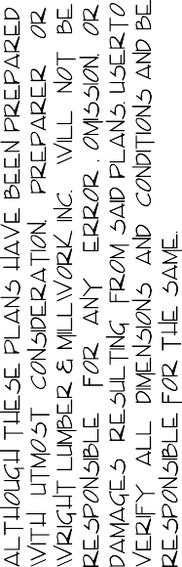

BOUNDARY AND TOPOGRAPHIC SURVEY FOR
DEAN FOWSER

IN THE NE 1/4 OF SECTION 18-118-24
HENNEPIN COUNTY, MINNESOTA

0 U. S. HIGHWAY NO. 12
------.,.-------l!) --------------------.::-.:_:_._.._.-"Nc;Ri'i'.iliN'EQ'FEA;;-:fi:Wi------------N 89°:_oso·48" E 1299-70:-- -------------------------------------- --------1----------------
NORTH LINE OF EAST HALF, EDGE OF BLACKTOP .,

NE 1/4, SEC. 18-118-24
------------------ -------- --- - -- -
. ·-- -

-m---;;;- ---=--=---- -
- - --- ---o- -
--- -t<T- ---- ---·
-- 78- - - -----
-- --- - - -- - 97& - -- - --
-- -----------------------

- - \
N·9°00'48" E 1\183.33
\

/ .¢ _ -

:;:t;
;;!j _ WEST LINE OF EAST HALF,
N . . NE 1/4, SEC. 18-118-24
w
in
....
\
\,
·-... \
\

\

0 "l!)'
0
0 '<!"

0 OJ
z

SOUTH LINE OF NORTH
- - 234.5 FT. OF EAST HALF, NE 1/4, SEC. 18-118-24

LEGAL DESCRIPTION OF PREMISES SURVEYED:

The North 234.5 feet of the East Half of the Northeast Quarter of Section 18, Township 118 North, Range 24 West of the
5th Principal Meridian.
'·\ \
\
\
I

This survey shows the boundaries and topography of the above described property, and the location of all buildings, if any, thereon,
the location of an existing gravel drive, and the proposed location of a proposed building. It does not purport to show any other improvements
or encroachments. 0 50 100 200
i
I ; I , I I I I I I z w0
5 ·"

0 Iron marker set
I I I
<( ·u

I , 0:: w

Existing contour line Proposed contour line
0 I
SCALE IN FEET u

z
I Q
I'
! !;;(
Cf), UJ g
z C!)
0 <( i!!:
_ ::;; 0
Cf) w ...J
5
0::

->w
0:::
al
0
w
wa:

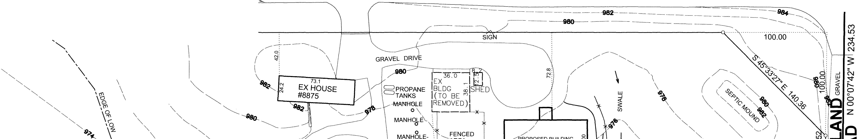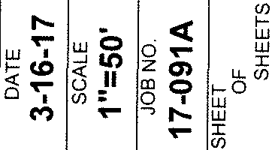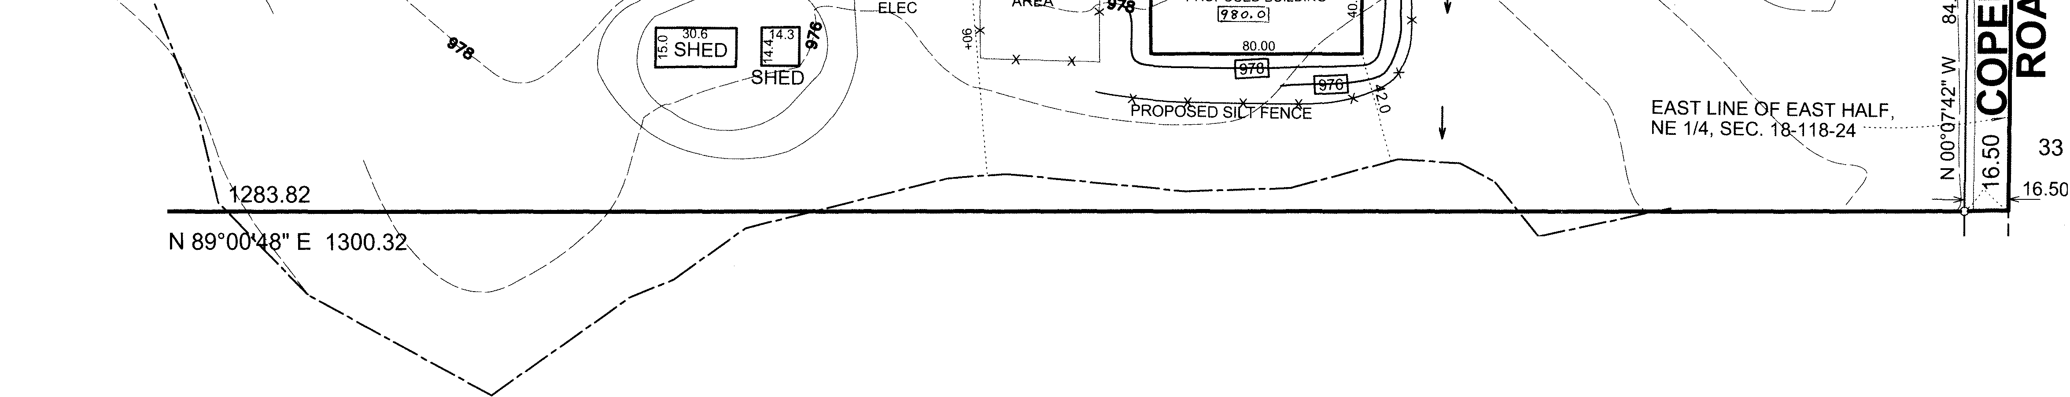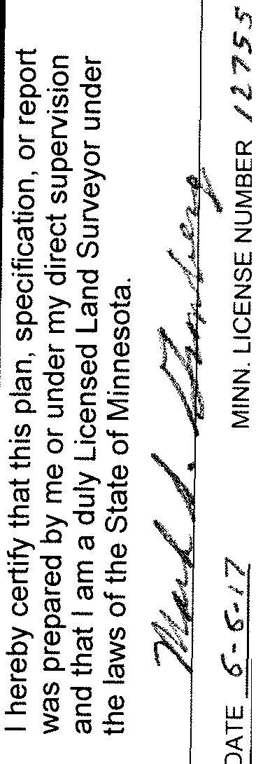
>­
!D I

17-091A

City of Independence, Minnesota Audit Results and Communications December 31, 2016

Investment advisory services are offered through CliftonLarsonAllen Wealth Advisors, LLC,
an SEC-registered investment advisor. | ©2016 CliftonLarsonAllen LLP

WEALTH ADVISORY | OUTSOURCING | AUDIT, TAX, AND CONSULTING

Agenda
©2016 CliftonLarsonAllen LLP

Financial Results

- MN Legal Compliance Letter

- Required Communications

- Internal Control Letter

- Other Items

WEALTH ADVISORY | OUTSOURCING | AUDIT, TAX, AND 2
CONSULTING

Financial Results
©2016 CliftonLarsonAllen LLP

Unmodified Opinion

- Comparative information for the sanitary sewer fund

WEALTH ADVISORY | OUTSOURCING | AUDIT, TAX, AND 3
CONSULTING

Financial Results (continued)
©2016 CliftonLarsonAllen LLP

$4,000,000
Government-wide Statements

$3,500,000

$3,000,000

$2,500,000

$2,000,000

$1,500,000

$1,000,000

2009 2010 2011 2012 2013 2014 2015 2016

Cash & Investments Expenses Expendable Net Position

 | 2009 | 2010 | 2011 | 2012 | 2013 | 2014 | 2015 | 2016
Cash & Investments | 2,035,055 | 2,425,515 | 2,400,047 | 2,317,446 | 1,876,037 | 1,699,751 | 3,153,077 | 1,903,697
Expenses | 2,810,990 | 2,758,256 | 2,860,683 | 2,942,665 | 3,311,817 | 3,130,273 | 3,355,597 | 3,335,346
Expendable Net Position | 1,854,984 | 2,004,226 | 1,981,543 | 2,577,263 | 2,804,415 | 2,815,582 | 2,504,514 | 2,354,330

WEALTH ADVISORY | OUTSOURCING | AUDIT, TAX, AND 4
CONSULTING

Financial Results (continued)
©2016 CliftonLarsonAllen LLP

General Fund Revenues
2,800,000

2,600,000

2,400,000

2,200,000

2,000,000

1,800,000
 | 2010 | 2011 | 2012 | 2013 | 2014 | 2015 | 2016
Miscellaneous | 16,536 | 12,876 | 21,197 | 38,120 | 10,896 | 19,524 | 16,365
Interest on Investments | 16,333 | 6,814 | 4,920 | 5,624 | 2,217 | 2,884 | 5,429
Fines and Forfeitures | 36,902 | 35,278 | 41,364 | 40,094 | 49,188 | 49,517 | 54,637
Charges for Service 73,209 | 23,640 | 21,907 | 91,881 | 74,295 | 100,542 | 81,973 | 37,275
Intergovernmental | 26,273 | 67,384 | 25,819 | 48,849 | 88,440 | 84,866 | 46,312
Licenses and Permits | 95,337 | 117,658 | 175,528 | 157,077 | 166,832 | 123,407 | 181,139
Property Taxes | 2,149,915 | 2,008,482 | 1,952,097 | 1,957,411 | 1,980,146 | 2,183,200 | 2,211,660

WEALTH ADVISORY | OUTSOURCING | AUDIT, TAX, AND 5
CONSULTING

Financial Results (continued)
©2016 CliftonLarsonAllen LLP

General Fund Expenditures

3,000,000

2,500,000

2,000,000

1,500,000

1,000,000

500,000

‐
 | 2010 | 2011 | 2012 | 2013 | 2014 | 2015 | 2016
Capital Outlay | 204,614 | 189,216 | 133,043 | 153,302 | 187,489 | 10,881 | 2,612
Culture and Recreation | 15,643 | 16,986 | 16,496 | 38,375 | 21,157 | 23,453 | 16,906
Public Works | 370,621 | 383,571 | 389,905 | 414,128 | 402,532 | 477,122 | 528,585
Public Safety | 1,186,024 | 1,185,266 | 1,209,042 | 1,254,568 | 1,299,549 | 1,387,522 | 1,568,503
General Government | 480,293 | 456,549 | 486,225 | 510,590 | 529,659 | 542,424 | 508,522

WEALTH ADVISORY | OUTSOURCING | AUDIT, TAX, AND 6
CONSULTING

Financial Results (continued)
©2016 CliftonLarsonAllen LLP

Taxes receivable per year

– 2016: $104,442
– 2015: $91,553
– 2014: $56,126
– 2013: $90,985
– 2012: $83,886
– 2011: $91,342
– 2010: $107,526
– 2009: $70,370
• $2,549,429 collected on $2,581,829 levy for 2016 (98.7% collection rate)

WEALTH ADVISORY | OUTSOURCING | AUDIT, TAX, AND 7
CONSULTING

Financial Results (continued)
©2016 CliftonLarsonAllen LLP

2,700,000
General Fund Revenues & Expenditures

2,600,000

2,500,000

2,400,000

2,300,000

2,200,000

2,100,000

2,000,000
 | 2009 | 2010 | 2011 | 2012 | 2013 | 2014 | 2015 | 2016
Revenues | 2,658,415 | 2,364,936 | 2,270,399 | 2,312,806 | 2,321,470 | 2,398,261 | 2,545,371 | 2,552,817
Expenditures | 2,316,958 | 2,257,195 | 2,231,588 | 2,234,711 | 2,370,963 | 2,440,386 | 2,441,402 | 2,625,128

WEALTH ADVISORY | OUTSOURCING | AUDIT, TAX, AND 8
CONSULTING

Financial Results (continued)
©2016 CliftonLarsonAllen LLP

Unassigned Fund Balance ‐ General Fund

$2,000,000

$1,800,000

$1,600,000

$1,400,000

$1,200,000

80.0%

70.0%

60.0%

50.0%

$1,000,000

$800,000

$600,000

$400,000

$200,000
40.0%

30.0%

20.0%

10.0%

$0
2008 2009 2010 2011 2012 2013 2014 2015 2016
0.0%

Unassigned Fund Balance % of Annual Expenditures

The 2016 percentage calculated based on 2017 budgeted expenditures.
Even though the percentage is less than the City’s goal of 50%, the City has transferred
$100,000 to capital project funds which are not reflected above as spendable.

WEALTH ADVISORY | OUTSOURCING | AUDIT, TAX, AND 9
CONSULTING

Financial Results (continued)
©2016 CliftonLarsonAllen LLP

Future Debt Service
(Principal & Interest)

$450,000

$400,000

$350,000

$300,000

$250,000

$200,000

$150,000

$100,000

$50,000

$0
2017 2018 2019 2020 2021 2022 2023 2024 2025 2026

WEALTH ADVISORY | OUTSOURCING | AUDIT, TAX, AND 10
CONSULTING

Financial Results (continued)
©2016 CliftonLarsonAllen LLP

$1,000,000

Sanitary Sewer Fund

$800,000

$600,000

$400,000

$200,000

$0

‐$200,000

‐$400,000

2010 2011 2012 2013 2014 2015 2016

Operating Revenues Operating Expenses Depreciation Nonoperating ‐ net Transfers In Operating Income (Loss)

WEALTH ADVISORY | OUTSOURCING | AUDIT, TAX, AND 11
CONSULTING

Financial Results (continued)
©2016 CliftonLarsonAllen LLP

Cash Flows from Operations

$40,000

$20,000

$0

‐$20,000

‐$40,000

‐$60,000

‐$80,000

‐$100,000

‐$120,000

‐$140,000

2009 2010 2011 2012 2013 2014 2015 2016
Cash Flows from Ops

WEALTH ADVISORY | OUTSOURCING | AUDIT, TAX, AND 12
CONSULTING

MN Legal Compliance
©2016 CliftonLarsonAllen LLP

1 disbursement of 25 tested did not have any supporting documentation to support the amount paid.

WEALTH ADVISORY | OUTSOURCING | AUDIT, TAX, AND 13
CONSULTING

Required Communications
©2016 CliftonLarsonAllen LLP

Audit provides reasonable, but not absolute
assurance

- Accounting policies – no changes from prior year

- Significant accounting estimates

- Audit adjustments and uncorrected misstatements

- No disagreements or difficulties with management

WEALTH ADVISORY | OUTSOURCING | AUDIT, TAX, AND 14
CONSULTING

Internal Control Letter
©2016 CliftonLarsonAllen LLP

Material weakness

Audit Adjustments

Prior period adjustment for Medina receivable, record net pension liability and related accounts
  - Lack of Segregation of Duties
    - Lack of documented controls over journal entries, payroll, capital assets, and year-end receivables and payables

- Significant deficiencies
  - None

- Management comments
  - None

WEALTH ADVISORY | OUTSOURCING | AUDIT, TAX, AND 15
CONSULTING

Other Items – Future Standards
©2016 CliftonLarsonAllen LLP

GASB Nos. 74 & 75 – Other Postemployment Benefits

#74 Applicable December 31, 2017
  - #75 Applicable December 31, 2018

WEALTH ADVISORY | OUTSOURCING | AUDIT, TAX, AND 16
CONSULTING

Thank You!
©2016 CliftonLarsonAllen LLP

Chris Knopik, Principal 612-397-3266
Christopher.Knopik@CLAconnect.com

Sarah Utsch, Manager 320-203-5536
Sarah.Utsch@CLAconnect.com

WEALTH ADVISORY | OUTSOURCING | AUDIT, TAX, AND 17
CONSULTING

City of Independence
Annual Public Comment Opportunity for MS4 Permit

To: City Council
From: Mark Kaltsas, Administrator
Meeting Date: June 13, 2017

Summary:
Each year the City is required to offer an opportunity to the public to provide comments relating to the City’s MS4 Stormwater Permit. No official public hearing is required.

From the Minnesota Pollution Control Agency

What is an MS4
A municipal separate storm sewer system is a conveyance or system of conveyances (roads with drainage systems, municipal streets, catch basins, curbs, gutters, ditches, man-made channels, storm drains, etc.) that is also:

- owned or operated by a public entity (which can include cities, townships, counties, military bases, hospitals, prison complexes, highway departments, universities, etc.) having jurisdiction over disposal of sewage, industrial wastes, stormwater, or other wastes, including special districts under State law such as a sewer district, flood control district or drainage districts, or similar entity, or an Indian tribe or an authorized Indian tribal organization, or a designated and approved management agency under section 208 of the Clean Water Act that discharges to waters of the United States;
- designed or used for collecting or conveying stormwater;
- which is not a combined sewer; and
- which is not part of a publicly owned treatment works.

The MS4 General Permit is designed to reduce the amount of sediment and pollution that enters surface and ground water from storm sewer systems to the maximum extent practicable. Stormwater discharges associated with MS4s are subject to regulation under the National Pollutant Discharge Elimination System/State Disposal System (NPDES/SDS). Through the MS4 General Permit, the system owner or operator is required to develop a stormwater pollution prevention program (SWPPP) that incorporates best management practices (BMPs) applicable to their MS4.

Page 1

City of Independence
City Council Meeting Schedule

To: City Council
From: Mark Kaltsas, Administrator
Meeting Date: June 13, 2017

Summary:
Council has discussed moving the regular City Council Meetings to the first and third Tuesday of each month at 6:30 PM. It is anticipated that this will commence in August, 2017. The City will need to amend the ordinance to remove the prescribed times at a future meeting. The following is a tentative Council Meeting Schedule:

June 13, 2017 – Regular City Council Meeting (7:30 PM) June 27, 2017 – No Meeting
July 11, 2017 – Regular City Council Meeting (7:30 PM)
July 18, 2017 – Joint City Council/Planning Commission Meeting (6:30 PM) July 25, 2017 – Regular City Council Meeting (7:30 PM) – if needed

New City Council Schedule
August 1, 2017 – National Night Out – Regular Meeting to be rescheduled to either Monday, July 31 or Wednesday, August 2 (6:30 PM).
August 15, 2017 – Regular City Council Meeting (6:30 PM)

Page 1

